From Bottom to Top
1 Bottom Case
- Caliper
- USB to USB cables
- USB to jack type M Barrel 5V DC power supply (spare cable for the network switch)
- D-Link Network switch empty box (the switch is in Peli Case 2)

.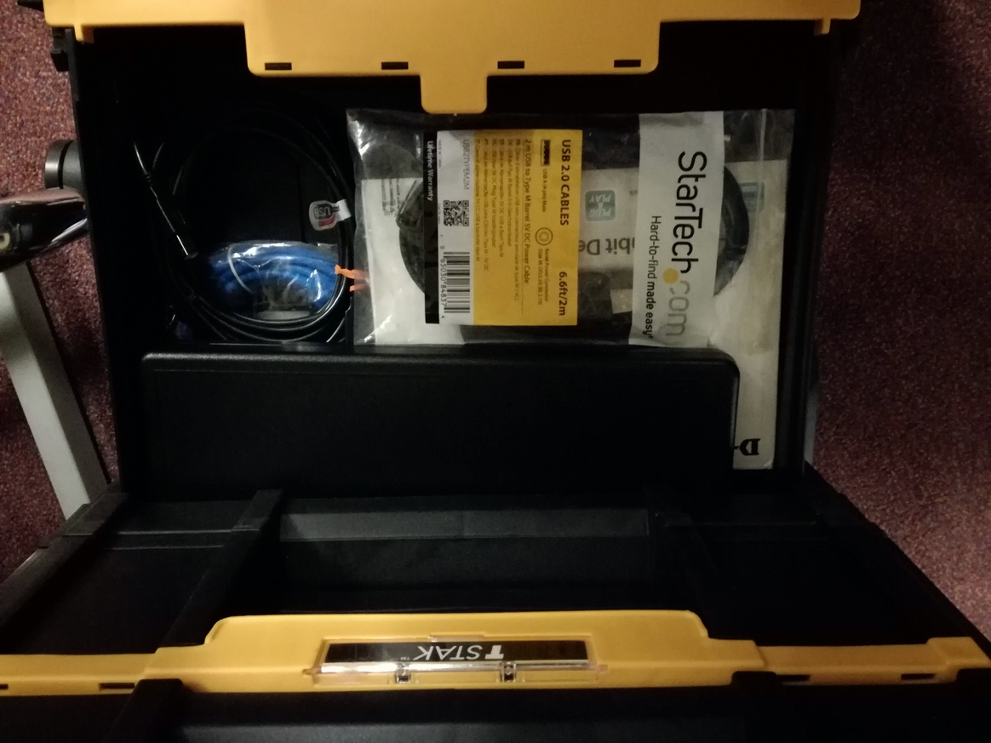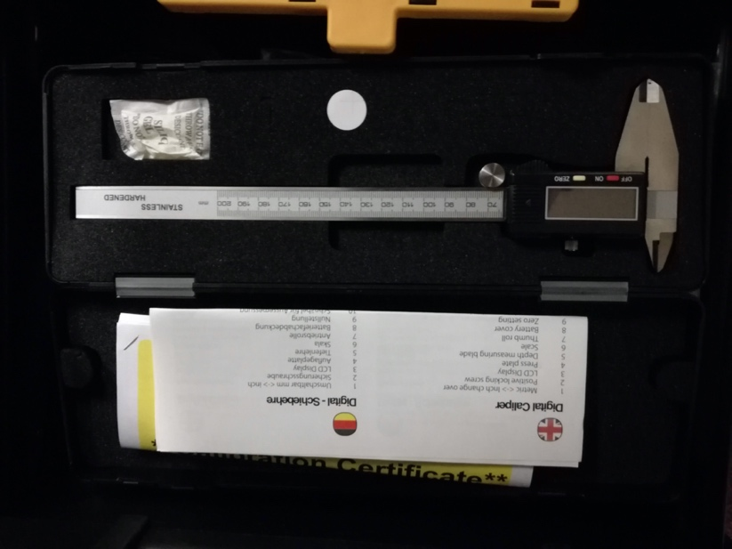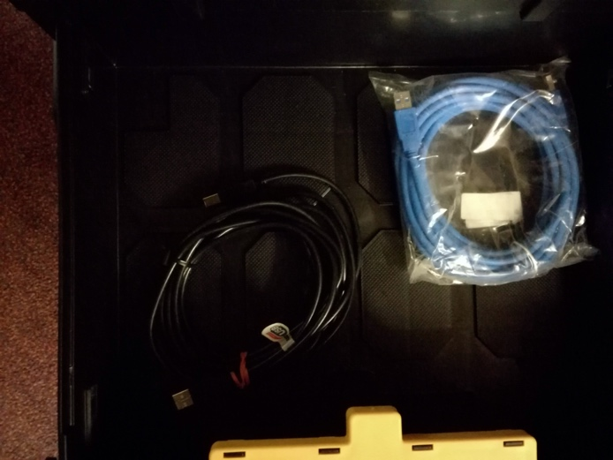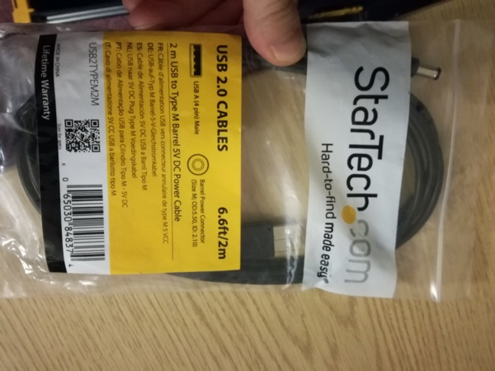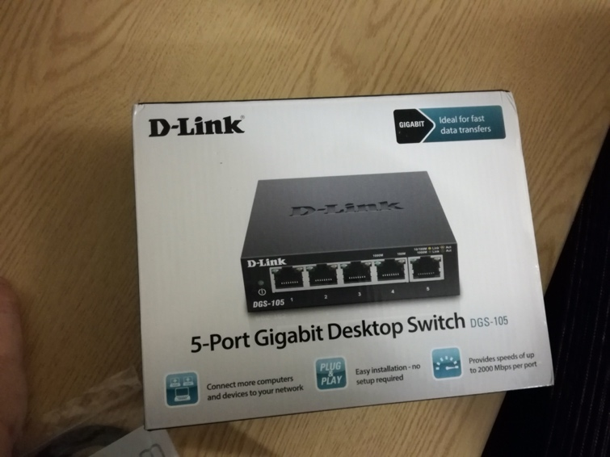

2.
- PMT
- Silicone Optical grease
- Scintillator cleaning wipes and liquid cleaner (isopropane?)
- black tape

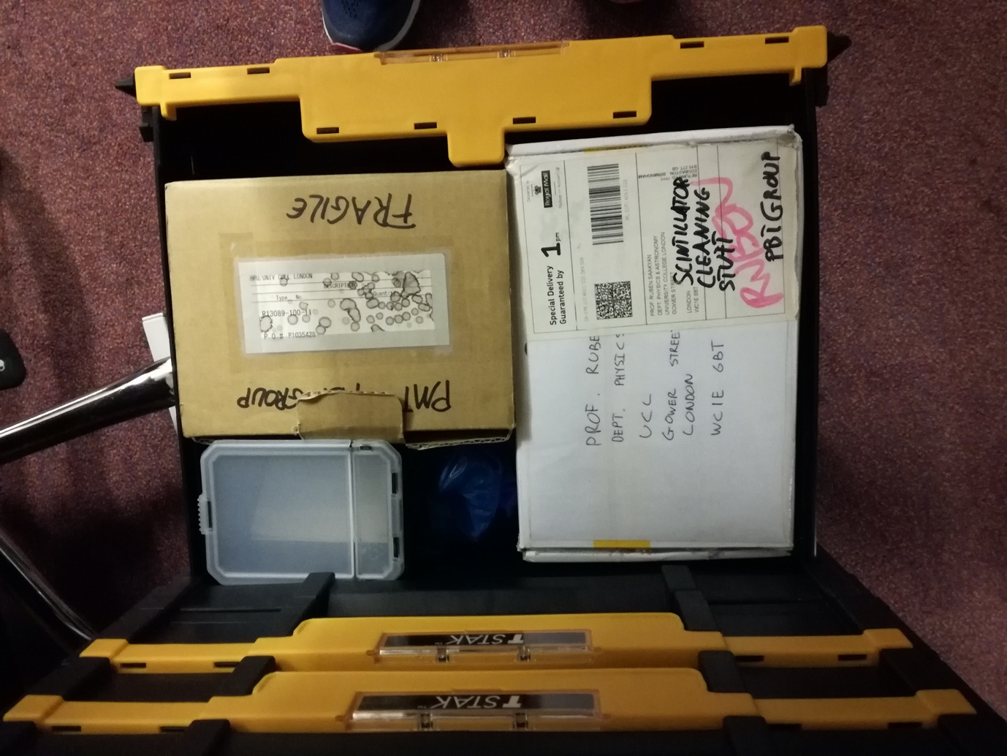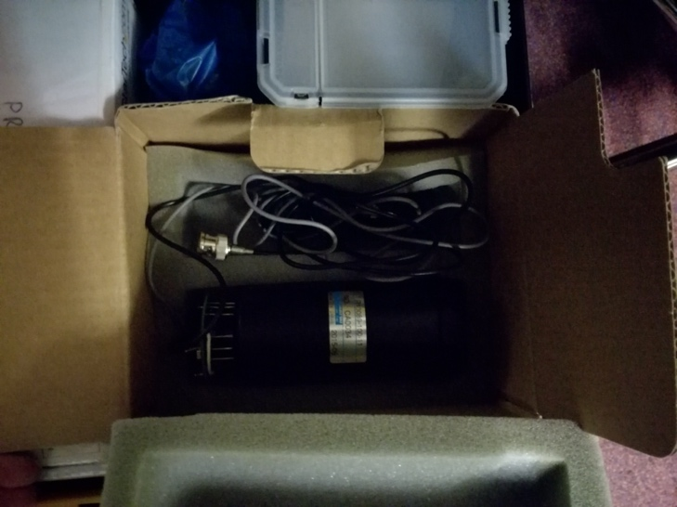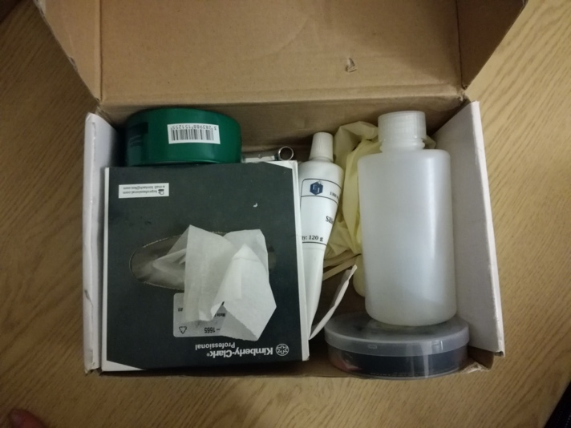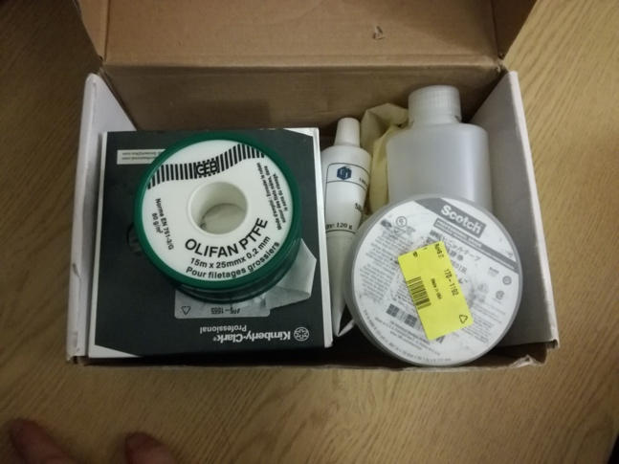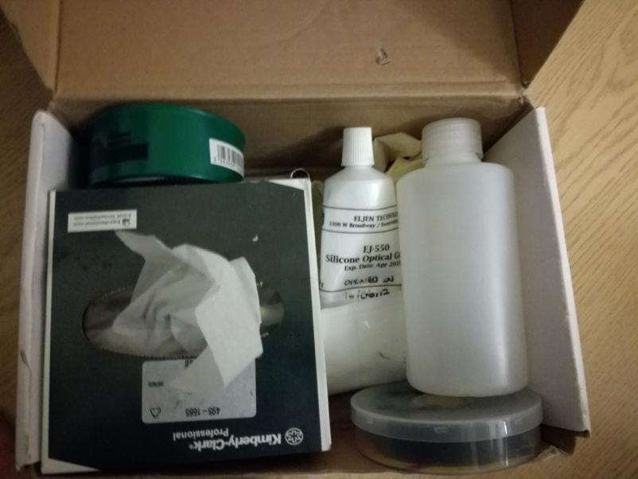

3.
-SMA to SMA long and short robust cables
-BNC to BNC cable
-BNC to MCX cables for the CAEN digitiser
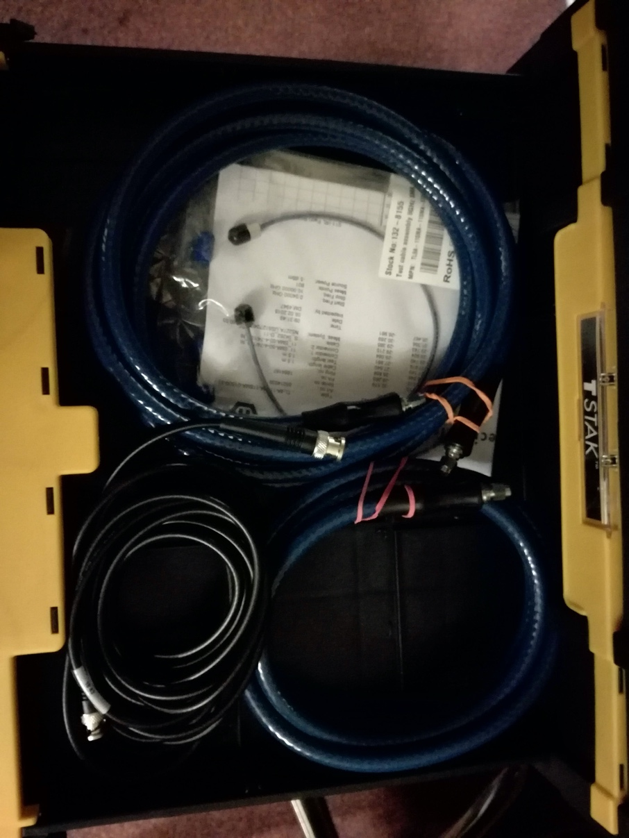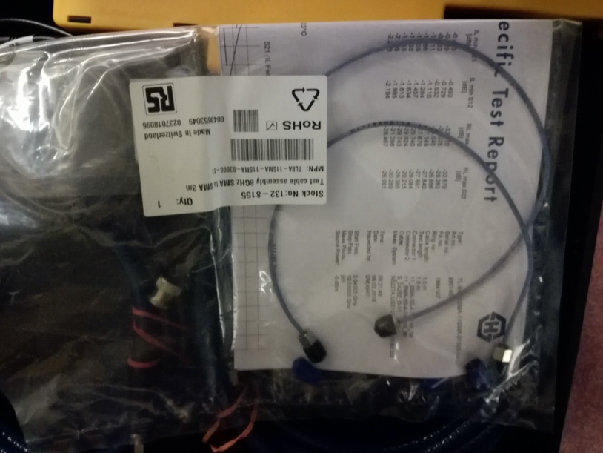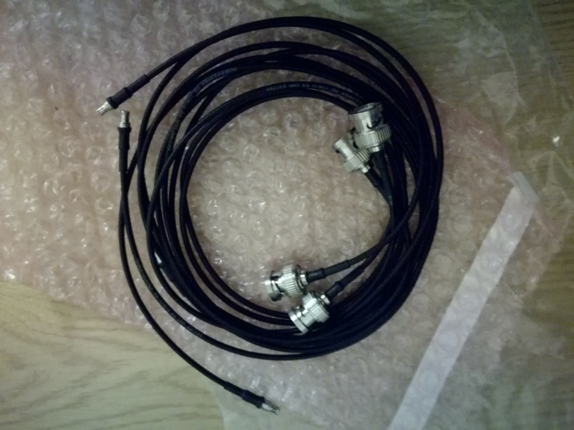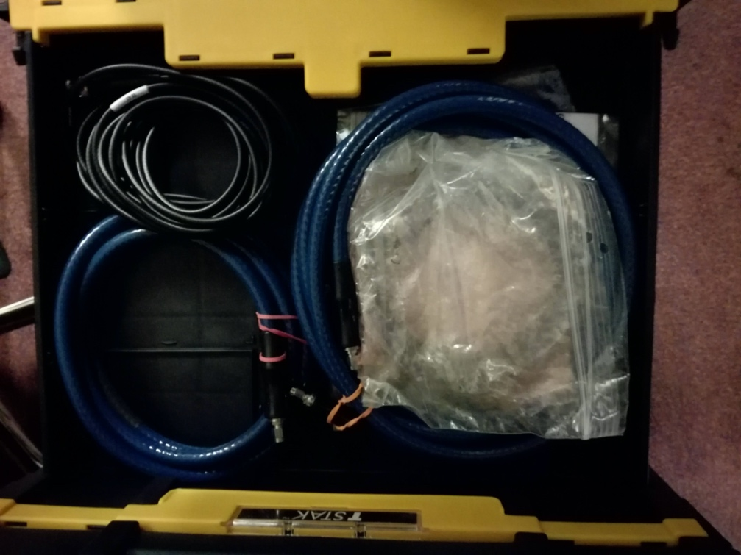

4.
Wera Tools: screwdrivers set , blade and L keys
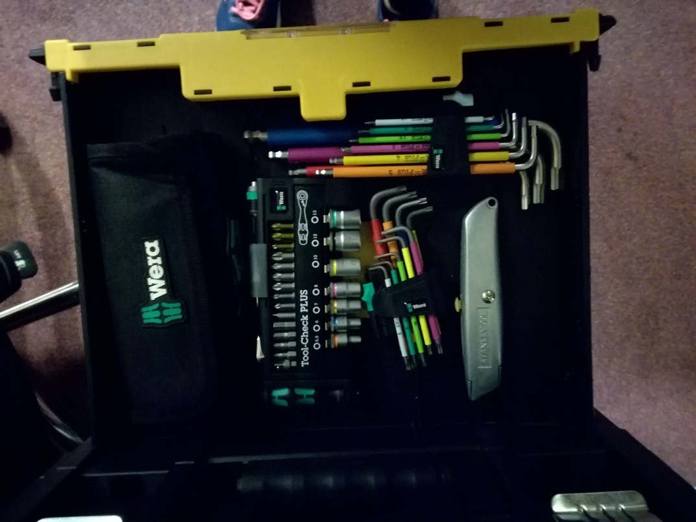

5.
Scintillators
- different sizes. Additional scintillator sheets are on my desk
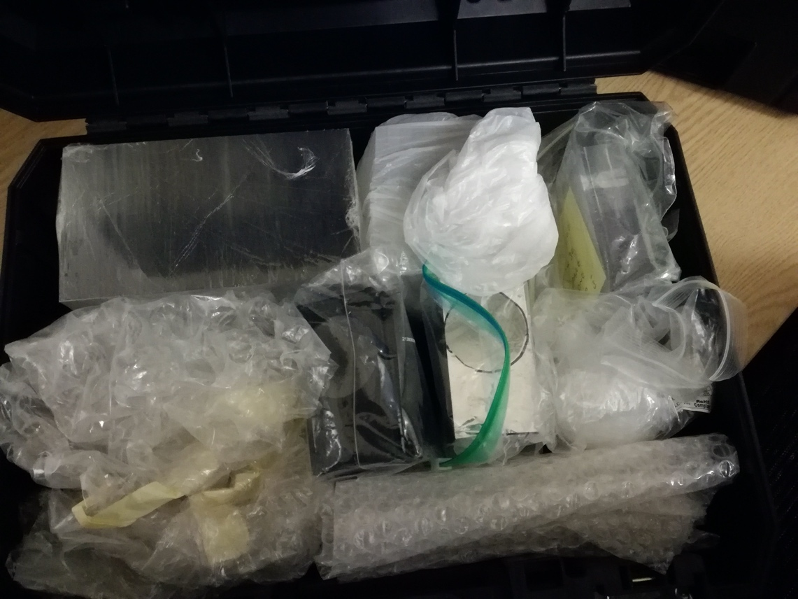

6
- BNC, SMA, and SHV patch panel
- 1 Power strip: USB and Universal sockets
- Mains power cable
- Ethernet cables
- 1 box containing: DC-4200 MHz Signal Splitter, SMA connectors, BNC to SMA connectors and SMA to MCX adaptor. Spanner for SMA connectors.

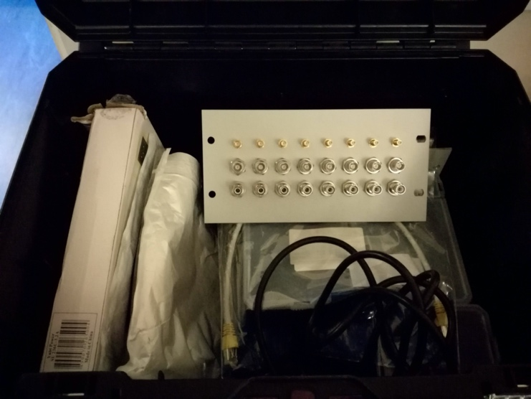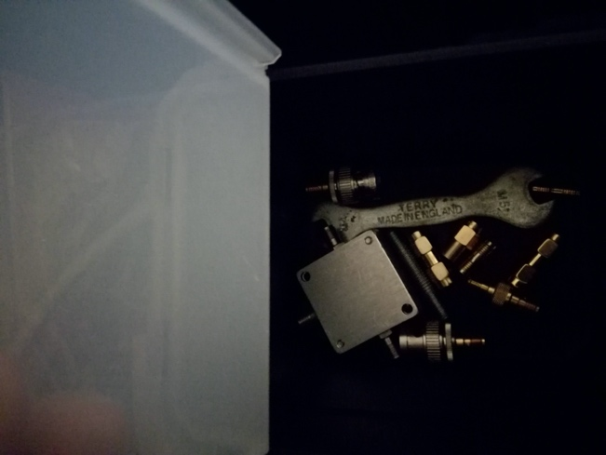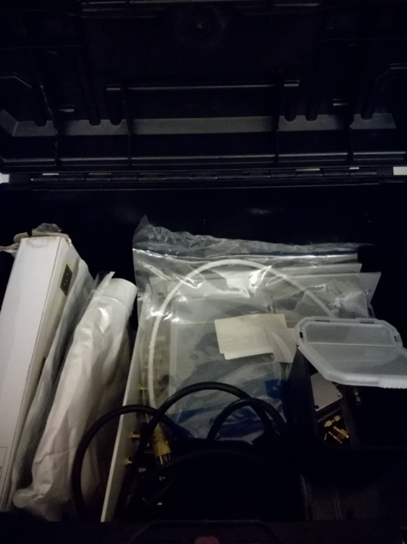

7
-ISDI CMOS sensor
- sensor enclosure screws and washers
- Camera Link Cable

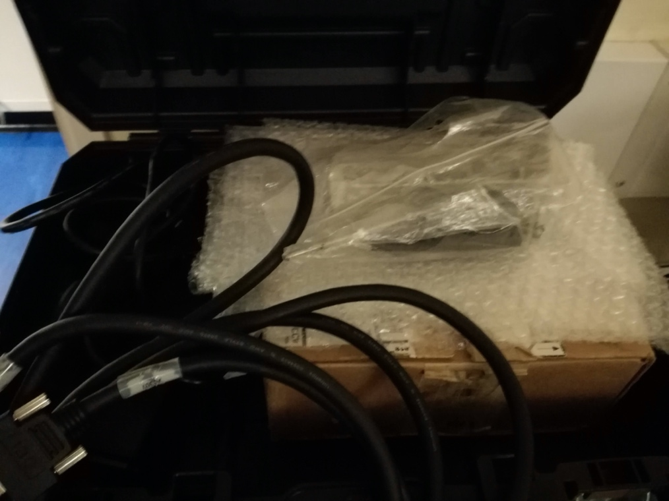

8 Top container
- BNC, SMA, and MCX connectors
- USB sockets for the parch panel
- Tape Measure
- Photodiodes and LEDs
- 