MCNPX Beamline Geometry December 2011
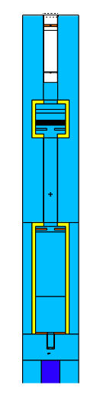

Source [0 cm]
Collimator [5 cm]
1st Scattering foil [8 cm]

Al tubing (7.2cm inner dia.) [to window]

Stopper & 2nd scattering foil [30 cm]
Kapton window [35.6 cm]

Al boxing (16x16cm inner) [45-65 cm]
Range-shifter [50 cm]

Modulator [~55 to 58 cm (32 steps)]

2nd collimator (not used) [60 cm]

Al tubing [65-110cm]

Anti-scatter collimator [113 cm]

Monitor chambers [115cm]

Al boxing [110-169.2cm]

Cross-wires [149.2cm]

Nozzle [169.2-176.6cm]

Patient collimator [176.2-177cm]

Wedge [179cm]

Phantom/patient [184cm]

