LECTURES ON THE MEDICAL ELECTRICAL

EQUIPMENT SAFETY STANDARD:
IEC 60601-1
BS EN 60601-1 (2006)

Dr Martin Fry
Lecturer in Medical Electronics
Department of Medical Physics and Bioengineering
University College London

E-mail: martin.fry@ucl.ac.uk

Version: 2015-11-05

USEFUL WEBSITES:

1. Articles on Electrical Safety under Articles section of
Electronic and Biomedical Engineering website:

http://www.ebme.co.uk

2. Medical Devices section of the MHRA (Medicines and
Healthcare products Regulatory Agency):

http://www.mhra.gov.uk

3. IEC (International Electrotechnical Commision)

http://www.iec.ch/

4. British Standards Online:

https://bsol.bsigroup.com/en/BsolHomePage/

HOW WE GOT TO WHERE WE ARE:
A HISTORY OF (UK) ELECTRICAL SAFETY DOCUMENTS

Hospital Technical Memorandum No. 8 (HTM8), 1963, Revised 1969.
“Safety Code for Electromedical Apparatus.”
Department of Health and Social Security (DHSS), London.

Draft Standard of the International Electrotechnical Commission (IEC), 1976.
“General Requirements for Safety of Electrical Equipment used in Medical Practice.”

Topic Group Report 24 (TGR24), 1977.
“A guide to Electrical Hazards and Safety Standards.” The Hospital Physicists’ Association (HPA).

Topic Group Report 25 (TGR25), 1977.
“A guide to Acceptance Testing of Electromedical Equipment.” HPA.

Health Equipment Information No. 95 (HEI95), 1981. “Code of practice for acceptance testing of medical electrical equipment.” DHSS

Health Equipment Information No. 98 (HEI98), 1982. “Management of equipment.” DHSS

BS 5724: Part 1: 1979.
(≡ IEC Publication 601-1)
Safety of Medical Electrical Equipment
(Superseded HTM8 in April 1981)

Topic Group Report 37 (TGR37), 1983.
“Safe Design and Construction of Electromedical Equipment.” HPA.

BS 5724: Part 1: 1989.
BS EN 60601-1:1990
(Issue 2, October 1997)
“Medical Electrical Equipment - Part 1. General requirements for safety.”

BS EN 60601-1:2006.
(Identical with IEC 60601-1:2005)
Medical electrical equipment –
Part 1: General requirements for basic safety and essential performance

ABOUT BS EN 60601-1:1990

Medical Electrical Equipment –
Part 1. General requirements for safety.

- Existed as a guidance document for manufacturers of medical equipment (or, as some have said, solely for the test bodies).

- Not aimed at use in the hospital. Standard not useful or easily applicable in this context.

- Part 1 requirements may be over-ridden by those in Part 2.

- Part 2 consists of many documents covering specific equipment, where variations or additions are required.

- A “hurdle to get to know.

- Perhaps half a dozen basic principles.

BS EN 60601-1:2006

Medical electrical equipment -

Part 1: General requirements for basic safety and essential performance.
For manufacturers, regulation bodies, independent certification bodies and professional users and beneficiaries of medical electrical equipment.
Revised and now in its third edition, BS EN 60601-1:2006 applies to medical electrical equipment intended to be used in the diagnosis, treatment, or monitoring of a patient or for compensation or alleviation of disease, injury or disability. This international standard focuses on the basic safety and essential performance of medical electrical equipment and medical electrical systems.
BS EN 60601-1:2006 encapsulates a large body of expertise on safety and performance from around the world, for the benefit of all:
- Manufacturers - who can satisfy many markets around the world with a single design

- Regulatory bodies and independent certification bodies who assess safety and performance

- The professional users, patients and disabled persons who depend on the equipment.

CHANGES INTRODUCED IN BS EN 60601-1:2006

- Name change because “essential performance” is related to safety (e.g. the accuracy of physiological monitoring equipment).

- Electrical requirements (and terminology) further aligned with those for IT equipment EN 60950-1.

- Requirement for a manufacturer to have a formal risk management process in place which complies with ISO standards.

- Not just protection against electrical hazards, but now must also consider:

- Mechanical hazards
- Unwanted and excessive radiation
- Temperature and other hazards (fire, spillage, biocompatibility, interruption of power)
- Accuracy of controls and equipment
- Programmable electrical medical systems (PEMS)
- Medical Electrical Systems

The standard = 200 pages + nearly 200 pages of explanatory annexes, e.g.
Annex A: General guidance and rationale.

WHY DO HOSPITAL STAFF NEED TO KNOW ABOUT
BS EN 60601-1?

- To understand the nature of electrical hazards and the special cases relating to patients (Remember: “The Number One Rule of Medical Physics).

- To undertake acceptance testing.

- To enable local construction or modification of equipment at the hospital (“modification technology”).

- To understand the implications of connecting equipment together into systems.

- To undertake routine electrical safety testing.
OUR AIMS:

- To conduct an in-depth study of the Standard.

- To become familiar with the terminology.

- To learn the philosophy behind the Standard.

- To learn about the test procedures possible and applicable in the hospital environment.

CE MARKING AND THE MEDICAL DEVICE DIRECTIVE

- Since 1 January 1996 all electrical devices sold in the EC must be CE marked to show compliance with current regulations.

- Medical Electrical Equipment is required to meet certain Electromagnetic Compatibility Requirements (EMC).

- Since June 1998, CE marking for Medical Electrical Equipment requires compliance with The Medical Devices Directive (MDD) “Council Directive 93/42/EEC” 1993.

- This has many requirements for Medical Electrical Equipment including compliance and type testing to 60601 series, and compliance of the manufacturer with Quality Management Practices.

- See lectures by Dr Steve Crook and Dr Julian Henty on: “Medical device regulations and the need for a Quality Management System”.

CE MARKING
- IMPLICATIONS

- Illegal to buy non-CE marked equipment.

- Manufacturer needs to satisfy a “notified body”.

- = Main standards test houses e.g. BSI (British Standards Institute) for UK.

- Controlled by “authorised body” e.g. MHRA (Medicines & Healthcare products Regulatory Agency)

In the early years: Claims of widespread abuse of system:

- Blame another country’s test houses for inadequate testing.

- Some manufacturers simply included CE label without employing a test house to demonstrate compliance.

- Software changes.

- Instances of enforced suspension of production.
CE MARKING – PROBLEMS

- Domestic equipment
No longer classed as medical equipment – so not required to comply.

Protective earth failure, damage to housings, hot surfaces, poor maintenance may compromise safety.

At present, medical need may still over-ride the desire or need to have all equipment comply with the standard.

2. Plain non-compliance
e.g. Vibrating pad wanted by Physiotherapy Department supplied by small US company
– Not legally allowable now if not CE marked.

3. In-house designs and modifications
If a hospital builds or modifies equipment for it’s own organisation, does it have to be CE marked? Not necessarily – but nevertheless, it must satisfy requirements of MDD.

- Collaborative research projects
- Grey area.
- Ultimately required to satisfy an Ethics Committee.

TERMINOLOGY
AND DEFINITIONS

60601-1:2006 Section 3 defines 139 terms

WHICH EQUIPMENT
IS MEDICAL EQUIPMENT?

Electrical equipment having an APPLIED PART or transferring energy to or from the PATIENT or detecting such energy transfer to or from the PATIENT which is:

a) provided with not more than one connection to a particular SUPPLY MAINS; and

b) intend by its MANUFACTURER to be used:

1) in the diagnosis, treatment, or monitoring of a PATIENT; or

2) for compensation or alleviation of disease, injury or disability.

2006 Clause 3.63
DEFINED TERMINALS & CONDUCTORS
(SCARY VERSION)
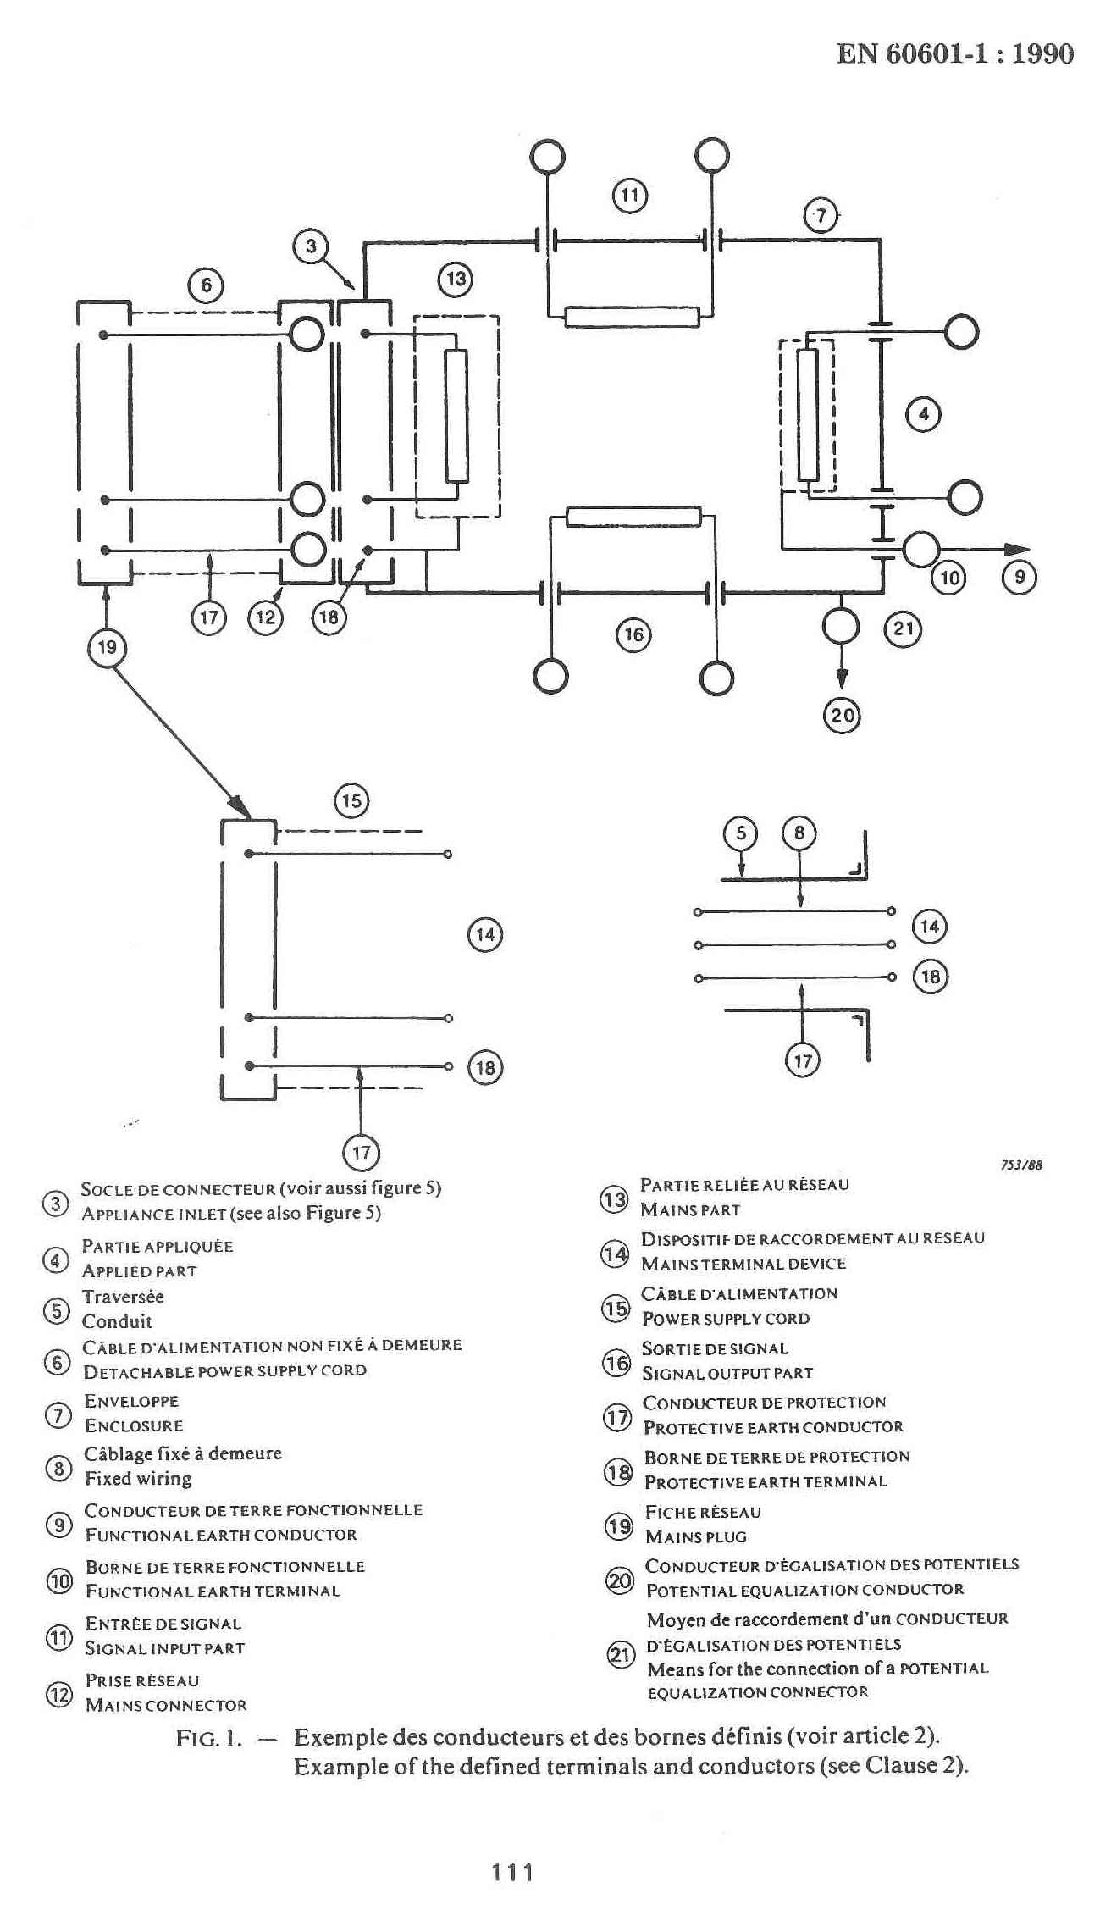
Note: This becomes Figure 2 in BS EN 60601-1:2006 (but without the French)
DEFINITIONS (FRIENDLY VERSION)

MAINS
PART
(MP)
APPLIED
PART
(AP)
PROTECTIVE
EARTH TERMINAL
ENCLOSURE
L

N

E

INSTRUMENT UNDER TEST
(IUT)
DEFINITIONS

ENCLOSURE:

Exterior surface of EQUIPMENT including:

- all ACCESSIBLE METAL PARTS, knobs and the like

- accessible shafts
1990 Clause 2.1.6

Exterior surface of electrical equipment or parts thereof
2006 Clause 3.26

NOTE: for the purpose of testing to this standard, metal foil, with specified dimensions, applied in contact with parts of the exterior surface made of material with low conductivity or made of insulating material is considered a part of the ENCLOSURE.

MAINS PART:

Electrical circuit that is intended to be connected to the SUPPLY MAINS.

NOTE 1: The MAINS PART includes all conductive parts that are not separated from the SUPPLY MAINS by at least one means of PROTECTION.

NOTE 2: For the purpose of this definition, the PROTECTIVE EARTH CONDUCTOR is not regarded as a part of the MAINS PART.

2006 Clause 3.49

APPLIED PART:

Part of the ME EQUIPMENT that in NORMAL USE: necessarily comes into physical contact with the PATIENT for ME EQUIPMENT or ME SYSTEM to perform its function.

+ NOTES 1, 2 and 3

2006 Clause 3.8

PATIENT CONNECTION:

Individual point on the APPLIED PART through which current can flow between the PATIENT and the ME EQUIPMENT in NORMAL CONDITION or SINGLE FAULT CONDITION.

2006 Clause 3.78

PROTECTIVE EARTH TERMINAL:

Terminal connected to conductive parts of CLASS I equipment for safety purposes. This terminal is intended to be connected to an external protective earthing system by a PROTECTIVE EARTH CONDUCTOR.

2006 Clause 3.95

METHOD
OF PROTECTION

AGAINST ELECTRIC SHOCK

- CLASS 1 equipment
Relies on protective earthing
Accessible metal parts cannot become live

- CLASS 2 equipment
Relies on reinforced or double insulation

- Internally powered equipment is a separate Class

MNEUMONIC: CLASS I CLASS II

Protective Double
Earthing Insulation

DEGREE
OF PROTECTION AGAINST
ELECTRIC SHOCK FOR
THE APPLIED PART

3 TYPES – B, BF, CF

Differ in allowable leakage current
Different methods required for the F type


TYPE B APPLIED PART
Any patient applied part may have a low impedance route to earth


TYPE BF APPLIED PART
Has a floating (isolated or “earth-free”) patient applied part able to withstand a dielectric strength test (i.e.not just high impedance to earth)

TYPE CF APPLIED PART
Similar to BF but with lower allowable leakage currents deemed to be safe even with connections directly to the heart

LEAKAGE CURRENT

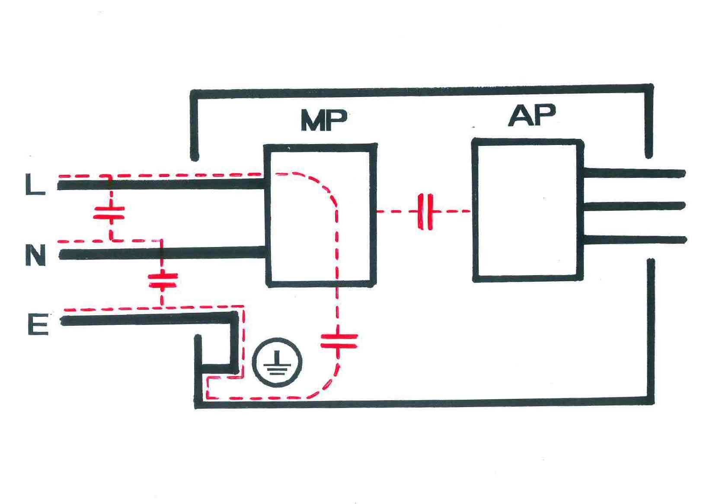

DEMONSTRATIONS:

- 100m mains extension lead
- Transformer:
- IEC mains inlet filters
LEAKAGE CURRENT:

Consider a capacitance between LIVE and the metal case connected to EARTH.

Reactance of a capacitor: $X_{C}=\frac{1}{ω C}=\frac{1}{2πfC}$

$$\begin{aligned}\left|I\right|=\frac{\left|V\right|}{X_{C}}=2πfCV \\ 2π×\text{50}×\text{240}×C \\ 7\text{.}5×{\text{10}}^{4}C\end{aligned}$$

 | C | X_{c} at 50Hz | I
Transformer:  Primary to chassis | 100pf | 32MΩ | 7.4μA
“Medical grade” IEC filter capacitors | 3300pF | 960kΩ | 240μA
100m mains cable: L to E | 11nF | 290kΩ | 0.8mA
IEC filter capacitors | 47nF  (0.047μF) | 67kΩ | 3.4mA
Dangerous “homemade” filter | 1.5μF | 2.1kΩ | 110mA

DEGREE
OF PROTECTION AGAINST
ELECTRIC SHOCK FOR
THE APPLIED PART

3 TYPES – B, BF, CF

Differ in allowable leakage current
Different methods required for the F type

TYPE B APPLIED PART
Any patient applied part may have a low impedance route to earth

TYPE BF APPLIED PART
Has a floating (isolated or “earth-free”) patient applied part able to withstand a dielectric strength test (i.e.not just high impedance to earth)

TYPE CF APPLIED PART
Similar to BF but with lower allowable leakage currents deemed to be safe even with connections directly to the heart

THE FIRST (COMMERCIAL) ELECTROCARDIOGRAPH 1912
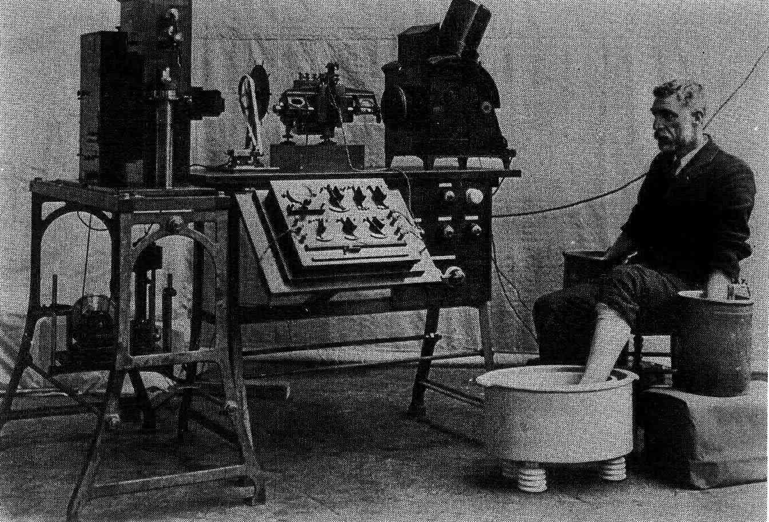

EVOLUTION OF THE ECG AMPLIFIER CIRCUIT
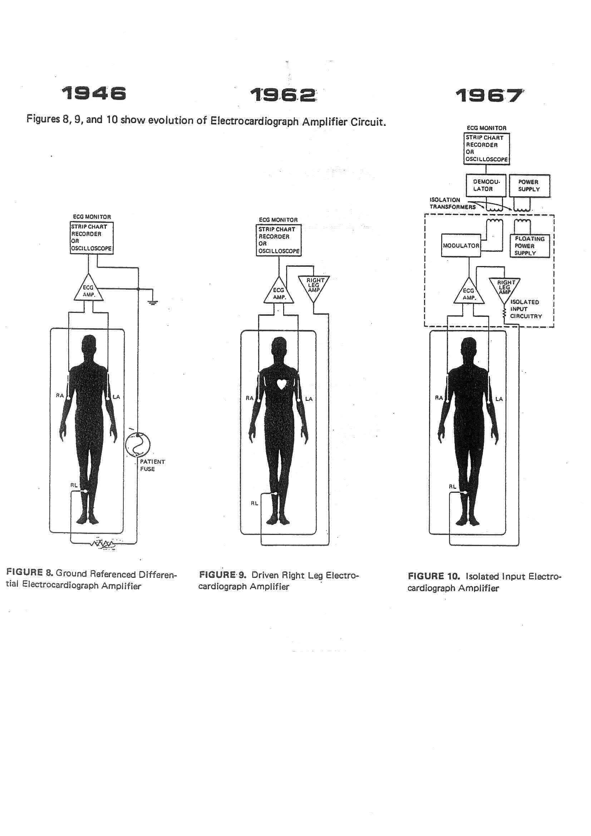

KONE CARDIAC MONITOR 573
ECG AMPLIFIER BLOCK DIAGRAM

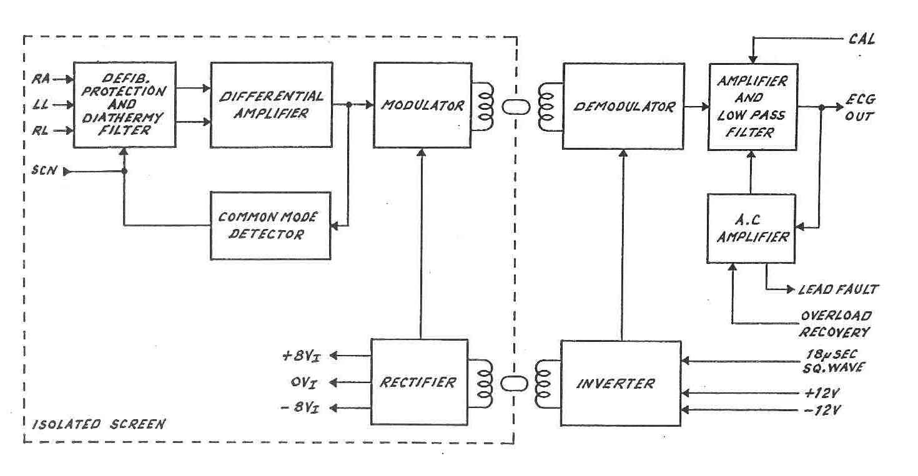

More detail in the UCL MSc in Physics and Engineering in Medicine (PEM) module:
MPHYGB20 Medical Electronics and Control

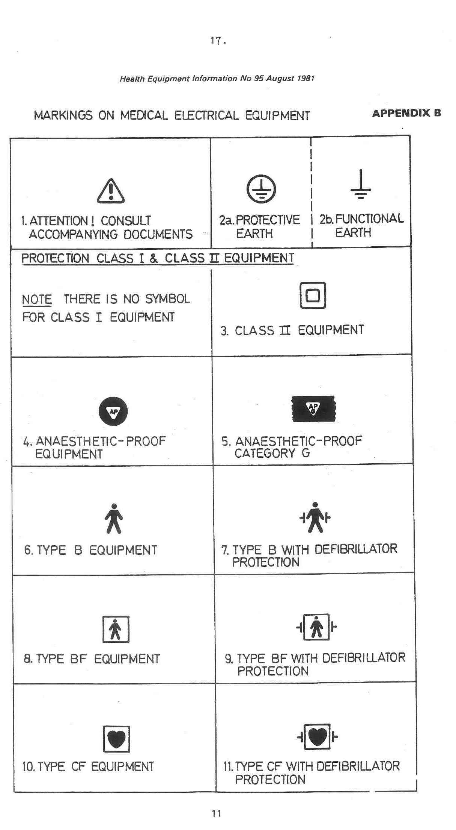
“OHMWORK”

What "Type" classifications WOULD BE APPROPRIATE FOR THE FOLLOWING EQUIPMENT:

- A cardiac monitor recording ECG from surface electrodes attached to a critically ill patient fitted with a central venous pressure catheter.

- A pulse oximeter.

- A pressure measuring system in a cardiac catheterisation laboratory.

- A peristaltic infusion pump.

- An electronic thermometer for measuring skin temperature.

6. An infra-red therapy lamp.
SINGLE FAULT CONDITIONS:

A condition in which a single means for reducing a RISK is defective or a single external abnormal condition is present.

2006 Clause 3.116 (See also 4.7 and 13.2)

The following are defined as SINGLE FAULT CONDITIONS:

- Interruption of a PROTECTIVE EARTH CONDUCTOR

- Interruption of one supply conductor

- Appearance of an external voltage on an F-TYPE APPLIED PART

- Appearance of an external voltage on a SIGNAL INPUT or SIGNAL OUTPUT

NOTE:

Earthing of a PATIENT is considered a NORMAL CONDITION.

Reversal of the MAINS SUPPLY is not considered as a fault, but must be tested for.
LEAKAGE CURRENT DEFINITIONS:

“Current that is not functional.”

2006 Clause 3.47

1. EARTH LEAKAGE CURRENT
Flows from the MAINS PART through or across the insulation into the PROTECTIVE EARTH CONDUTOR.

2006 Clause 3.25

- Equipment powered from mains via tester
MD in line with earth connection

- Only appropriate for Class I equipment

2. TOUCH CURRENT (FORMERLY KNOWN AS “ENCLOSURE LEAKAGE CURRENT”)
Flows from the ENCLOSURE … through an external CONDUCTIVE CONNECTION other than the PROTECTIVE EARTH CONDUCTOR to earth or another part of the ENCLOSURE.

2006 Clause 3.129

- Equipment powered from mains via tester
MD between points on enclosure and tester earth (not the equipment protective earth)

- Class I and II

3. PATIENT LEAKAGE CURRENT

Flows from the PATIENT CONNECTIONS via the PATIENT to earth.
2006 Clause 3.63

4. PATIENT LEAKAGE CURRENT
(MAINS ON APPLIED PART)

Originating from the unintended appearance of a voltage from an external source on the PATIENT and flowing from the PATIENT via the PATIENT CONNECTIONS of an F-TYPE APPLIED PART to earth

2006 Clause 3.63

5. PATIENT AUXILIARY CURRENT
Flows in the PATIENT in NORMAL USE between any PATIENT CONNECTION and all other PATIENT CONNECTIONS and not intended to produce a physiological effect.

2006 Clause 3.77

MEASURING EARTH LEAKAGE CURRENT
(SCARY VERSION)

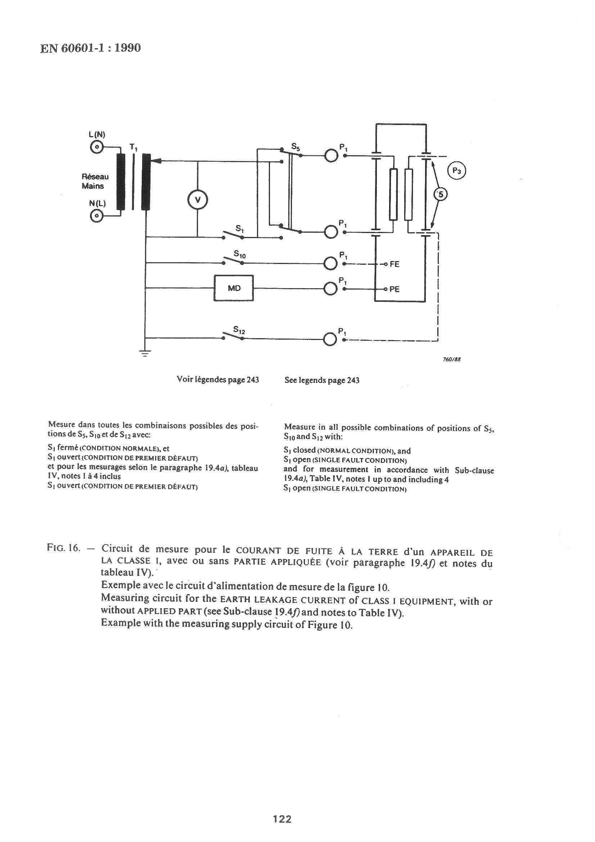

Note: This becomes Figure 13 in BS EN 60601-1:2006

1. EARTH LEAKAGE CURRENT

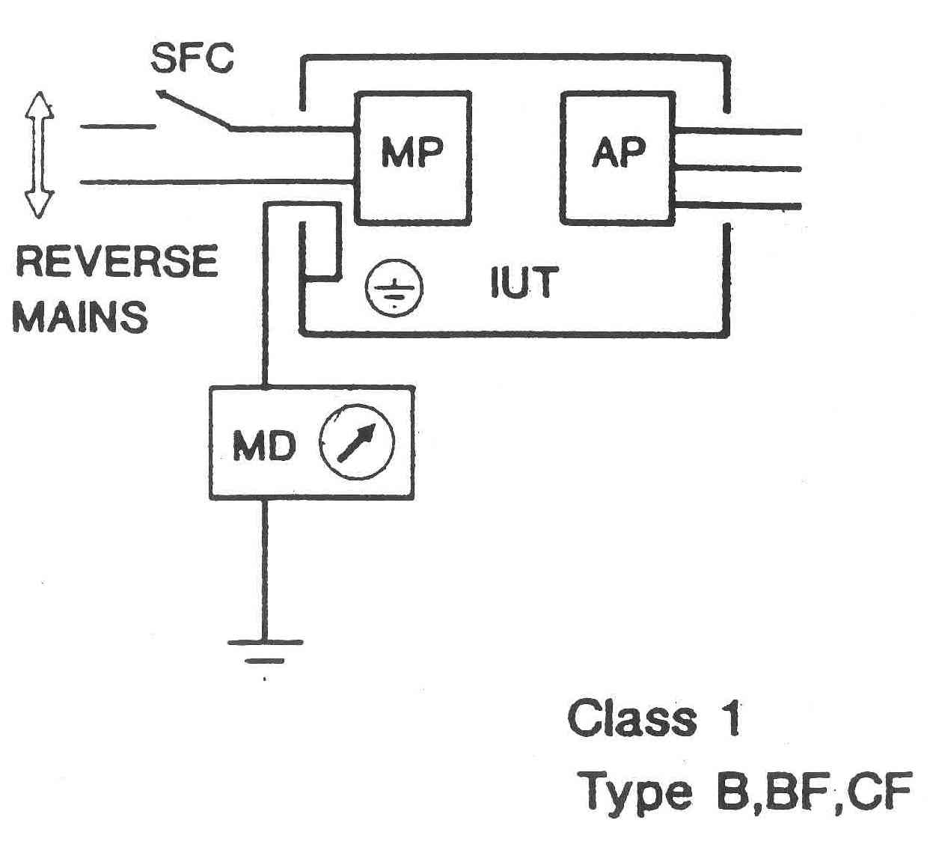

Flows from the MAINS PART through or across the insulation into the PROTECTIVE EARTH CONDUTOR.
2006 Clause 3.25

- Equipment powered from mains via tester
MD in line with earth connection

- Only appropriate for Class I equipment
THE MEASURING DEVICE (MD)

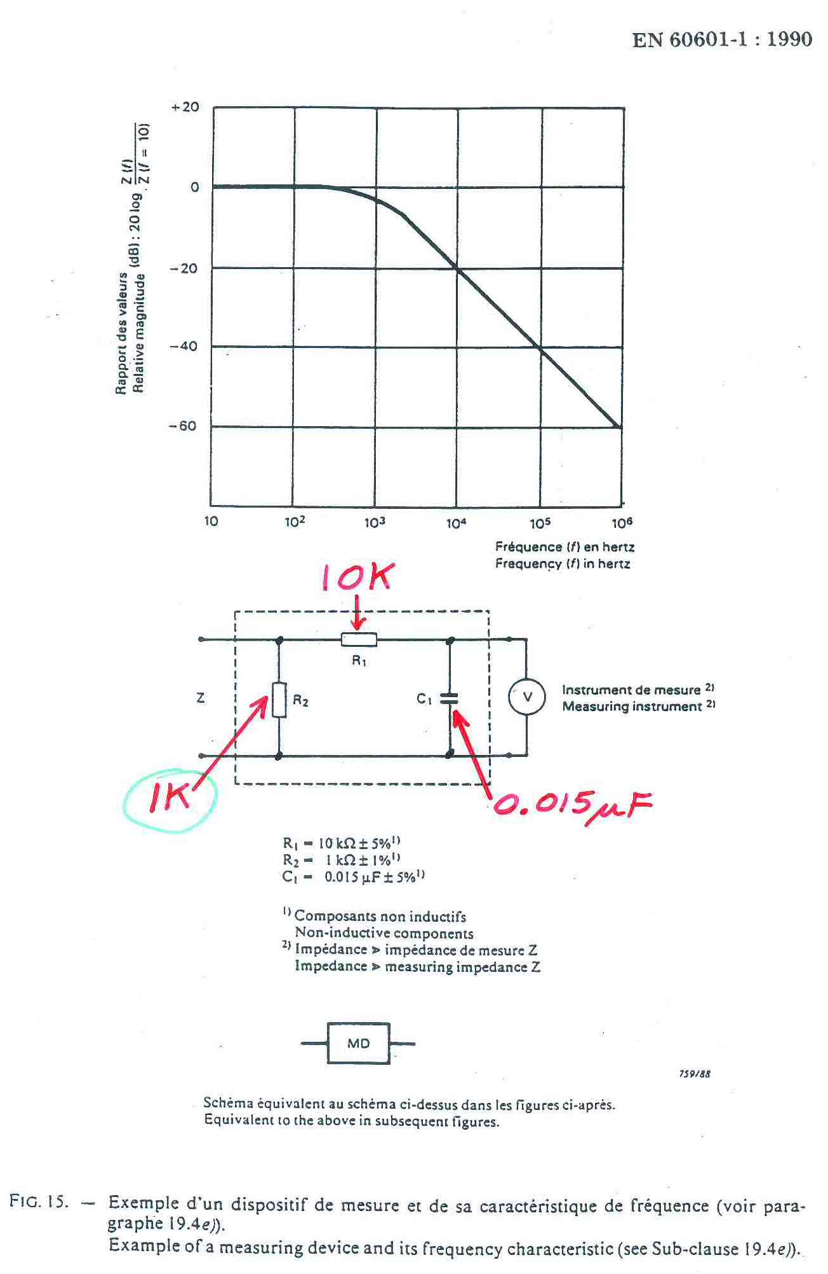

Note: This becomes Figure 12 in 60601-1:2006

2. TOUCH CURRENT (FORMERLY KNOWN AS “ENCLOSURE LEAKAGE CURRENT”)
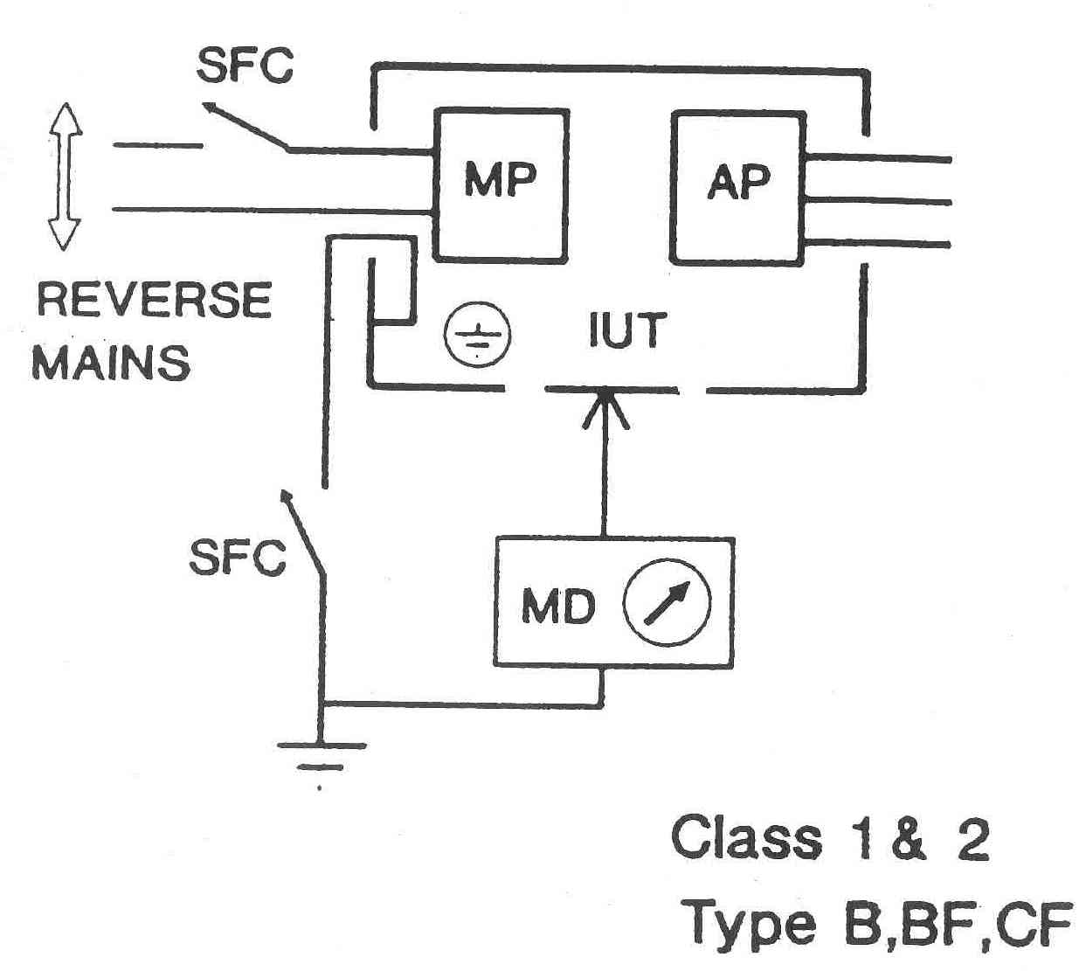

Flows from the ENCLOSURE … through an external CONDUCTIVE CONNECTION other than the PROTECTIVE EARTH CONDUCTOR to earth or another part of the ENCLOSURE.

2006 Clause 3.129

- Equipment powered from mains via tester
MD between points on enclosure and tester earth (not the equipment protective earth)

- Class I and II
3. PATIENT LEAKAGE CURRENT

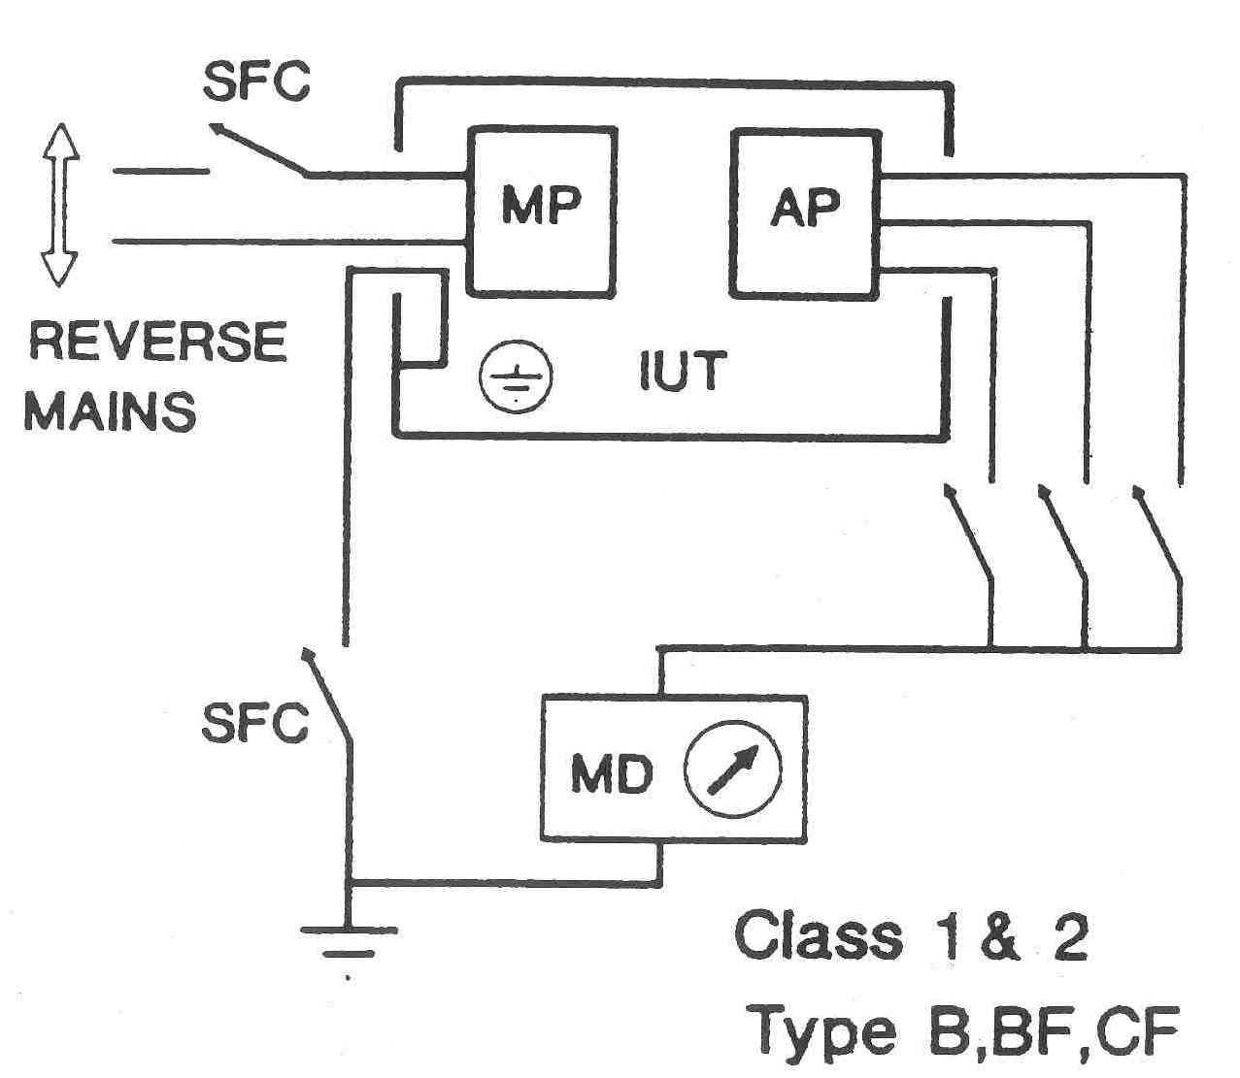

Flows from the PATIENT CONNECTIONS via the PATIENT to earth.
2006 Clause 3.63
4. PATIENT LEAKAGE CURRENT
(MAINS ON APPLIED PART)

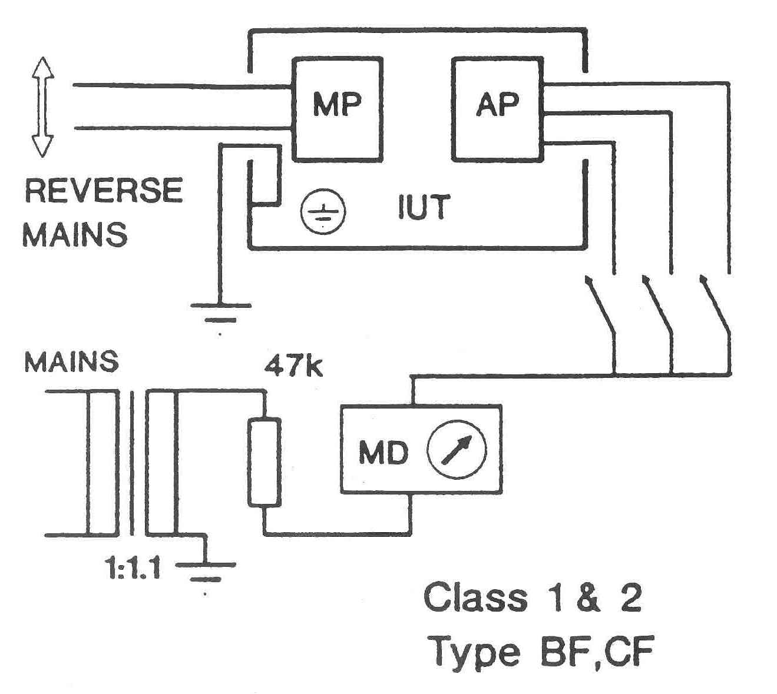

Originating from the unintended appearance of a voltage from an external source on the PATIENT and flowing from the PATIENT via the PATIENT CONNECTIONS of an F-TYPE APPLIED PART to earth

2006 Clause 3.63

5. PATIENT AUXILIARY CURRENT

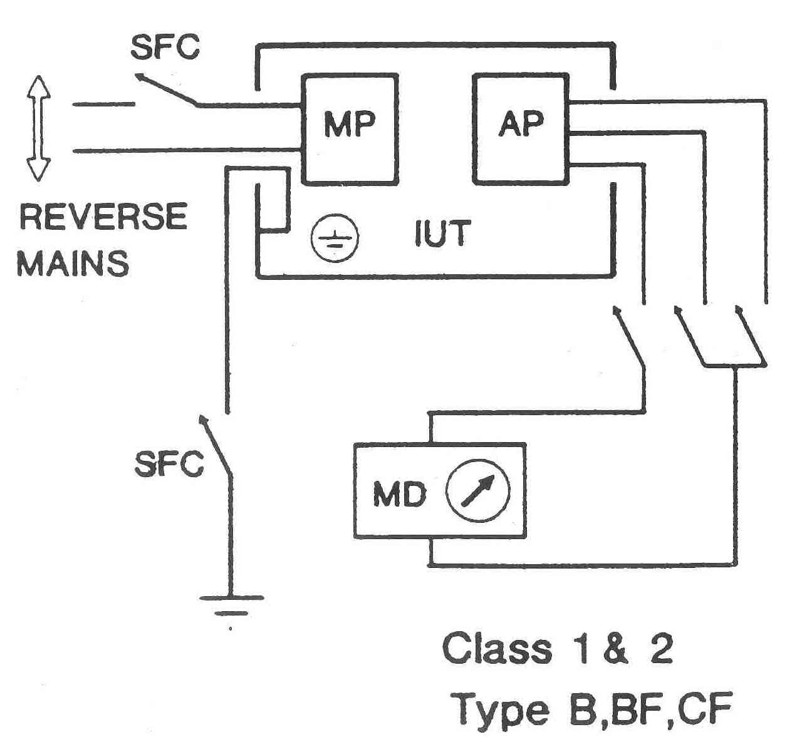
Flows in the PATIENT in NORMAL USE between any PATIENT CONNECTION and all other PATIENT CONNECTIONS and not intended to produce a physiological effect.

2006 Clause 3.77

Example 1: Obtain breathing rate by passing a small current through ECG electrodes and measuring ΔZ.

Example 2: Surgical diathermy plate “fall-off” detector.
MAXIMUM ALLOWABLE
LEAKAGE CURRENTS (mA)
BS EN 60601-1: 2006

 |  | Type B  Applied Part |  | Type BF  Applied Part |  | Type CF  Applied Part
 |  | NC | SFC | NC | SFC | NC | SFC
Earth Leakage Current |  | 0.5  5 | 1  10 | 0.5  5 | 1  10 | 0.5  5 | 1  10
Touch Current |  | 0.1 | 0.5 | 0.1 | 0.5 | 0.1 | 0.5
Patient Leakage Current | DC  AC | 0.01  0.1 | 0.05  0.5 | 0.01  0.1 | 0.05  0.5 | 0.01  0.01 | 0.05  0.05
Patient Leakage Current  (mains on applied part) |  |  |  |  | 5 |  | 0.05
Patient Auxiliary Current | DC  AC | 0.01  0.1 | 0.05  0.5 | 0.01  0.1 | 0.05  0.5 | 0.01  0.01 | 0.05  0.05

NOTES ON TABLE OF MAXIMUM ALLOWABLE
LEAKAGE CURRENTS

- Earth Leakage Current and Touch Current relate to the enclosure – and not dependent on Type of Applied Part.

- Maximum allowable ELC for NC and SFC increased by factor of 10 compared with BS EN 60601-1:1990.

- Patient Leakage Current and Patient Auxiliary Current maximum limits are lower for DC compared with AC because of electrolysis.

- Patient Leakage Current and Patient Auxiliary Current AC maximum limits for Type CF Applied Parts are lower compared with Type B and BF Applied Parts.

- “No entries” for Patient Leakage Current (mains on applied part) because it is not an appropriate test for Type B Applied Parts AND it is not a NC – it is a SFC.
EARTH CONTINUITY

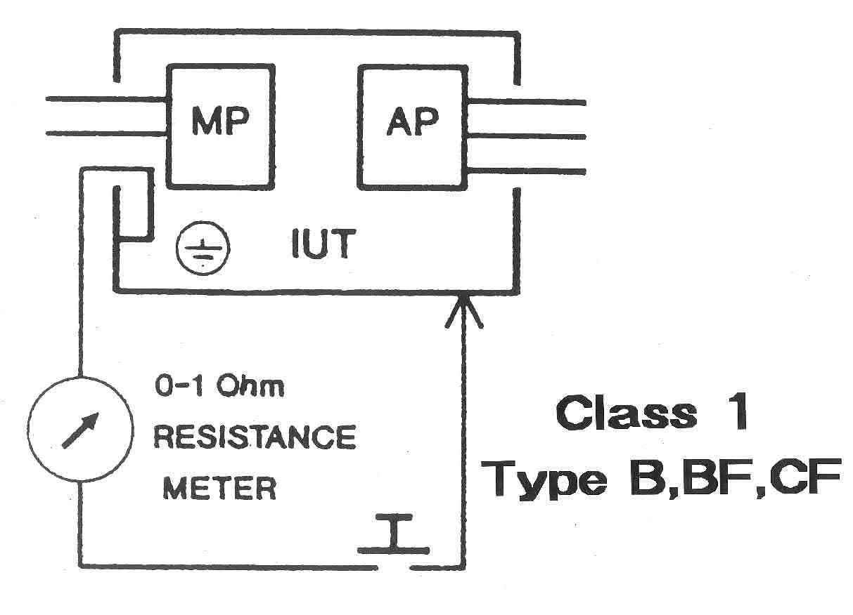

- For equipment with an appliance inlet:

Resistance between:
Conductive parts of the equipment and the protective earth terminal ≤ 0.1 Ohm

- For equipment with a non-detachable power supply cord:

Resistance between:
Conductive parts of the equipment and the earth pin of the mains plug ≤ 0.2 Ohm
EARTH CONTINUITY

BS EN 60601-1:1990 states:
“Compliance is checked by the following test:

A current of 25 A or 1,5 times the rated current of the EQUIPMENT, whichever is greater (±10%), from current source with a frequency of 50 Hz or 60 Hz with a no-load voltage not exceeding 6 V is passed for 5 s to 10 s through the PROTECTIVE EARTH TERMINAL or the protective earth contact in the APPLIANCE INLET or the protective earth pin in the MAINS PLUG and each ACCESSIBLE METAL PART which could become LIVE in case of failure in BASIC INSULATION.

The voltage drop between the parts described is measured and the impedance determined from the current and voltage drop. It shall not exceed the values indicated in this sub-1990 Clause.”

1990 Clause 18f

“Ohmwork”: How does this compare with the 2006 version of the standard?
INSULATION RESISTANCE
MAINS PART

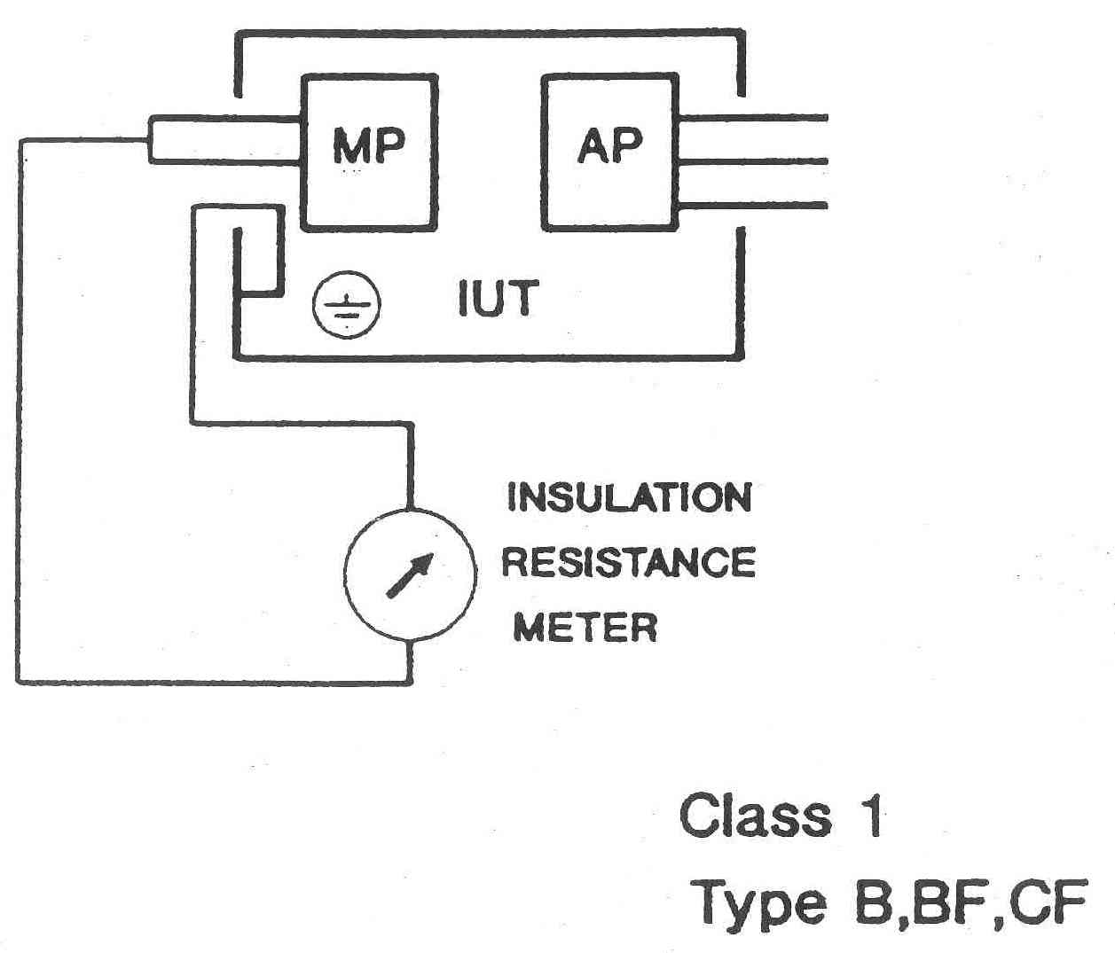
- Use 500V DC insulation tester
(BS EN 60601-1 specifies “Dielectric Strength Test” – potentially destructive
- Measure between earth pin and L & N connected together
- Any equipment switch in ON position
- Not less than 50 Megohms
- If substantially lower, investigate with manufacturer
QUESTION:
WHY DO WE NEED 500V
TO MEASURE RESISTANCES > 50 MΩ?

Ohm’s Law:
$V=I⋅R$ $I=\frac{V}{R}$

R = 50MΩ
V = 9V | V = 500V | V = 1000V
I = 0.18μA | I = 10μA | I = 20μA

ANSWER:
SO THAT AN EASILY MEASURABLE CURRENT FLOWS
INSULATION RESISTANCE
APPLIED PART

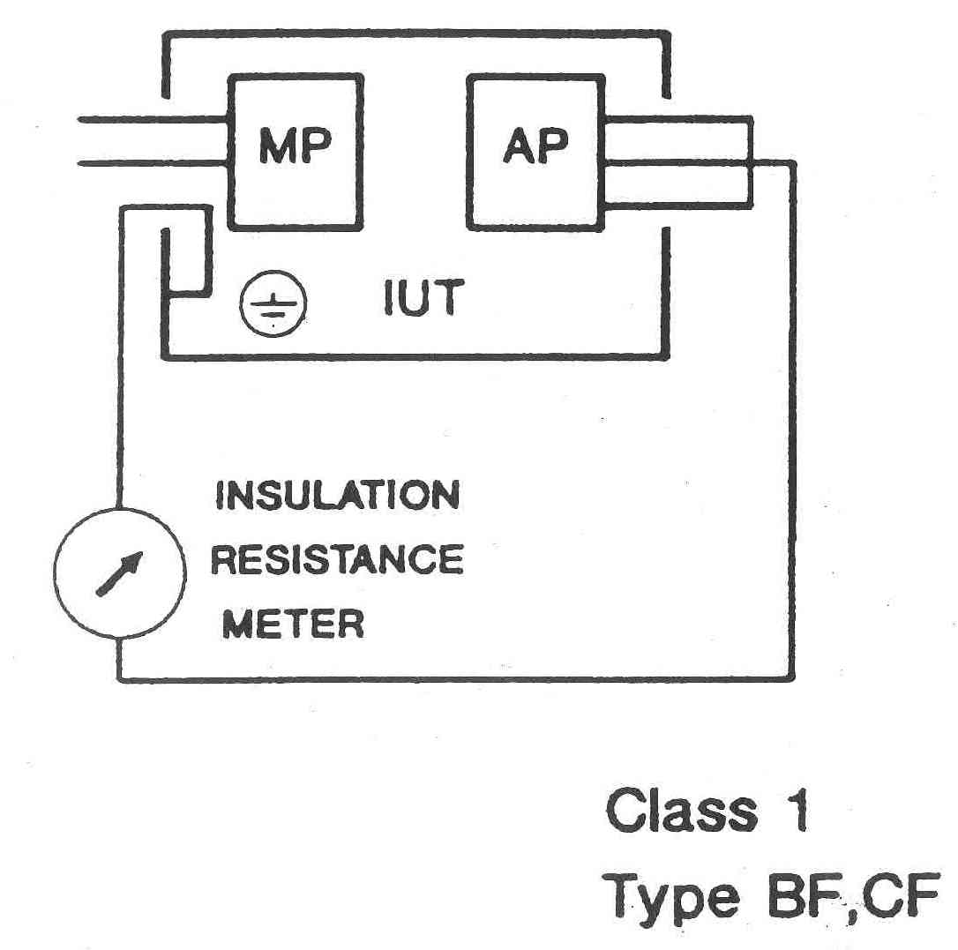

- Use 500V DC insulation tester
- Measure between applied parts and earth connection
- Not less than 50 Megohms

PERSPECTIVE

Each hospital typically spends around £100,000 per year on electrical safety testing.

Number of deaths per year in UK due to:

- ELECTRICITY ? ∼ 200
Many know electricity is a hazard
But don’t understand the nature of the hazard
Most deaths relate to water & restricted movement

- MURDER ? ∼ 200

- ROAD ACCIDENTS ? ∼ 2000

- MEDICAL ELECTRICAL EQUIPMENT ?

THE MICROSHOCK SCARE

- 1960’s equivalent of Y2K, BSE and GM food

- Concern that some catheterized patients were electrocuted by small, imperceptible currents

- Peak: Carl Walter (1970) and Ralph Nader (1971) claimed 1200 Americans electrocuted each year during diagnostic & therapeutic procedures

Comprehensive review of 25 years by 2 Canadian anaesthetists (Bruner and Leonard 1989) found only 4 deaths that could be attributed to these small currents:
→ 3 prior to 1961
→ Most recent in 1970.

John M. R. Bruner and Paul F. Leonard
Electricity, Safety and the Patient
Year Book Medical Publishers, Inc. 1989
ISBN 0-8151-1291-2

Some unnecessary precautions, but many improvements:

- Electrically isolated patient connections
- Manufacturers “groomed” to meet standards
- Education on safety for medical personnel
- Medical equipment testing procedures

INTRINSIC SAFETY

So that the possibility of being injured can’t arise.

- 2mm plug patient lead problem

Between 1985 and 1994 24 children received severe electric shocks from patient leads being plugged into IEC connectors that “looked like” ECG head-boxes.

- Electric lawn mower connectors

- 3-pin IEC connector wired with 2-core mains cable

- Mains plug connected on each end of a cable

E.g. Extension lead made by film crew

The greatest risk
is related to the mains lead.
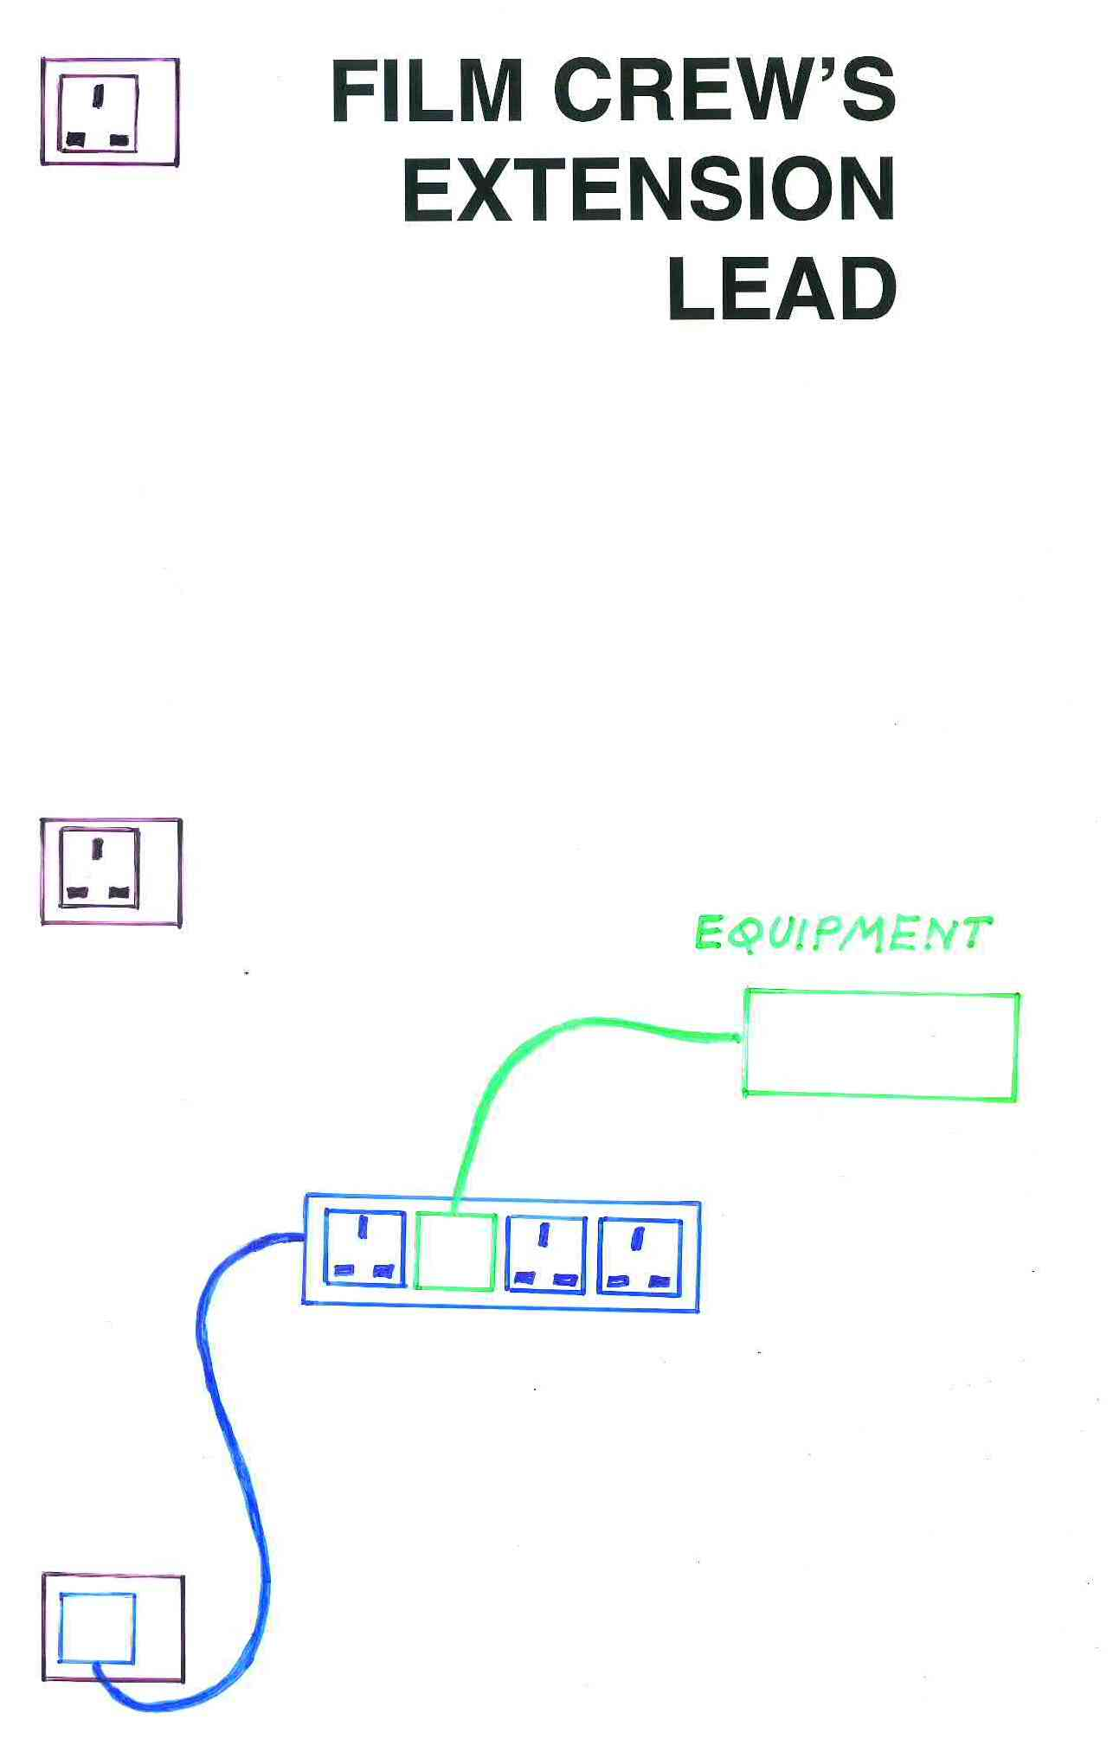
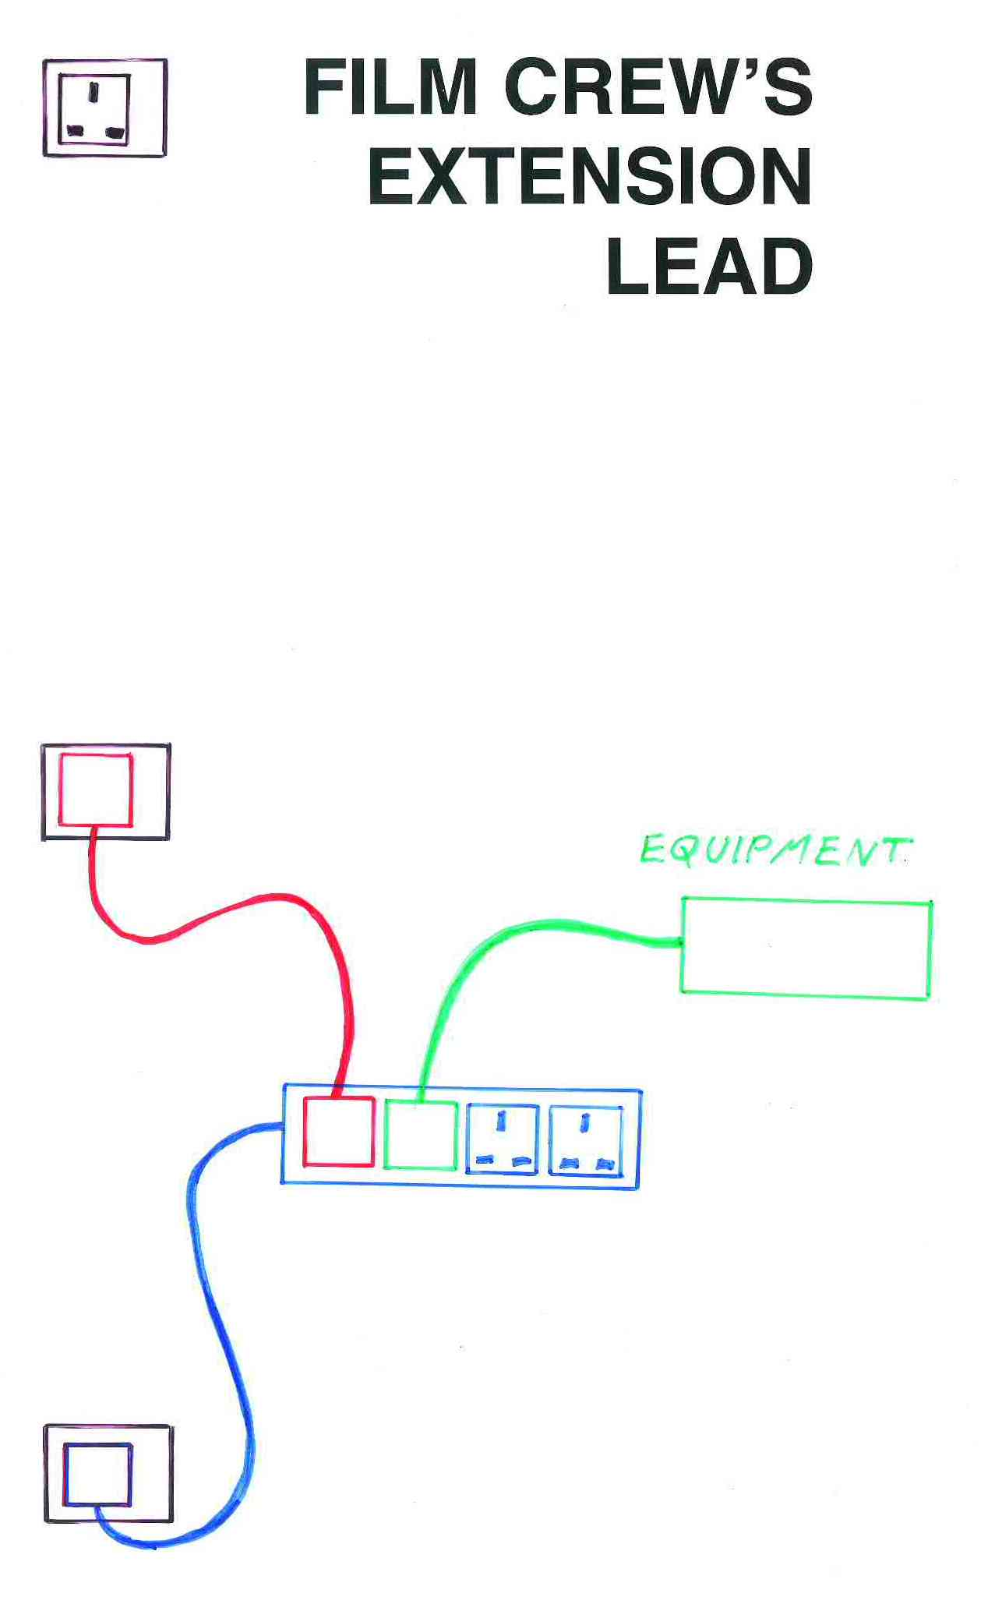
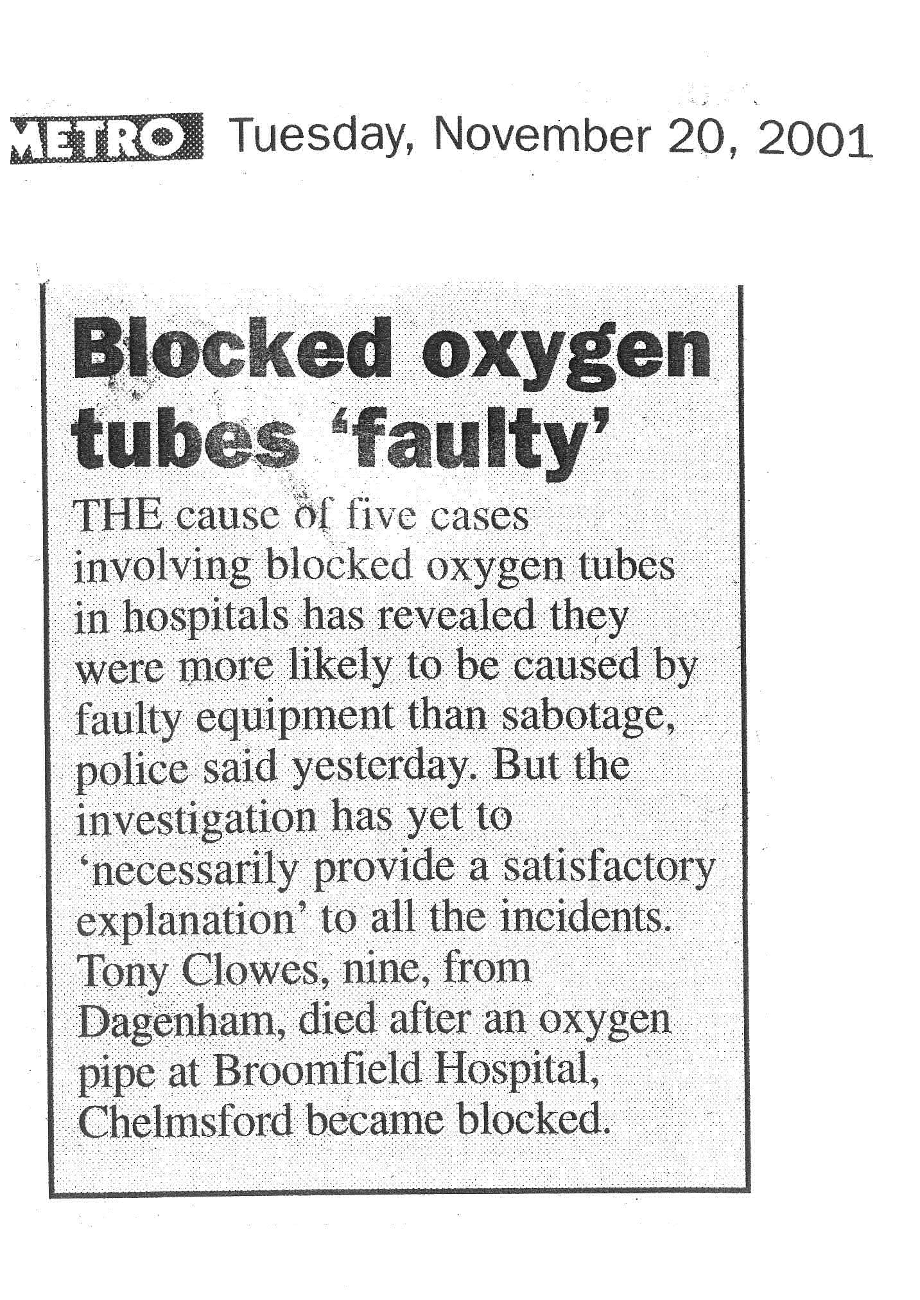

INSPECTION

Majority of equipment faults
- mains lead
- found by visual inspection

Some automatic safety testers perform 40 or more tests
- a complete waste of time ??

No, but:
“A quick inspection and shake is worth as much as or more than 40 automated tests.”

