The Data Acquisition and Calibration System for the ATLAS Semiconductor Tracker
FirstAuthor, SecondAuthor, ThirdAuthor …
The semiconductor tracker (SCT) data acquisition (DAQ) system will calibrate, configure, and control the approximately six million front-end channels of the ATLAS silicon strip detector. It will provide timing and synchronization between detector elements, communicate first-level triggers to the front-end chips, and transfer information about hit strips to the ATLAS high-level trigger system. The system has been used extensively for calibration and quality assurance during SCT barrel and endcap macro-assembly and for performance confirmation tests after transport of the barrels and endcaps to CERN. It has also been operated in data-taking mode, recording more than 450 thousand events during synchronous cosmic-ray operation at CERN. In this paper we describe the components of the data acquisition system, discuss its operation in calibration and data-taking modes and present some detector performance results from tests during SCT macro-assembly as well as in cosmic-ray commissioning test at CERN.

Introduction
The Semiconductor Tracker (SCT) forms the intermediate tracking layers of the ATLAS Inner Detector. It will measure four three-dimensional space-points for charged particle tracks with pseudo-rapidity |η| < 2.5. Individual silicon modules are constructed to provide space point resolutions of σ_{Rφ} = 16 μm and σ_{Rφ} (σ_{R}) = 580 μm.
The complete SCT consists of 4088 front-end modules [,], each of which has two planes of silicon. The planes are offset by a small stereo angle (40 mrad) to allow the third coordinate of the track location to be determined. Each of the two planes has 768 active strips of p⁺ implant on n-type bulk []. The implant strips are capacitively coupled to aluminium metalisation, and are read out by application-specific integrated circuits (ASICs) known as ABCD3TA []. Each of these chips is responsible for reading out 128 channels, so twelve are required for each SCT module. The complete SCT therefore consists of total of 49,056 ASICs and more than six million individual read-out channels.
Figure 1. Cross section of the ATLAS Inner Detector showing a quarter of the barrel and half of one of the two endcap regions.
The SCT is geometrically divided into a central barrel region and two endcaps (known as ‘A’ and ‘C’). The barrel region consists of four concentric cylindrical layers (barrels). Each endcap consists of nine discs. The role of the data acquisition (DAQ) system is to configure the front-end ASICs, to calibrate each individual channel, to identify and diagnose problems, to communicate first-level triggers, and to transfer data from the front-end chips to the ATLAS high-level trigger system. The number of modules on each barrel and endcap disk is given in Table 1 Table 2.
Barrel | B3 | B4 | B5 | B6 | Total
Radius / mm | 299 | 371 | 443 | 514
Modules | 384 | 480 | 576 | 672 | 2112
Table 1: Radius and number of modules on each of the four SCT barrel layers.
Disc | 1 | 2 | 3 | 4 | 5 | 6 | 7 | 8 | 9 | Total
|z| / mm | 847 | 934 | 1084 | 1262 | 1377 | 1747 | 2072 | 2462 | 2727
Modules | 92 | 132 | 132 | 132 | 132 | 132 | 92 | 92 | 52 | 988
Table 2: Longitudinal position and number of modules for each of the nine discs on each SCT endcap.
This paper is organized as follows. In section 2 there is a description of the readout hardware. The readout software and control system is discussed in section 3. In section 4 there is an overview of the calibration procedure. A demonstration of the use of the DAQ system in detector macro-assembly and cosmic-ray commissioning is given in section 5. A list of abbreviations is given in the appendix.

Off-detector hardware overview
The off-detector readout hardware for the SCT data acquisition (DAQ) connects the SCT front-end modules to the ATLAS central trigger and data acquisition system []. It consists of several different modules, housed in a standard LHC-specification 9U VME64x crate []. The Read Out Driver (ROD) module [Error: Reference source not found] performs the main control and data handling. A complementary Back Of Crate (BOC) module handles the I/O requirements to and from the front end modules. Each ROD/BOC pair deals with the control and data for 48 front-end modules. There can be up to 16 RODs and BOCs in a single crate, occupying slots 5-12, 14-21. The TTC Interface Module (TIM) accepts the TTC (Timing, Trigger and Control) signals from ATLAS and distributes them to the RODs and BOCs. There is one TIM per crate, in slot 13 of the crate. The ROD Crate Controller (RCC) is a commercial 6U Single Board Computer [] running Linux which acts as the VME Master, and hence it usually occupies slot 1 of the crate. The RCC configures the other components and provides overall control of the data acquisition functions within a crate. The main DAQ crate connections are shown diagrammatically in Figure 1.
Figure 2. Block diagram of the SCT data acquisition hardware showing the main connections between components.
In physics data-taking mode, triggers pass from the ATLAS TTC through the TIM and are distributed to the RODs. Each ROD fans out the triggers via its BOC to the front end modules. The resultant hit data from the front-end modules pass back from the through the BOC and are passed on through the S-Link to the ATLAS central DAQ. The RODs can be set up to sample and histogram events and errors from the data stream for monitoring purposes.
The SCT DAQ can also operate separately from the central ATLAS DAQ. In this mode the ATLAS TTC and ROS are not used. The TIM generates the required clock, fast commands and serialised event and trigger identifiers internally, and the S-Link data are discarded. This mode is typically used for calibration scans, where the ROD monitoring functions generate occupancy histograms which are then transferred over VME to the ROD Crate Controller and then over the LAN to CPU servers for further analysis.

The Read-out Driver (ROD)
The Silicon Read-out Driver (ROD) [] is a 9U 400mm deep VME64x electronics board. The primary functions of the Silicon ROD are Front End (FE) module configuration, trigger propagation and event data formatting. The secondary functions of the ROD are detector calibration and monitoring. Control commands are sent from the ROD to the FE modules as serial data streams. These commands can be Level-1 triggers, bunch-crossing (clock) resets, event counter (trigger) resets, calibration commands or module register data. Each ROD board is capable of controlling the configuration and processing the data read-out of up to 48 SCT FE modules. After formatting the data collected from the modules, the ROD builds event fragments that are transmitted to the ATLAS read-out subsystem (ROS) [] via a serial optical link (S-Link) [].
A hybrid architecture of Field Programmable Gate Arrays (FPGAs) and Digital Signal Processors (DSPs) allows the ROD maximum versatility during physics data-taking and calibrations. Four FPGA designs are used to perform all of the real-time operations required for data processing at the ATLAS trigger rate. The Formatter, Event Fragment Builder and Router FPGAs are dedicated to performing time-critical operations such as the formatting, building and routing of events. The Controller FPGA controls operations such as ROD setup, module configuration and trigger distribution. A single “Master” and four “Slave” DSPs on the board are used to control and coordinate on-ROD operations, as well as for performing high-level tasks such as data monitoring and module calibration. Once configured, the ROD FPGAs handle the event data-path to ATLAS Level-2 without further assistance from the DSPs (Figure 3).
Figure 3. An overview of the ATLAS Silicon Read-out Driver (ROD).

Operating Modes
The ROD supports two main modes of operation: physics data-taking and detector calibrations. The data-path through the Formatter and the Event Fragment Builder FPGAs is the same in both modes of operation. In data-taking mode the Router FPGA then transmits Event Fragments to the ROS via the S-Link and optionally also to the SDSPs for monitoring. In calibration mode the S-Link is disabled and the Router FPGA sends events to the farm of Slave DSPs (SDSPs) for histogramming.

Physics Data-taking
Once the data-path on the ROD has been setup, event data processing is performed by the FPGAs without any intervention from the DSPs. During physics data-taking triggers issued from ATLAS are relayed to the ROD via the Timing Interface Module (TIM) electronics board. If the S-Link is receiving data from the ROD faster than it can be transferred to the ROS, back-pressure will be applied to the ROD, thereby halting the transmission of events and causing the internal ROD FIFOs to begin to fill. Once back-pressure has been relieved, the flow of events through the S-Link resumes. If the internal FIFOs fill to a critical limit, a ROD busy signal is sent to the TIM thereby halting the issuance of triggers.
During physics data-taking the Router FPGA can be set up to capture events with a user-defined pre-scale on a non-interfering basis and transmit them to the farm of SDSPs. Histogramming these captured events and comparing them against a set of reference histograms can serve as an indicator of channels with unusually high or low occupancies and the captured data can be monitored for errors.

Calibration
When running calibrations the Master DSP (MDSP) serial ports can be used to issue triggers to the modules. In calibration mode the transmission of data through the S-Link is inhibited. Instead, frames of data (256 32-bit word chunks) are passed from the Router FPGA to the SDSPs using a direct memory access transfer. Tasks running on the SDSPs flag these transferred events for processing and subsequent histogramming. A monitoring task can be run on the SDSPs that is capable of parsing the event errors flagged by the FPGAs and reporting these errors back to the RCC. More details on the use of the ROD histogramming tasks for calibration can be found in Section 4.

ROD Communication
The ROD contains many components, and is required to perform many different operations in real time. For smooth operation it is important that the different components have well-defined communication protocol. A system of communication registers, primitives, tasks and text-buffers is used for RCC-to-ROD and Master-to-Slave inter DSP communication and control.
A series of communication registers, blocks of 32-bit words at the start of the DSP’s internal memory, are regularly checked by the Master DSP (MDSP) inside of the main thread of execution running on the processor. The MDSP polls these registers, watching for requests from the RCC. These registers are also polled by the RCC and so can be used by it to monitor the status of the DSPs. Such registers are used, for example, to keep a tally of the number of tasks currently running, note if the event trapping is engaged and to report calibration test statistics.
The ROD FPGA registers are mapped in the MDSP memory space. A system using software entities known as primitives allows the MDSP to remain in control of its memory while receiving commands from the RCC. Each primitive is an encoding in a block of memory which indicates a particular command to the receiving DSP. It is through the use of primitives that reading and writing to ROD registers is possible, and through primitives that the ROD is configured and initialized. Generally each primitive is executed once by the receiving DSP. Primitives exist for reading and writing FPGA registers, reading and writing regions of MDSP memory, loading or modifying front end module configurations, and starting the SDSPs. The MDSP can send lists of primitives to the SDSPs, for example to start calibration histogramming. The DSP software is versatile enough to easily handle new primitives representing extra commands when required.
ROD functions which execute over an extended period of time are called tasks. These are started and stopped by the RCC (or MDSP) sending primitives and continue to execute independently of the primitive list thread. They run until complete or until they are halted by other primitives. Examples of tasks are the event trapping and histogramming tasks. The former runs on the SDSPs to handle event trapping while the latter manages the sending of triggers as well as the processing and binning of event data.

Back of Crate card (BOC)
The BOC transmits commands and data between the ROD and the optical fibre connections which service the front end modules, and is responsible for sending formatted data to the ROS. It also distributes the 40 MHz bunch-crossing clock to the FE modules and to its paired ROD. A block diagram of the function of the BOC is shown in Figure 4.
Figure 4. Block diagram showing the layout and main communication paths on the BOC card.
The 40 MHz clock is usually distributed from the TIM via the backplane to the BOC. However, in the absence of this backplane clock, a phase-locked loop on the BOC will detect this state and generate a replacement local clock. This is important not only because the ROD relies on this clock to operate, but also as the FE modules dissipate much less heat when the clock is not present and changes could cause thermal shock on the detector.
The front end modules are controlled and read out through digital optical fibre ribbons. One fibre per module provides trigger, timing and control information. There are also two data fibres per module which are used to transfer the digital signal from the modules back to the off-detector electronics. A more detailed description of the optical system is given in [].
On the BOC each command for the FE modules is routed via a TX plug-in as shown in Figure 4. The command is combined with the 40 MHz clock to generate a single Bi-Phase Mark (BPM) encoded signal which allows both clock and commands to occupy the same stream. Twelve streams are handled by each BPM12 chip []. The encoded commands are then converted from electrical to optical on a 12-way VCSEL array [Error: Reference source not found] before being transmitted to the FE modules via a 12-way fiber array. The intensity of the laser light can be tuned in individual channels by controlling the current supplied to the laser, using a DAC on the BOC. This is both to cater for variations in the individual lasers, fibers and receivers and also to allow for loss of sensitivity in the receiver due to radiation damage.
The timing of the outgoing signals from the TX plug-in can be adjusted so that the clock transmitted to the FE Modules has the correct phase relative to the passage of the particles from the collisions in LHC. This phase has to be set on a module by module basis to allow different optical fiber lengths and time-of-flight variations through the detector. It is also necessary to ensure that the Level 1 trigger is received in the correct 25 ns time bin, so that the data from the different ATLAS detectors are merged into the correct events. For this reason, there are two timing adjustments available – a coarse one in 25 ns steps, a fine one in 280 ps steps.
Incoming data from the FE modules are accepting by the BOC in optical form, converted into electrical form and forwarded to the ROD. As each FE module has two data streams there are up to 96 incoming streams on a BOC. The incoming data is initially converted from optical to electrical signals at a 12-way PIN diode array on the RX plug-in. These signals are then discriminated by a DRX12 chip [Error: Reference source not found]. The data for each stream is sampled at 40 MHz, with the sampling phase adjusted so that a reliable ‘1’ or ‘0’ is selected. The binary stream is synchronized with the clock supplied to the ROD to ensure that it receives the data at the correct phase to ensure reliable decoding.
After the data are checked and formatted in the ROD, they are returned to the BOC for transmitting to the first element of the ATLAS higher-level trigger system (the ROS) via the S-Link connection. There is a single S-Link connection on each BOC.

Hardware Implementation
The BOC is a 9U, 220mm deep board and is located in the rear of the DAQ crate in the “transition card” region. It is not directly addressable via VME as it only connects to the J2 and J3 connectors on the backplane and so all configuration is done over a set-up bus via the associated ROD.
A CPLD is used for overall control of the BOC. Further CPLDs handle the incoming data – these have been used rather than non-programmable devices as the BOC was designed to also be usable by the Pixel Detector, which has special requirements. As can be seen from the previous section, there is a significant amount of clock timing manipulation on the BOC. Many of these functions are implemented using the PHOS4 chip [], a quad delay ASIC which provides a delay of up to 25 ns in 1 ns units. The functions of the BOC (delays, receiver thresholds, laser currents etc.) are made available via a set of registers. These register are mapped to a region of ROD address space via the set up bus, so that they are available via VME to the DAQ. The S-Link interface is implemented by a HOLA [] daughter card.

TTC Interface Module (TIM)
The TIM interfaces the ATLAS Level 1 Trigger system signals to the RODs In normal operation it receives clock and trigger signals from the ATLAS TTC system [] and distributes these signals to a maximum of 16 RODs and their associated BOCs within a crate. Figure 5 illustrates the principal functions of the TIM – transmitting fast commands and event identifier from the ATLAS TTC system to the RODs, and sending the clock to the BOCs (from where it is passed on to the RODs).
Figure 5. Block diagram showing a functional model of the TIM hardware.

The TIM has various programmable timing adjustments and control functions. It has a VME slave interface to give the local processor read and write access to its registers allowing it to be configured by the RCC. Several registers are regularly inspected by the RCC for trigger counting and monitoring purposes.
The optical TTC signals are received on the TIM using an ATLAS standard TTCrx receiver chip [], which decodes the TTC information into electrical form. In the physics mode the priority is given to passing the bunch-crossing clock and commands to the RODs in their correct timing relationship, with the absolute minimum of delay to reduce the latency. The TTC information (listed in Table 3) is passed onto the backplane of a ROD crate with the appropriate timing. The event identifier is transmitted with a serial protocol and so a FIFO buffer is used in case of rapid triggers.
Clock: | BC | Bunch-crossing clock
Fast command: | L1A | Level-1 trigger identifier
 | ECR | Event counter reset count
 | BCR | Bunch crossing reset count
 | CAL | Calibration signal
 | L1ID | 24-bit Level-1 trigger number
 | BCID | 12-bit bunch-crossing identifier
 | TTID | 8-bit trigger type (+ 2 spare bits )
Table 3. TTC information required by the BOC and the SCT front end electronics.
For tests and calibrations, the TIM can, at the request of the local processor (RCC), generate all the required TTC information itself. It can also be connected to another TIM for stand-alone SCT multi-crate operation. In this stand-alone mode, both the clock and the commands can be generated from a variety of sources. The clock can be either generated on-board using an 80.16 MHz crystal oscillator, or transferred from external sources in either NIM or differential ECL standards. Similarly, the fast commands can be generated on the command of the RCC, or automatically by the TIM under RCC control. Fast commands can also be input from external sources in either NIM or differential ECL. These internally or externally generated commands are synchronised to whichever clock is being used at the time, to provide the correctly timed outputs. All the backplane signals are also mirrored as differential ECL outputs on the front panel to allow TIM interconnection.
A sequencer, using 8×32k RAM, allows long sequences of commands and identifiers to be written in by the local processor and used for testing the FE and off-detector electronics. A ‘sink’ (receiver RAM) of the same size is also provided to allow later comparisons of commands and data sent to the RODs.
The TIM controls the crate’s busy logic, which tells the ATLAS CTP when it must suspend sending triggers. Each ROD returns an individual busy signal to the TIM, which then produces a masked OR of the ROD busy signals in each crate. The overall crate busy is output to a separate busy module. ROD busy signals can be monitored using TIM registers.

TIM Hardware Implementation
The TIM is a 9U, 400 mm deep board. The interface to the ATLAS trigger, timing and control system is based on the TTCrx receiver chip, together with the associated PIN diode and preamplifier developed by the RD12 collaboration at CERN [Error: Reference source not found]. This provides the bunch-crossing clock and the signals listed in Table 3. On the TIM modules, the TTCrq mezzanine board [] is used to allow an easy replacement if required.
Communication with the BOCs is via a custom J3 backplane. The bunch-crossing clock destined for the BOCs and RODs, with the timing adjusted on the TTCrx, is passed via differential PECL drivers directly onto the point-to-point parallel impedance-matched backplane tracks. These are designed to be of identical length for all the slots in each crate to provide a synchronised timing marker. All the fast commands are also clocked directly, without any local delay, onto the backplane to minimise the TIM latency budget.
On the TIM module, a combination of FastTTL, LVTTL, ECL, PECL and LV BiCMOS devices is used. The Xilinx Spartan IIE FPGA series were chosen as the programmable logic devices. The TIM uses two of these FPGAs per board. These devices contain enough RAM resources to allow the RAMs and FIFOs to be incorporated into the FPGA.
The TIM switches between different clock sources without glitches, and in the case of a clock failure, does so automatically. To achieve this, dedicated clock-multiplexer devices have been used. These devices switch automatically to a back-up clock if the selected clock is absent. Using clock detection circuits, errors can be flagged and transmitted to all the RODs in the crate via a dedicated backplane line, allowing RODs to tag events accordingly.

Readout Software
The ATLAS SCT DAQ hardware comprises 8 crates containing 8 TIMs, 8 Linux RCCs, 90 ROD/BOC pairs and 9 rack-mounted Linux PCs. The calibration and control software [-] both controls the operation of this hardware and provides the operator with uniform interface for observing the status of the front end modules, and for initiating and viewing the results of calibrations.
In calibration mode the software can optimise the optical communication registers on the BOC as well as testing and calibrating the front end ASICs. It is important that this calibration can be performed, as far as is possible, in a parallel manner, so that the entire detector can be characterized within a reasonable time. Because an iterative, step-wise calibration is used, the results of each step of the calibration need to be recorded and analysed, and any resultant optimization performed, before the subsequent step is started. Both the data-taking and the data-analysis of each step must therefore be performed as quickly as possible. To control the different hardware elements, and to achieve good time performance for analysis, many parallel processes are run in a very distributed environment.
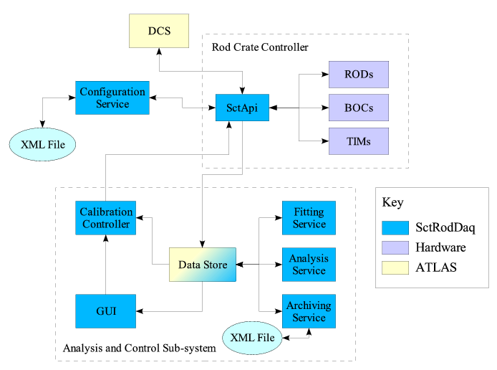
Figure 6. Simplified information flow diagram of the SCT calibration and control software. Each box represents a different process, or set of processes. Arrows indicate command or data transfer. This diagram represents the system as used with a single crate during macro-assembly. During multi-crate operation many of the component processes are operated in parallel on more than one RCC or PC, and extra processes are introduced to allow synchronised operation across DAQ crates. From [Error: Reference source not found].
A diagram of the main software components is shown in Figure 6. The readout software comprises approximately 250 thousand lines of code, written largely in c++ and java. The hardware-communication parts of the software (SctApi) run on the RCCs and control the RODs, BOCs and TIMs over VME. They are responsible for loading configuration data, setting up the on-and off-detector hardware, performing the actions required during run state transitions, and retrieving monitoring histograms from the RODs. During calibration, they initiate calibration scans and retrieve calibration histograms from the RODs.
The analysis subsystem and user interface run on rack-mounted Linux PCs. The calibration controller is responsible for synchronizing control during calibration operation. The fitting and analysis services perform the data-reduction and calculate optimal values for calibration parameters. The archiving services write and read data information from transient objects to persistent storage on disk. Inter-process communication is based a number of ATLAS online software tools [] which provide a partition-based naming service for CORBA-compliant interfaces.
Since many operations need to be done in near real-time, most of the processes have various concurrent threads of execution. For example the service which fits the raw data histograms implements a worker/listener pattern. As new data arrives it is added to a queue by a listener thread which is then immediately free to respond to further data. Meanwhile one or more worker threads undertake the processor-intensive job of performing the fits. The fit algorithms have also been optimized for high performance since for most tests several fits are required for every read-out channel (see Section 4).
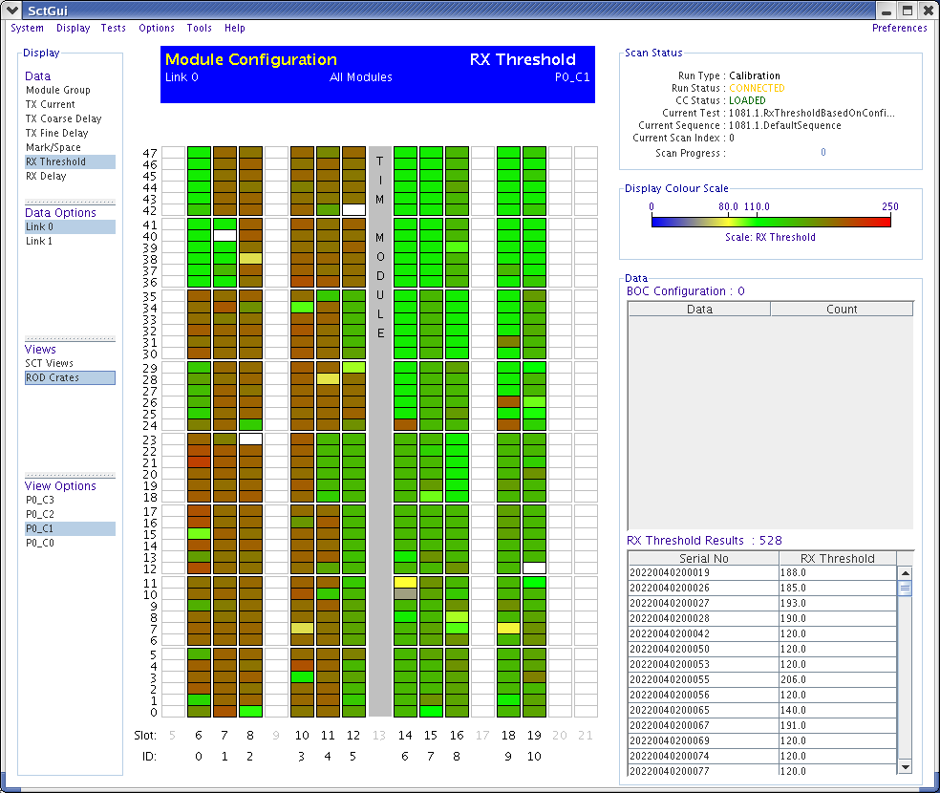
Figure 7. A view of the SCT graphical user interface. This display is showing the BOC receiver thresholds for the RX data links on all BOCs on a particular DAQ crate. The colour scale indicates the current value of the threshold. The display is set in a crate view where vertical lines of modules represent complete RODs, each of which services up to 48 modules.
The front-end and DAQ system configuration information can be stored either in an xml file or in a relational database. It is populated with data from previous calibrations, including quality assurance tests taken during FE module assembly, and confirmation tests performed during macro-assembly and detector commissioning. A java-based graphical user interface (Figure 7) allows the operator to launch calibration tests, to display the results of tests, to display calibration information and to compare results to reference data.

Detector setup and calibration
During commissioning and calibration periods, the DAQ system will used to optimise both the operation of the detector. A set of procedures has been designed which allow timing, communication and front-end parameters to be set at the appropriate values for physics running.
The front-end calibration is crucial for the correct operation of the detector because a large amount of pre-processing and data reduction occurs on the SCT’s front-end ASICs. The output from the ASICs is a determination of whether or not the charge on each channel was larger than a pre-determined threshold. In this “binary” readout system it is especially important that the front-end thresholds are well calibrated before data taking, since all pulse-size information is discarded, and only a single bit of information is retained for each channel. The discriminator threshold must therefore be set at a level that guarantees uniform good efficiency while maintaining noise occupancy at a low level.
Furthermore the detector must maintain good performance even after a total ionizing dose of 2×10¹⁴ neutrons/cm² of 1-MeV neutron equivalent fluence, corresponding to 10 years of operation of the LHC at its design luminosity. The performance requirements are that channel hit efficiency should be greater than 99% and noise occupancy less than 5×10⁻⁴ even after irradiation. These benchmarks have been chosen based on track-finding and pattern-recognition considerations.
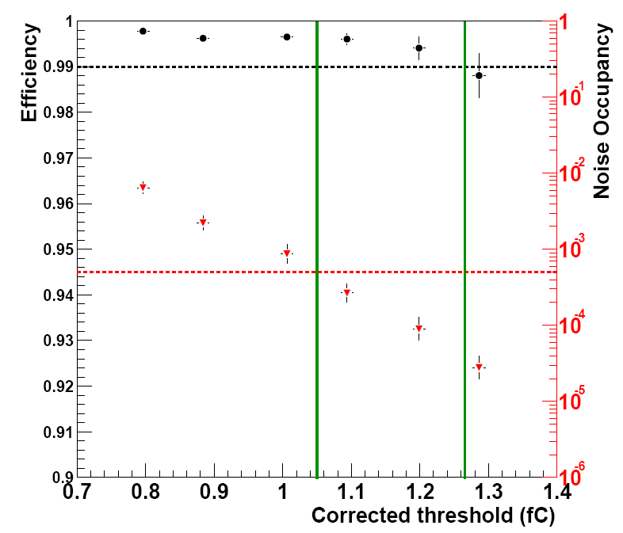
Figure 8. Efficiency (left hand axis, black points) and noise occupancy (right hand axis, red points) measurements for an irradiated module. This beam test measurement was made on a module irradiated to 3×10¹⁴ protons per square centimetre. The fluence corresponds to 10 years of operation from the LHC at design luminosity with a 50% safety margin. Efficiency is greater than 99% and the noise occupancy is less than 5×10⁻⁴ for thresholds in the approximate range 1.05 to 1.25 fC. From [].
Before irradiation it is not difficult to find thresholds for which both the noise occupancy (< 5×10⁻⁴) and efficiency (> 99%) targets can be satisfied. After the FE module is irradiated, setting the threshold at a suitable level becomes even more important. Irradiation decreases the signal collection, and increases the noise seen by the front-end. This means that after 10-years LHC equivalent radiation, the working region narrows, and to satisfy the performance requirements the channel thresholds need to be set within in a more limited range (Figure 8).
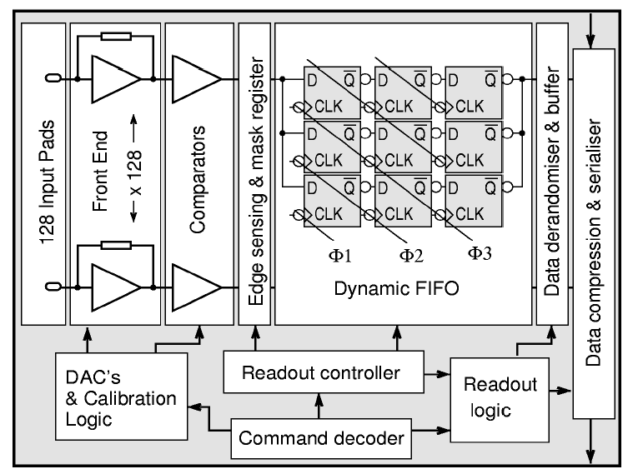
Figure 9. Simplified Block Diagram of a SCT ABCD3TA ASIC. From [1].
The most important features of the ABCD3TA chip can be seen in Figure 9. For a detailed reference of their design and performance the reader is referred to [Error: Reference source not found]. The analogue front-end is composed largely of bipolar devices. This part of the chip carries out charge integration, pulse shaping, amplitude discrimination, and latching of data. The digital pipeline and signal processing is in CMOS. Here the resultant binary 1-bit per channel information is stored for 132 clock cycles pending the global ATLAS first level trigger (L1) decision. If a L1 trigger is received the data are then read-out serially with token passing between the chips daisy-chained on the module. The encoding algorithm compresses the data assuming that hits are sparse (as is expected during physics data taking).

Module communication
When first powered the SCT modules return the 40.08 MHz input clock signal on each of their two optical links with the returned signal having half frequency of the clock. Once basic communication is confirmed, the next step is to optimize the optical communication parameters, such as the optical receiver threshold and phase applied to the incoming data on the BOC. An example plot, showing the information used to set the receiver threshold optimum on a particular data stream can be seen in Figure 10.
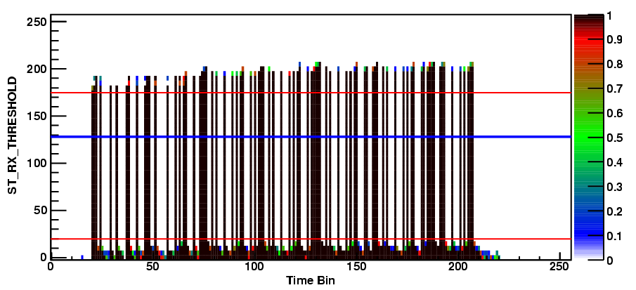
Figure 10. Bit pattern of sample binary module data as a function of BOC receiver threshold (y-axis). For this particular data stream, the analysis algorithm has determined that optical threshold register values of between about 20 and 175 would give a clean signal (thin red horizontal lines). The optimum value has been set to an intermediate value (thicker blue line).
Here talk about Rx Threshold and Rx Delay and refer to Figure 10.

Front end calibration
The amplitude of the discriminator voltage determines whether or not a pulse is registered as a hit. Each FE chip has an 8-bit DAQ which allows a threshold to be set globally across that chip. To assure uniformity of threshold, every channel has its own 4-bit DAC (TrimDAC) which is used to compensate for channel-to-channel threshold variations. The TrimDAC steps can themselves be set to one of four different values, allowing uniformity of threshold to be maintained even as uncorrected channel-to-channel variations increase during irradiation.
Internal calibration circuits can be used for injecting test charges at the front end. Every fourth channel can be tested simultaneously by applying a known voltage across a calibration capacitor from another 8-bit digital-to-analogue converter. By injecting various known charges, and measuring the occupancy at different thresholds, the analogue properties of each channel can be determined.
Since pulse size information is not available from the FE, the basic unit of many calibration tests is a histogram of occupancy against threshold. A complementary error function is fitted to the data: the threshold at which occupancy is 50% corresponds to the median of the injected charge, and the sigmas is a measure of the analogue output noise in mV. An example threshold scan is shown in Figure 11. During this calibration scan 500 triggers were sent per threshold point, and the charge injected was 1.5 fC.
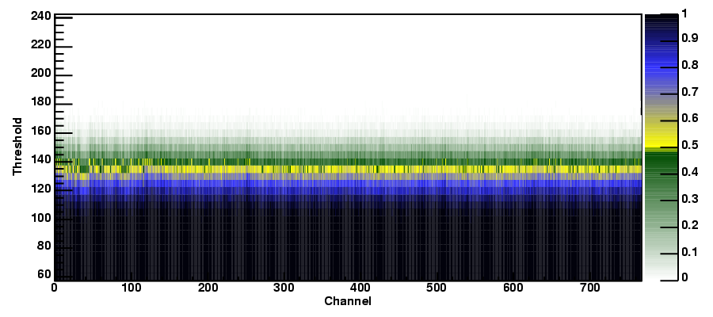(a)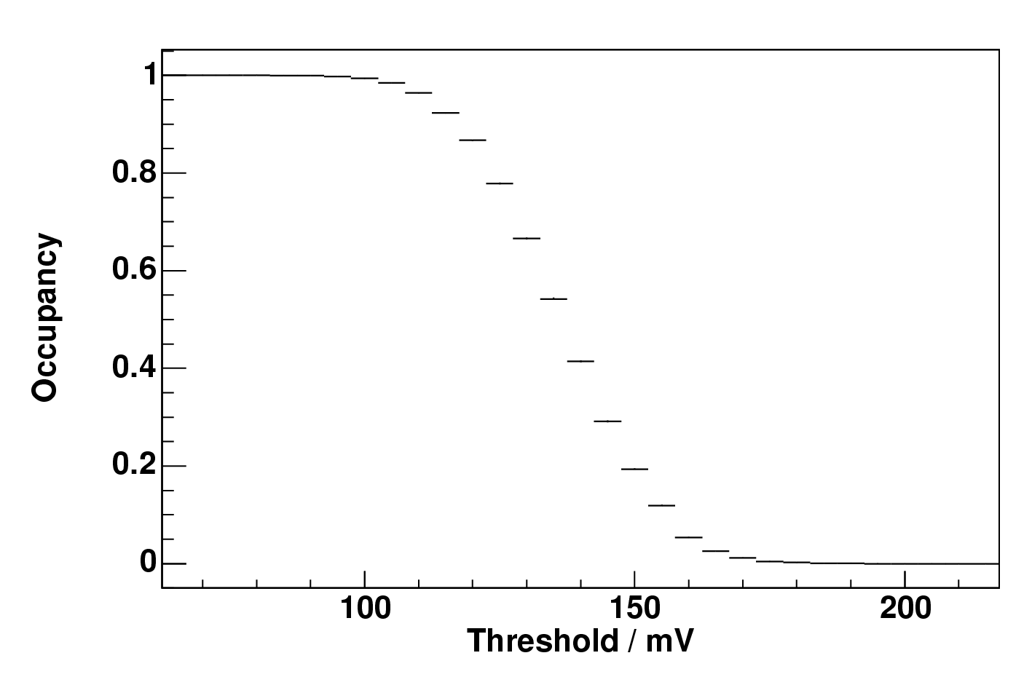(b)
Figure 11. Occupancy as a function of front-end threshold. (a) The shading scale shows the fraction of hits, as a function of the channel number (x axis, and comparator threshold in mV (y-axis) for one all channels on one side of a barrel module (6 chips; 768 channels). The FE parameters were already optimized before this scan, so the channel-to-channel and chip-to-chip occupancy variations are small. (b) Mean occupancy for one of those FE chips.
To calibrate the threshold DAQ, threshold scans are performed at different values of the injected charge. An example ten-point response curve for a particular chip is shown in Figure 12. From the data used to create these plots the front end gain, and input noise can be calculated: the gain is the gradient of the response curve, and the input noise can be calculated by dividing the output noise (at 2.0 fC) by the gain.
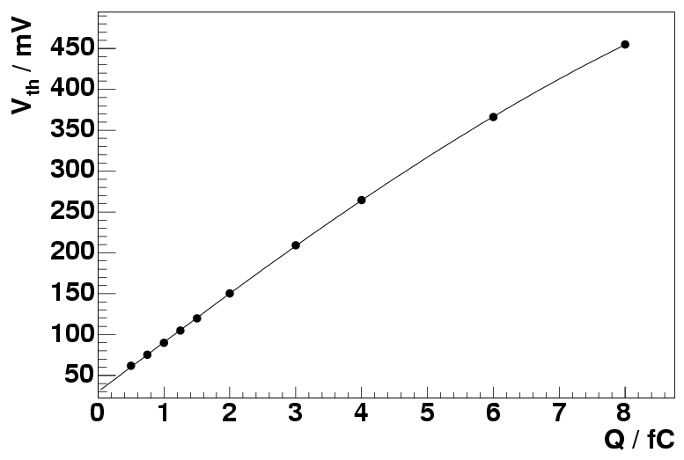
Figure 12. A response curve, showing value of the discriminator threshold at which the mean chip occupancy is 50% (V_{th}) as a function of the charge injected (Q).
Similar scans are used to optimise the TrimDAC registers. In these scans the injected charge is kept constant and threshold scans are performed for different values of the TrimDAQ registers.
Threshold scans without charge injection are used to find the noise occupancy. The response curve allows the threshold to be calibrated in units of input charge and the occupancy near the 1 fC nominal working point to be obtained. A variety of different noise scans can be used to test for noise pickup from cross-talk between FE modules, and from electrical or optical activity associated with the readout [].
A full test sequence contains other procedures which are not strictly calibration, but rather are a verification of the digital performance of the ASICs. These exercise and test the FE trigger and bunch-crossing counter registers, the channel mask registers, pipeline cells and chip token-passing logic as described in [Error: Reference source not found,,].

Application and results

Barrel and endcap macro-assembly
The SctRodDaq software was used extensively to test the performance of large numbers of modules after mounting onto their support structures at the assembly sites [Error: Reference source not found, Error: Reference source not found, , ]. Groups of up to 672 modules (full barrel 6) were tested simultaneously with a single crate DAQ. The ATLAS central elements (CTP, LTP, ROS etc) were not present, so the DAQ was operated in calibration mode, with triggers generated either on the RODs or on the TIM. The hit data were histogrammed on the RODs and the S-Link data discarded. Tests were performed to measure the noise performance, confirm known problem channels, and check that no new electrical defects had been introduced during the assembly process.
During barrel assembly, of the 2112 modules on the four barrels 14 were removed and replaced due to problems detected during testing: 3 modules had counter faults: 3 modules caused readout errors which could not be cured by masking off an acceptable number of channels; 3 were replaced by modified modules at locations were only one optical datalink was operational; 2 modules had one dead chip; 1 modules lost its bias connection after a full-barrel cold test; 1 module had high noise; 1 module had excessive leakage current.
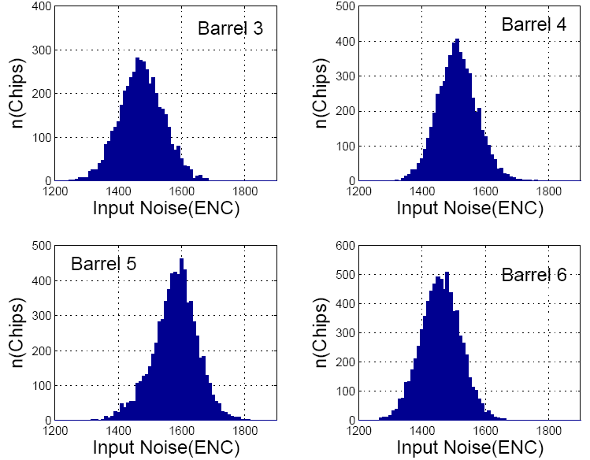
Figure 13. Average input noise for chips on each of the four SCT barrels. The units on the x-axis are equivalent noise charge in electrons. From [Error: Reference source not found].
Histograms of the chip-averaged input noise values for each barrel are shown in Figure 13. Barrels 3, 4, and 6 were tested “cold” at the macro-assembly site, and have noise around 1480 ENC. Barrel 5 was tested “warm” at CERN and has a slightly higher mean noise of about 1600 ENC. Approximately 80 ENC difference may be accounted for by the temperature difference of approximately 13 C. The number of defective channels is summarised in Table 4. The numbers include channels which were found to be dead, unbonded, part-bonded, or to have unacceptably high noise, or have other defects which made them unusable in practice.
 | Total channels | Problem channels | Functional Channels
Barrels | 3,244,032 | 8,326 | 99.74%
Endcap A | 1,517,568 | 4,371 | 99.71%
Endcap C | 1,517,568 | 4,205 | 99.72%
Table 4. Summary of the defective and functional channels on the barrels and on each endcap.
Similar tests were performed during endcap macroassembly. The module-average input noise for endcap modules is shown in Figure 14. On each endcap, five of the nine disks contain some modules with shorter strips (“short-middle” and “inner” modules) which have lower noise than those with standard-length strips [Error: Reference source not found]. The number of defective and fractional of function channels on the endcaps is also summarised in Table 4.
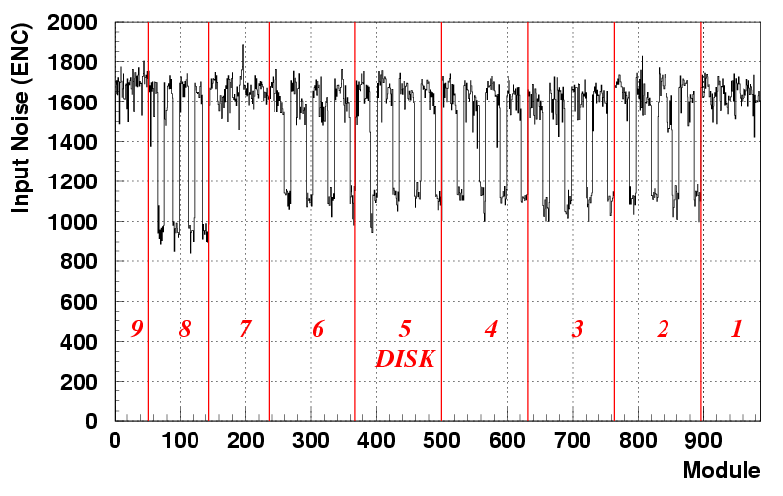(a)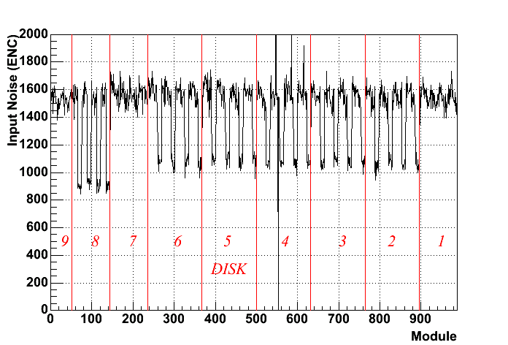(b)
Figure 14. Average input noise per module for (a) endcap A and (b) endcap C.

Commissioning and cosmic ray tests
The SCT barrel and endcaps were each separately integrated [] with the corresponding sections of the transition radiation tracker (which forms the outer layer of the ATLAS tracking detector []). Further tests, including combined SCT/TRT cosmic ray studies, were then performed.
For the barrel test, 468 modules (22%) from the four barrels were cabled to make top and bottom sectors opposing in φ. There was no applied magnetic field and care was taken to reproduce, as far as possible, the service routing and grounding of the final setup in the pit.
The cosmic rays were triggered using coincident signals from a pair of scintillators located above and below the barrel. Unlike the assembly tests, the clock, trigger identifier information (Table 3) were distributed to the SCT TIM and to the TRT DAQ using ATLAS Local Trigger Processor (LTP) modules. The resultant hit data were transferred from the SCT DAQ via the S-Link to a ROS and then written to disk. As well as the cosmic trigger, noise data were recorded in physics mode under a variety of test conditions, using fixed frequency or random triggers from master LTP.
To time-in the SCT with the cosmic trigger, the module relative timings were calculated from known differences in optical fiber lengths. The global delay was determined using dedicated ROD monitoring histograms which recorded, as a function of the global delay, the number of coincident hits on neighbouring chips on opposing sides of each module. After timing-in, hits from cosmic rays traversing the detector could be observed on the event display (Figure 15).
Figure 15. An ATLANTIS [] event display showing a cosmic ray traversing the semiconductor tracker. Hits on a single silicon plane are indicated by small (yellow) squares. Double hits indicating hits on both sides of a module are shown by larger (red) squares. The line indicates the position of a straight track fitted to the points.
In the noise tests, the occupancies obtained were not significantly different from those found for single barrel tests made on individual barrels before integration. No significant change in the noise occupancy was observed when running concurrently with the TRT, when running at different trigger rates (5 Hz to 50 kHz) or for synchronous versus asynchronous triggering. A histogram of the chip-averaged noise occupancies from a typical test is shown in Figure 16.
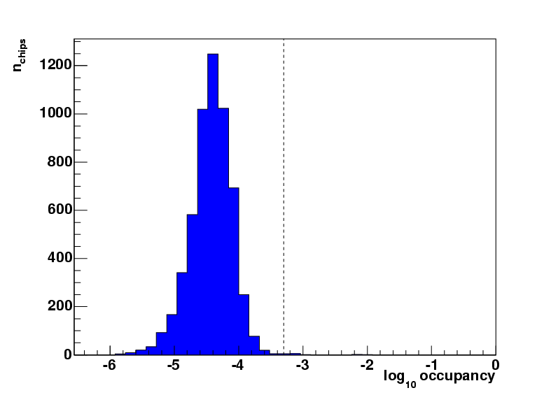
Figure 16. Histogram of the logarithm of the chip average noise occupancy (hit probability per event and per channel) for the 468 barrel modules under test. The results are based on 50k events triggered at 5 kHz when the calibrated FE discriminator threshold was 1.0 fC. The dotted line indicates the performance target of 5×10⁻⁴. The modules were operating with electrical hybrid temperatures of approximately 28 C.
In total more than 450k cosmic ray events and over 1.5M synchronous noise events were recorded in the barrel tests. Further information about the setup and results of these commissioning tests can be found in [-]).
Endcap Cosmics results?

Conclusions
The ATLAS SCT data acquisition system has been used extensively since January 2005 for performance testing and quality assurance during assembly and commissioning. Quality assurance tests in calibration mode, made simultaneously on groups of up to 672 modules (11% of the complete SCT) have helped ensure that the barrel and both endcaps were each delivered to CERN with more than 99.7% of channels performing to specification.
Commissioning tests in physics mode have demonstrated the continued good performance of the SCT barrel and endcaps after integration with the TRT. Over two million events have been successfully taken with synchronous triggers, demonstrating successful operation of both the DAQ system and the SCT detector with the final ATLAS trigger and data chain.
The flexibility of the DAQ hardware and software will allow the performance of the SCT to be monitored, and its calibration fine-tuned as the detector properties change during irradiation.

Acknowledgements
We acknowledge the support of the funding authorities of the collaborating institutes, including the Spanish National Programme for Particle Physics; the Research Council of Norway; the Particle Physics and Astronomy Research Council of the United Kingdom; The Polish Ministry of Education and Science; the German Ministry of Science; the Swiss National Science Foundation; the State Secretariat for Education and Research and the Canton of Geneva; the Slovenian Research Agency and the Ministry of Higher Education, Science and Technology of the Republic of Slovenia; the Ministry of Education, Culture, Sports, Science and Technology of Japan; the Japan Society for the Promotion of Science; the Office of High Energy Physics of the United States Department of Energy; the United States National Science Foundation; the Australian Department of Education, Science and Training; the Dutch Foundation for Fundamental Research on Matter (FOM); the Ministry of Education, Youth and Sports of the Czech Republic; the National Science Council, Taiwan; the Swedish Research Council.

Appendix
Alphabetical list of selected abbreviations:
ABCD3TA SCT front-end application-specific chip.
BOC Back of crate card
CTP The ATLAS central trigger processor
DAQ Data acquisition
ENC Equivalent noise charge
FE Front-end
HOLA High speed optical link for ATLAS
LHC The CERN Large Hadron Collider
LTP Local trigger processor module
MDSP Master digital signal processor.
RCC Rod crate controller
ROD Read-out driver
ROS Read-out subsystem
RX Receiver
S-Link A serial optical link
SCT Semiconductor tracker
SDSP Slave digital signal processor
TTC Trigger, timing and control
TIM TTC interface module
TrimDAC DACs which allow correction of individual channel thresholds
TX Transmitter

[?] A. Abdesselam et al, “The barrel modules of the ATLAS semiconductor tracker”, Nucl.Instrum.Meth.A568:642-671,2006
[?] Forward modules paper
[?] XXX et al, “The Silicon Microstrip Sensors of the ATLAS SemiConductor Tracker”
[?] F. Campabadal et al, “Design and performance of the ABCD3TA ASIC for readout of silicon strip detectors in the ATLAS semiconductor tracker”, Nucl.Instrum.Meth.A552:292-328,2005
[?] Central ATLAS TDAQ system XXX
[?] http://atlas.web.cern.ch/Atlas/GROUPS/FRONTEND/documents/Crate_Technical_Specification_final.pdf XXX
[?] http://atlas.web.cern.ch/Atlas/private/DIG/RCC/ XXX
[?] B.G. Taylor “Timing distribution at the LHC” in 8th Workshop on Electronics for LHC Experiments Electronics for LHC Experiments , Colmar, France , 9-13 Sep 2002, pp 63-74
[?] Rod paper: et al “A Read-out Driver for ATLAS Silicon Detector Modules" in preparation
[?] http://atlas.web.cern.ch/Atlas/GROUPS/DAQTRIG/ReadOut/
[?] http://hsi.web.cern.ch/HSI/S-Link/ XXX
[?] A. Abdesselam et al. “The Optical Links for the ATLAS SCT” In preparation
[?] M-L Chu et al, “The Off-Detector Opto-electronics for the Optical Links of the ATLAS SemiConductor Tracker and Pixel Detector”, Nucl.Instrum.Meth.A530:293 (2004)
[?] http://lhcb-elec.web.cern.ch/lhcb-elec/meetings/lhcbweek_february00/Delaychip_SpecificationsV1.pdf Link above broken already!
[?] http://hsi.web.cern.ch/HSI/S-Link/devices/hola/ XXX
[?] http://ttc.web.cern.ch/TTC/intro.html XXX
[?] http://www.cern.ch/TTC/TTCrx_manual3.9.pdf XXX
[?] http://proj-qpll.web.cern.ch/proj-qpll/images/manualTTCrq.pdf XXX
[?] M. J. Palmer, thesis, University of Cambridge, Jan 2005
[?] B. J. Gallop, thesis, University of Birmingham, Sep 2005
[?] The ATLAS online software. REF?
[?] F. Campabadal et al, “Beam tests of ATLAS SCT silicon strip detector modules”, Nucl.Instrum.Meth.A538:384-407,2005
[?] P. Philips, “Functional testing of the ATLAS SCT barrels”, Nucl.Instrum.Meth.A570 292-328 (2007)
[?] L. Eklund et al, “Electrical Tests of SCT Hybrids and Modules”, ATLAS-INDET-XXX
[?] A.J. Barr, “Calibrating the ATLAS Semiconductor Tracker Front End Electronics”, ATL-INDET-CONF-2006-001, IEEE NSS Conference Records, 16-22 Oct. 2004, 1192-1195
[?] G. Viehhauser, Conference Record of the 2004 IEEE Nuclear Science Symposium, Rome, Italy, 16–22 October 2004 (2004), pp. 1188–1191.
[?] D. Ferrère, “The ATLAS SCT endcap: From module production to commissioning” Nucl.Instrum.Meth.A570 225-229 (2007).
[?] H. Pernegger, “Integration and test of the ATLAS Semiconductor Tracker”, Nucl.Instrum.Meth.A572 108-112 (2007)
[?] The TRT general paper
[?] ATLANTIS
[?] The SCT cosmics note
[?] B.M. Demirköz, “Cosmic tests and performance of the ATLAS SemiConductor Tracker Barrels”, Nucl.Instrum.Meth.A572 43-47 (2007)

