Forth year projects 4C00
Claire O’Dea
Supervisor: Dr Jon Butterworth

Modelling the highest energy collisions in the World

Aim

The basis for the project is to look at data for proton-proton collisions and make predictions for future models using JetWeb. JetWeb is a program that can compare existing data and theoretical models to see how they agree, and is therefore a tool to see how our theoretical models can be modified to fit the current data. Past data will be examined and predictions for my own models will be made using HzTool and Fortran.

Introduction

CERN (Conseil Europeene pour la Researche Nucleaire) was set up in 1954 as a European based project for researching particle physics. By 2007 CERN will have finished building a new large hadron collider (LHC) which will collide beams of protons together at a centre of mass energy of 14TeV and at luminosities of up to 10³⁴cm⁻²s⁻¹. These will be the highest energy collisions yet carried out. Bellow is a picture (left) from the CERN website showing the proton Synchrotron at CERN in 1959, three weeks before the machine delivered its first beam at full energy. On the right is a picture showing the enormity of the 27Km large electron positron collier (LEP) tunnel.

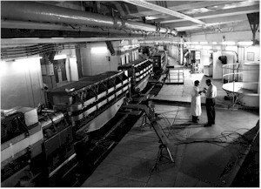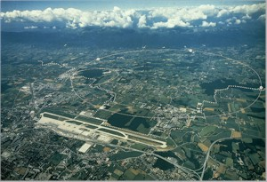
From www. http://hepweb.rl.ac.uk
In proton-proton collisions many different types of particles will be observed. Among them are W⁺ and Zº bosons these can then undergo fragmentation to give jets of quarks. Also neutrinos, leptons, will be released which could further enhance understandings of fundamental neutrino properties. This will help determine the mass of the neutrino, this has further implementations for CP violation of leptons. One of the main priorities of the new LHC at CERN will be to detect the Higgs Boson. This is a particle, which if found, will support many of our current fundamental particle physics models, as it is the quanta of the Higgs field with which particles interact to obtain their mass. There will be also lots of other particles in the debris of a proton-proton collision that will not be of any important physics significance. Therefore to screen out any unwanted data so that only vital data will be recorded and analysed JetWeb must be used.

Method

JetWeb contains a database of data and predictions for collisions and allows calculated models and data from observations to be compared. JetWeb uses HzTool to compare different models with the data from experiments. HzTool is a library of sub routines; these sub routines correspond to different published papers. Results from HzTool are processed by a Fortran programme that makes histograms of the data from HzTool. HzTool can be supplied with the final states of simulated collisions and the routines can then perform analysis of the final state as it was preformed in the paper. This provides simulated data points that can then be compared to the measurement. JetWeb stores the data from HzTool so that it can be easily accessed via the Internet.

For the beginning part of this investigation I will be learning and familiarising myself with the commands of HzTool. For the first few weeks of the project I will be going through models and making histograms from data that has already been created in HzTool. This is to familiarise myself with the program so that I can begin to understand the steps involved in making the final routines and histograms. After I have learnt the commands and am more accustomed with HzTool I will then compare the routines currently in HzTool to the research papers that they are based upon. This will help me to understand how the routines are made from the research papers. From this I will then be able to understand the basic template upon which the models are built. I will compare the routines with a variety of papers so as to fully understand how the routines were compiled. This will be done in the later half of term one.

By term two I will look at a variety of papers for which no routines have get been made in HzTool, which are therefore not stored in JetWeb. The beginning of term two will then be spent making my own routine from a chosen research paper. The final result will be histograms that compare the physics models to the results. From this I will be able to look at the models and the results of the data and assess which models agree with the data and which do not, and therefore I will be able to see which are good physics models for the data.

Bibliography

- Fortran 77 Summary User Guide from http://www.npac.syr.edu/hpfa/userguides/f77user.html

- HzTool information from http://hztool.hep.ucl.ac.uk/

- Physics World volume 17 number 9 Septermber 2004, ‘Cern 50 years and counting’.

- http://jetweb.hep.ucl.ac.uk/

- http://hepweb.rl.ac.uk

