Resonant Cavities
as Beam Position Monitors
Part 1. Waveguides and cavities

A. Liapine

1. Waves and waveguides

Electromagnetic fields oscillating on high frequencies ("radio" and "microwave" ranges) can be transmitted by means of waveguides. Basically, a waveguide is a metallic pipe filled with dielectric or vacuum, but there are many other special types (like stripline, microstrip, radial lines etc). The electromagnetic field is known to propagate through the waveguide as a wave (or a mixture of a few waves) with a fixed configuration. This configuration depends on the frequency of oscillations, waveguide type and excitation type.
Let's take a look on an example of the common wave in a circular waveguide:

TE₁₁
(Transverse Electric)
≡ H₁₁
Direction of propagation
z
r
φ
- electric field is shown with red lines, magnetic with blue ones
- wave is Transverse Electric - the electric field has no longitudinal component (in some literature it is marked as H-wave)
- the direction of the propagation is given by [E, H]
- maximums and nodes of transversal components of E and H coincide in case of vacuum filling

A bit more about indexes on an example of a rectangular waveguide:
TE₁₀
TE₁₁
TE₀₁
y
x

- indexes show the numbers of variations of the field for both axes (x, y for rectangular, φ, ρ for a circular waveguide)

There are several possibilities to couple to the fields in the waveguide (or cavity)
P
Magnetic
coupling
P
Electric
coupling
Electromagnetic
coupling
- magnetic coupling uses a loop acting to the magnetic field. The coupling strength depends on the magnetic flux through the loop i.e. inductivity of the loop
- electric coupling uses an antenna , the coupling depends on its capacitance.
- electromagnetic coupling is a sum of two – electric and magnetic, they may sometimes even cancel each other.

2. Circular waveguide

We start with a wave equation for the $E_{z}$-component of the electric field
$∇^{2}E_{z}+k^{2}E_{z}=0$,
were $k^{2}=ω^{2}\text{εμ}$.
It is convenient to use the cylindrical coordinate system. So we write
$\frac{∂^{2}E_{z}}{∂r^{2}}+\frac{1}{r}\frac{∂E_{z}}{∂r}+\frac{1}{r^{2}}\frac{∂^{2}E_{z}}{∂ϕ^{2}}+\frac{∂^{2}E_{z}}{∂z^{2}}+k^{2}E_{z}=0$.
We uncouple dependencies on r, φ, z, introducing $E_{z}=R(r)Φ(ϕ)Z(z)$, in that way we get three independent equations
$$\begin{aligned}r^{2}\frac{d^{2}R}{{\text{dr}}^{2}}+r\frac{\text{dR}}{\text{dr}}+R[r^{2}(k^{2}−k_{z}^{2})−m^{2}]=0, \\ \frac{1}{Φ}\frac{d^{2}Φ}{{dϕ}^{2}}=−k_{ϕ}^{2}=−m^{2}, \\ \frac{1}{Z}\frac{d^{2}Z}{{\text{dz}}^{2}}=−k_{z}^{2};\end{aligned}$$
with solutions
$$\begin{aligned}R(r)=C_{1}J_{m}(r\sqrt{k^{2}−k_{z}^{2}})+C_{2}N_{m}(r\sqrt{k^{2}−k_{z}^{2}}), \\ Φ(ϕ)=C_{3}\text{cos}(mϕ−ψ), \\ Z(z)=C_{4}e^{−{\text{ik}}_{z}z}+C_{5}e^{{\text{ik}}_{z}z}\text{.}\end{aligned}$$
Combining these solutions and introducing $k_{c}^{2}=k^{2}−k_{z}^{2}$ we get equations describing two waves traveling in +z and –z directions:
$E_{z}=A_{1,2}J_{m}(k_{c}r)\text{cos}(mϕ−ψ)e^{i(ωt∓k_{z}z)}$.
We want to know the transversal components as well. They can be obtained from the longitudinal components with help of the Maxwell equations. In cylindrical coordinate system
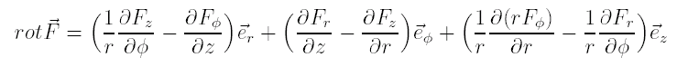
For the harmonic oscillating fields the Maxwell equations can be simplified to

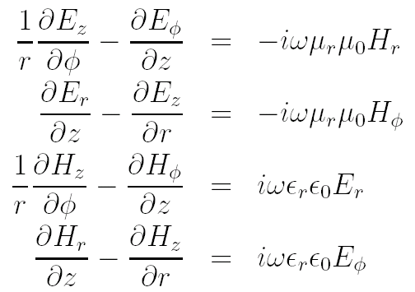
Combining these equations and evaluating the z-derivatives we get
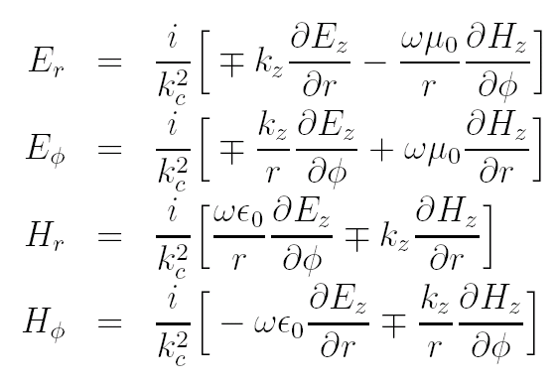
We are interested in transverse magnetic oscillations, so we put $H_{z}=0$and come to the components
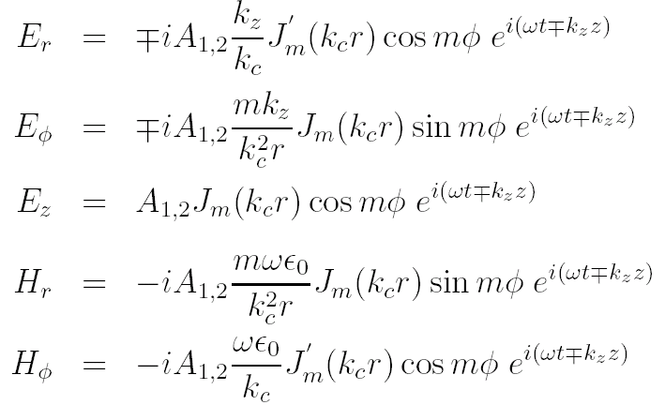
Boundary condition$E_{z}(r=R)=0$gives an evaluation for the $k_{c}$:$k_{c}^{\text{mn}}=\frac{j_{\text{mn}}}{R}$; $j_{\text{mn}}$is the $n$th zero of the Bessel function $J_{m}$.

3. Cylindrical resonant cavity

We can "make" a cavity out of a cylindrical waveguide cutting it transversally with conductive planes at $z=0$ and$z=l$.
0
L
z
r
φ

The sum of the transversal components of the reflected and initial waves must be equal to 0 at these planes:

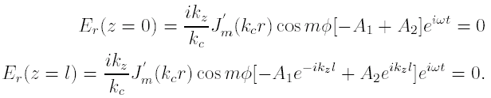

This means that $A_{1}=A_{2}=C/2$ and $k_{z}=\frac{pπ}{l}$. We get the components of the electromagnetic field in the cavity:

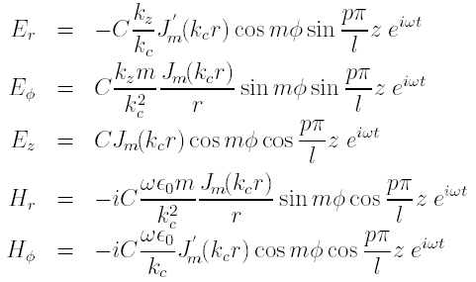
These equations describe the fields of all possible transverse magnetic modes in a cylindrical cavity. Indexes m, n and p enumerate the number of variations in φ, r and z directions respectively.
Using the equation $k^{2}=k_{c}^{2}+k_{z}^{2}$ we can establish a connection between the geometrical sizes of the cavity and its resonant frequencies:
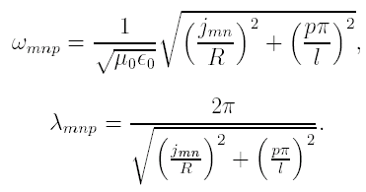
The fields and the frequencies, given by m, n, p are eigenmodes and eigenfrequencies of the cavity.
4. Single bunch excitation and coupled signals

A beam, passing through a cylindrical cavity, interacts with its eigenmodes exciting them. The mode, which is used for the beam position monitoring, is the first dipole mode, TM₁₁₀. Its excitation depends on the position of the beam and the phase of the excited field depends on the direction of the offset with respect to the cavity centre. This mode has the strongest excitation among the all position dependent modes (dipole, quadruple, etc).
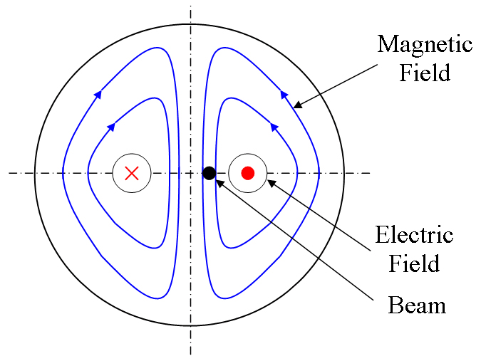
The field components of the dipole mode are given by
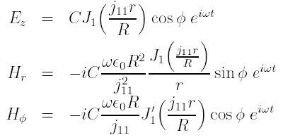
Integration of the electric field among the trajectory of the bunch $V=\int_{−∞}^{+∞}{\vec{E}\vec{v}}\text{dt}$ gives us the voltage seen by a bunch passing through the cavity. In the accelerator physics this voltage is known as an accelerating voltage ($V_{\text{acc}}$). This voltage depends on the field strength and the effective length of the cavity – its actual length multiplied by the transit time factor. The transit time factor indicates that the field in the cavity changes during the passage. In the assumption that the electric field is constant among the z-axis and the beam trajectory is parallel to z-axis we get $V=E_{0}T_{\text{tr}}l$. The accelerating voltage can also be written as
$$V=\int_{−∞}^{+∞}{{\text{Ee}}^{iωt}v}\text{dt}=\int_{−∞}^{+∞}{{\text{Ee}}^{\text{ikz}}}\text{dz}$$
if $\vec{E}||\vec{v}$.

The definition of the accelerating voltage can be also used for the calculation of the beam excitation. The fundamental theorem of the beam loading says that the voltage seen by the bunch exciting the cavity itself is a half of the voltage excited in the cavity which can be seen by a probe charge traveling behind the exiting charge.
Using the model of a closed cavity for the calculation of the excitation we do not take into account the fact, that a cavity BPM has beampipes. Therefore the excitation is proportional to the Bessel function of the offset, which looses the linearity very fast with the increasing beam offset.

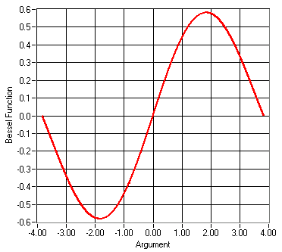
As a matter of fact, the excitation is almost linear in the beam pipe region. In order to show it, we replace
$$E_{z}={\text{AJ}}_{1}\left(\sqrt{k^{2}−k_{z}^{2}}r\right)\text{cos}ϕ$$
by an integral over all $k_{z}$possible in an infinite beampipe
$E_{z}=\int_{−∞}^{+∞}{A\left(k_{z}\right)J_{1}\left(\sqrt{k^{2}−k_{z}^{2}}r\right)\text{cos}{ϕe}^{−{\text{ik}}_{z}z}{\text{dk}}_{z}}$.
a
R
L
Assuming the electrical field to be constant among z-axis in the cavity gap we can find the constants $A\left(k_{z}\right)$ fitting the field in the cavity to the field in the beampipe at $r=a$. We apply an additional integration over dz to be able to use $\int_{−∞}^{+∞}{e^{i(k_{z}^{'}−k_{z})z}\text{dz}}=2\text{πδ}\left(k_{z}−k_{z}^{'}\right)$*:

$\int_{−∞}^{+∞}{e^{{\text{ik}}_{z}^{'}z}\text{dz}}\int_{−∞}^{+∞}{A\left(k_{z}\right)J_{1}\left(\sqrt{k^{2}−k_{z}^{2}}a\right)\text{cos}{ϕe}^{−{\text{ik}}_{z}z}{\text{dk}}_{z}=\int_{−∞}^{+∞}{e^{{\text{ik}}_{z}^{'}z}\text{dz}}\left\{E_{0}\text{cos}ϕ,−l/2≤z≤l/20,\text{elsewhere}\right.}$;
In the right part we get the expression for the accelerating voltage for $r=a$:
$\int_{−∞}^{+∞}{e^{i(k_{z}^{'}−k_{z})z}\text{dz}}\int_{−∞}^{+∞}{A\left(k_{z}\right)J_{1}\left(\sqrt{k^{2}−k_{z}^{2}}a\right){\text{dk}}_{z}=E_{0}T_{\text{tr}}l}$.
Applying * we get:
$2πA\left(k_{z}^{'}\right)J_{1}\left(\sqrt{k^{2}−k_{z}^{'2}}a\right)=E_{0}T_{\text{tr}}l$.
Now the field is given by:
$E_{z}=\int_{−∞}^{+∞}{\frac{E_{0}T_{\text{tr}}l}{2{πJ}_{1}\left(\sqrt{k^{2}−k_{z}^{2}}a\right)}J_{1}\left(\sqrt{k^{2}−k_{z}^{2}}r\right)e^{−{\text{ik}}_{z}z}{\text{dk}}_{z}}$.
This is still an integral with infinite limits, but we need to calculate the accelerating voltage:
$V=\int_{−∞}^{+∞}{E_{z}e^{iωt}\text{dz}}=\int_{−∞}^{+∞}{e^{\text{ikz}}\text{dz}\frac{E_{0}T_{\text{tr}}l}{2π}\int_{−∞}^{+∞}{\frac{J_{1}\left(\sqrt{k^{2}−k_{z}^{2}}r\right)}{J_{1}\left(\sqrt{k^{2}−k_{z}^{2}}a\right)}}e^{−{\text{ik}}_{z}z}{\text{dk}}_{z}}$.
We come again to the integral * and we get:
$V=E_{0}T_{\text{tr}}l\underset{k→k_{z}}{\text{lim}}\frac{J_{1}\left(\sqrt{k^{2}−k_{z}^{2}}r\right)}{J_{1}\left(\sqrt{k^{2}−k_{z}^{2}}a\right)}=E_{0}T_{\text{tr}}l\frac{r}{a}$.
This equation shows a pure linear dependence of the excited voltage on the beam offset.

For the estimation of the excited and the output voltages of a mode n it is convenient to relate them to the secondary cavity parameters, such as quality factor and shunt impedance. We calculate the accelerating voltage integrating the electric field of this mode:
$$V_{n}=\int_{−∞}^{+∞}{\vec{E}\vec{v}}\text{dt}$$
The energy lost by the bunch is the voltage multiplied by the bunch charge q:
$W_{n}={\text{qV}}_{n}$.
The voltage induced in the cavity is a doubled voltage seen by the bunch:
${\hat{V}}_{n}=2V_{n}=\frac{2W_{n}}{q}$.
Rearranging the above equation we get:
$${\hat{V}}_{n}^{2}=\frac{2W_{n}}{q}{\hat{V}}_{n}$$
${\hat{V}}_{n}=\frac{{\hat{V}}_{n}^{2}}{2W_{n}}q=\frac{ω_{n}}{2}\frac{{\hat{V}}_{n}^{2}}{ω_{n}W_{n}}q$.
Now we use the definition of the shunt impedance
$$R_{n}=\frac{{\hat{V}}_{n}^{2}}{P_{n,\text{loss}}}$$
and the internal quality factor
$$Q_{n,0}=\frac{ω_{n}{\bar{W}}_{n}}{P_{n,\text{loss}}}$$
to get a normalized shunt impedance
${\left(\frac{R}{Q}\right)}_{n}=\frac{{\hat{V}}_{n}^{2}}{ω_{n}{\bar{W}}_{n}}$.
$P_{n,\text{loss}}$ is here the power dissipated in the cavity walls.
Introducing ${\left(\frac{R}{Q}\right)}_{n}$into our equation we get a material independent solution, because the normalized shunt impedance does not depend on the cavity's material. It depends only on the geometry.
${\hat{V}}_{n}=\frac{ω_{n}}{2}{\left(\frac{R}{Q}\right)}_{n}q$,
$W_{n}=\frac{ω_{n}}{4}{\left(\frac{R}{Q}\right)}_{n}q^{2}$.
We use next the definition of the external quality factor
$Q_{n,\text{ext}}=\frac{ω_{n}{\bar{W}}_{n}}{P_{n,\text{out}}}$,
which characterize the coupling strength, and get the output power as
$P_{n,\text{out}}=\frac{ω_{n}^{2}}{4Q_{n,\text{ext}}}{\left(\frac{R}{Q}\right)}_{n}q^{2}$.
In the output line with the impedance Z
$$V=\sqrt{\text{ZP}}$$
so the output voltage is
$V_{n,\text{out}}=\frac{ω_{n}}{2}\sqrt{\frac{Z}{Q_{n,\text{ext}}}{\left(\frac{R}{Q}\right)}_{n}}q$.
Let us consider the above equation for the dipole mode and show the offset dependence there. We take the shunt impedance for a fixed offset, which is reasonable for the calculation/simulation. The shunt impedance is proportional to the offset squared and the voltage is in a linear dependence on the offset, so we can scale it to any offset we are interested in:
$V_{\text{out}}=\frac{ω_{0}}{2}\sqrt{\frac{Z}{Q_{\text{ext}}}{\left(\frac{R}{Q}\right)}_{\text{fix}}}\frac{r}{r_{\text{fix}}}q$.
This voltage can be compared to the noise level produced by the thermal noise in the bandwidth of the dipole mode $V_{\text{noise}}=\sqrt{4\text{kTZ}Δf}$in order to estimate the best resolution achievable with the BPM.

Further comments to this calculation:
The energy lost by the bunch depends on the voltage seen by the bunch and the bunch charge. It depends on the bunch offset, because the voltage depends on the offset. We assume no losses during the excitation time, the system is closed. That means that the whole energy is stored in the cavity's fields.
If a certain amount of energy is stored in the cavity, the strength of the fields is given by this energy, because it is an integral of the fields over the volume of the cavity. The voltage calculated as a linear integral has an offset dependence and, being involved squared into the shunt impedance definition, gives$\left(\frac{R}{Q}\right)\text{\sim }r^{2}$, that means that the output voltage in the last equation is proportional to the offset.
The last key is given by the fundamental theorem of the beam loading, which connects the voltage seen by the bunch exciting the cavity and the voltage seen by a probe charge traveling behind the bunch.

The fundamental theorem of the beam loading

To illustrate this theorem we assume that a charge q goes through a cavity and sees a fraction f of its own induced voltage V_{b1} for a particular mode. The energy lost by the charge is then:
$U_{1}={\text{qfV}}_{b1}$.
Consider a second equal charge following the first charge by exactly one half of the mode’s oscillation period. When the second charge excites that mode, the field induced by the first charge changes its phase by 180⁰ and becomes accelerating for the second charge. The voltage induced by the second charge will cancel the voltage excited by the first charge, which is equal by value, but has changed its sign. As a result no energy remains stored in this mode. The energy gained by the second charge must be equal the energy lost by the first one by the conservation law:
$U_{1}={\text{qfV}}_{b1}=U_{2}=q(V_{b1}−{\text{fV}}_{b2})={\text{qV}}_{b1}(1−f)$.
This means that f=1/2.

