Resonant Cavities
as Beam Position Monitors
Part 2. Features

A. Liapine

1. Multi bunch excitation

The energy, stored in the cavity (in some mode) decays exponentially as
$W\left(t\right)=W_{0}e^{−\frac{ωt}{Q_{L}}}$ .
The loaded Q-value $Q_{L}$ takes into account both, the power dissipated in the cavity walls and the output power
$\frac{1}{Q_{L}}=\frac{{\overline{P}}_{\text{loss}}+{\overline{P}}_{\text{out}}}{ω\overline{W}}=\frac{1}{Q_{0}}+\frac{1}{Q_{\text{ext}}}$.
Let's imagine, what happens, while a bunch train passes through the cavity. The first bunch excites all the resonant modes in the cavity. Their decay times depend on the losses and on the coupling strength. Then the next bunch comes. It will be accelerated by some modes (will take some energy from them) and decelerated by the others (will give them some energy) depending on the phase. Then the third, the forth etc bunches come… It is clear, that the modes which are harmonics of the bunch repetition rate are excited stronger than the others. If the dipole mode is in resonance, than we get a stronger offset dependent signal, but at the same time the average position of the bunch train is measured. In case, when the position of single bunches has to be measured, the dipole mode signal, caused by previous bunches, has to decay down to a certain limit.
We can estimate the voltage in the cavity for an infinite bunch train. We assume that all bunches has the same position and the voltages excited by all bunches can be added i.e. the case of synchronization. The resulting voltage in the cavity can be written as a series:
$$V_{∞}=V_{0}+V_{0}e^{−\frac{{ωt}_{b}}{2Q_{L}}}+V_{0}e^{−2\frac{{ωt}_{b}}{2Q_{L}}}+\text{.}\text{.}\text{.}$$
$t_{b}$is the distance between the bunches.
As the series converges we can calculate its sum:
$V_{∞}=\frac{V_{0}}{1−e^{−\frac{{ωt}_{b}}{2Q_{L}}}}$.
We can compare the sum voltage with the single bunch excitation and calculate the error:
$E_{∞}=\frac{V_{∞}−V_{0}}{V_{0}}=\frac{1}{e^{\frac{{ωt}_{b}}{2Q_{L}}}−1}$.
This equation can be solved with respect to$Q_{L}$. In that way we get a limitation for the quality factor for a given error$E_{∞}$,
$$Q_{L}=\frac{{ωt}_{b}}{2\text{ln}E_{∞}}\text{.}$$
Note that this limit assures that the signals excited by all previous bunches do not affect the signal of the actual bunch at the cavity output, but does not guarantee a good time resolution of the whole BPM system including cables, electronics etc.

2. Beam incline effect

The dipole mode of a cylindrical cavity is also excited, if a bunch travels through the cavity centre with some incline with respect to the axis. We can compare the excitation in cases of pure offset and pure incline excitation. Due to the linearity of the Maxwell's equations the results can be used for a mixed excitation as well.

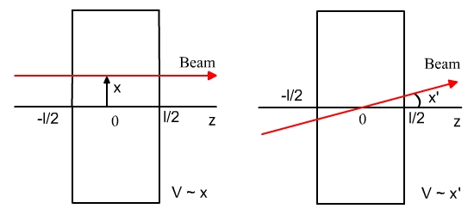
We calculate the voltage excited in both cases inside the cavity integrating the field of the dipole mode along the beam trajectory.
a) pure offset:
$V_{\text{110}}=\int_{−∞}^{+∞}{\vec{E}\vec{v}\text{dt}=\int_{{−l}/2}^{{+l}/2}{E_{z}e^{\text{ikz}}\text{dz}=E_{z}\frac{\text{sin}\frac{\text{kl}}{2}}{\frac{\text{kl}}{2}}l=E_{z}T_{\text{tr}}l={\text{CJ}}_{1}\left(\frac{j_{\text{11}}r}{R}\right)T_{\text{tr}}l}}$,
$V_{\text{110}}≈C\frac{j_{\text{11}}r}{2R}T_{\text{tr}}l$.
b) pure incline:
$V_{\text{110}}=\int_{−∞}^{+∞}{\vec{E}\vec{v}\text{dt}=\int_{{−l}/2}^{{+l}/2}{{\text{CJ}}_{1}\left(\frac{j_{\text{11}}r}{R}\right)e^{\text{ikz}}\text{dz}≈C\frac{j_{\text{11}}\text{tan}x'}{2R}\int_{{−l}/2}^{{+l}/2}{z}e^{\text{ikz}}\text{dz}≈\frac{{\text{iCj}}_{\text{11}}x'}{k^{2}R}\left(\text{sin}\frac{\text{kl}}{2}−\frac{\text{kl}}{2}\text{cos}\frac{\text{kl}}{2}\right)}}$.
We estimate the ratio of the two voltages in order to be free of the charge dependence:
$\frac{V'_{\text{110}}}{V_{\text{110}}}≈\frac{\text{ix}'}{\text{kr}}\left(1−\frac{\text{kl}}{2}\text{cot}\frac{\text{kl}}{2}\right)$.
This equation shows that there is a phase offset of 90⁰ between the two components of excitation. Using a synchronous detection scheme it is possible, basically, to separate the components. The behavior of this ratio in dependence on the cavity length is shown in the following picture.

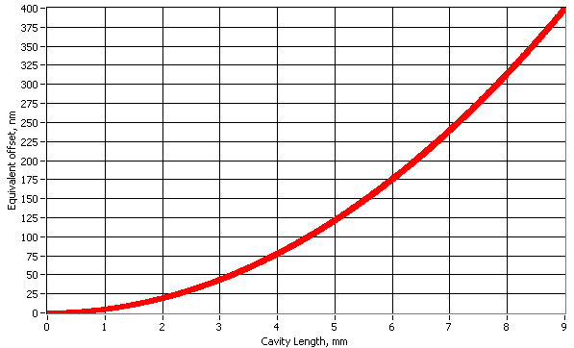

3. Monopole modes

The dipole mode does not have the strongest excitation among all modes. In fact, it is quite small, especially for small offsets, because the dipole mode has a node at the z-axis of the cavity. Monopole modes with a maximum at the axis are excited much stronger and the difference is not a factor of 2 or 3, but in the order of 100 dB. We could imagine that filtering the signal with a bandpass filter tuned to the dipole mode frequency we avoid this problem. But in fact these modes have finite Qs and therefore components in the range of the dipole mode resonance.
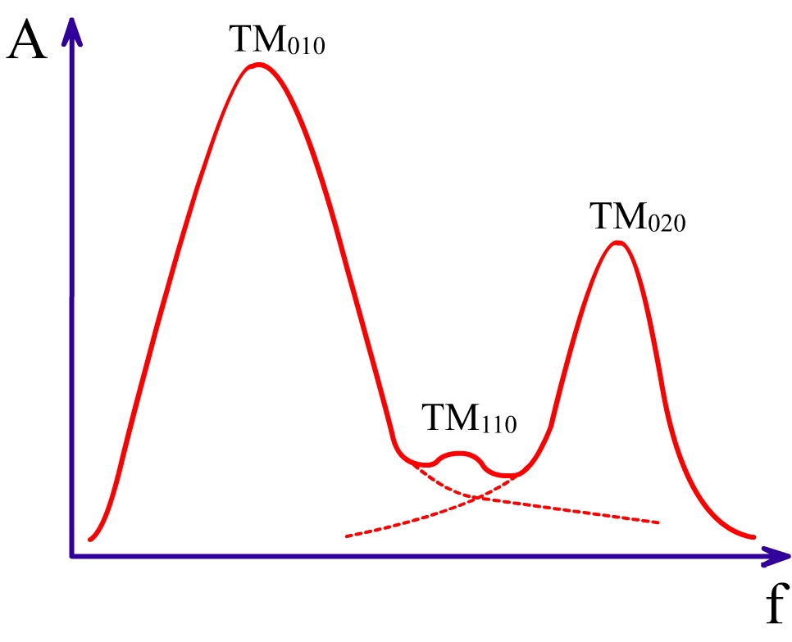
These components are weaker as the signals at resonances,
$V\left(f\right)=\frac{V\left(f_{0}\right)}{\sqrt{1+a^{2}}},a=\frac{2Q_{L}\left(f−f_{0}\right)}{f_{0}}$,
but typically the attenuation is about 40-50dB, what is not enough. Some mode-selective solution is needed.
Different structures were proposed in order to reduce this effect:

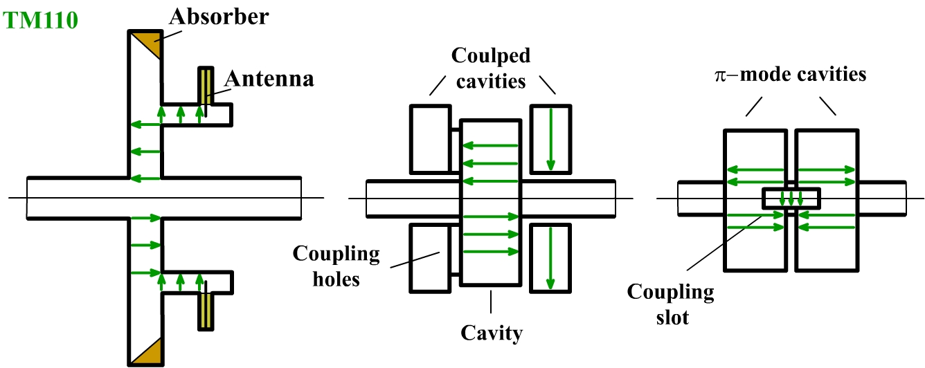

The first structure uses a choke mode cavity. The dipole mode is trapped and coupled out, while the others are damped. But it means a frequency selection, not the mode selection. The second structure uses additional cavities for spatial filtering. Monopole and dipole modes couple to different modes in the coaxial cavity and the coupling strength is different. It can be a solution, but the structure is too complicated. The third solution is to use a rectangular waveguide for the dipole mode coupling. Two cavities are used to build a symmetrical field in the waveguide. Actually, one cavity is enough because it does not change the boundary conditions providing the coupling.
A 3D view of a structure using one cavity with a rectangular slot for coupling is schematically shown in the next figure.
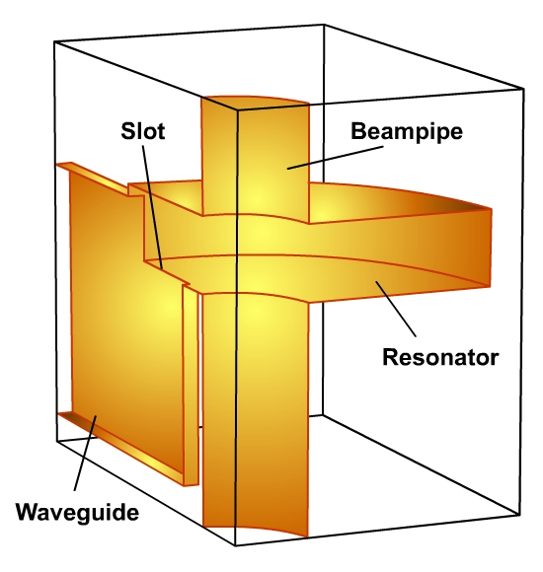
The dipole mode has an electric boundary condition at the axis. Therefore it can build a field transversal to the z-direction. At the same time the monopole modes have a magnetic boundary condition which does not allow transversal electric field. That means, the monopole modes can not couple to the lowest wave in the waveguide. They can couple to higher waves, but then most of these modes, at least the strongest ones are well below cut-off.
TM₀₁₀
TM₁₁₀
TE₁₁
TE₁₀
resonator
slot
E-field
wall
currents
magnetic
boundary
electric
boundary

4. Polarization and cross-talk

In an ideal cylindrical cavity the orientation of the excited dipole mode field is given by the bunch offset. Taking arbitrary x and y axes we can present the excited field as a superposition of two orthogonal polarizations of the dipole mode.
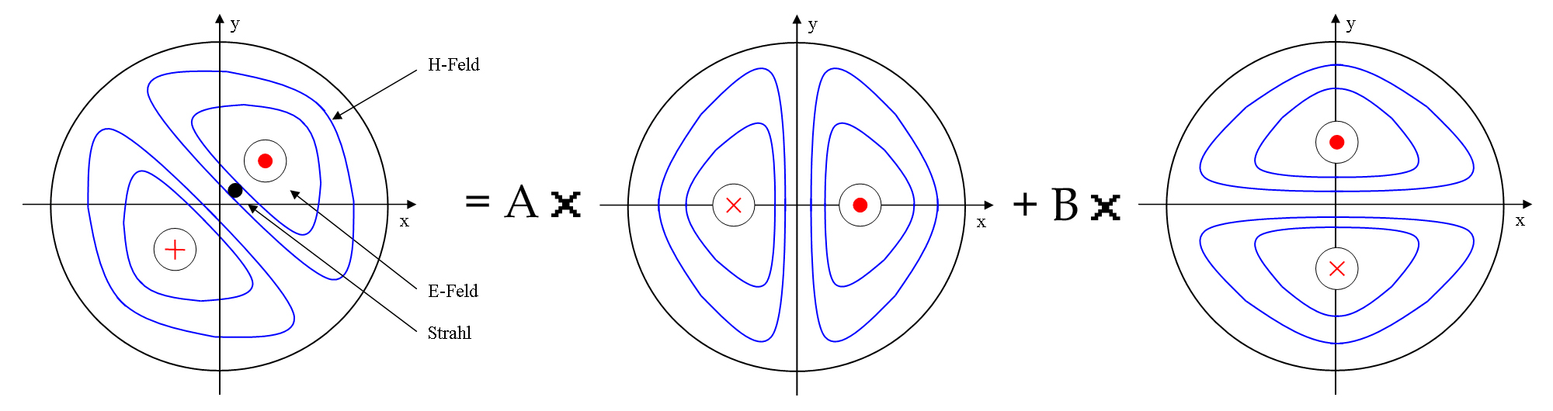
Orienting the output couplers to x and y directions we can measure x and y offsets of the beam separately. A real cavity has always some imperfections that can be summarized as an elasticity of the cavity. In that case the two polarizations are not arbitrary anymore, but fixed to the semiaxes of the ellipse. Their frequencies are close to each other, but not equal. Suppose that x and y coincide the semiaxes of the ellipse. In that case we still have x and y signals separated at the output. Another step to the reality – we suppose an angle α between the x, y axes and semiaxes of the cavity ellipse. At the outputs we get a mixture of two polarizations. The contributions of the polarizations are given by sine and cosine functions of α. The couplers can not be arranged perfectly to be in 90⁰ to each other, we have to introduce another angle β similar to α for one of the couplers. As last we have two polarizations with two different frequencies contributing to the output signals in couplers as sine and cosine functions of α and β.

So we meet two tasks: we have to force the polarizations to orient themselves to x and y and we have to separate the contributions of two polarizations in the output signal. An artificial "imperfection" can be introduced in the cavity. It has to be aligned to one of the axes so that the polarizations orient themselves to the axes automatically. Affecting one of the polarizations much stronger than another one this imperfection shifts its frequency. This allows for a separation of the polarizations in the output signal with help of filters. An extreme case is a rectangular cavity, where the polarizations are in fact different modes.
y
x
y
x

x
y
y
x

