Atlas SCT Barrel End Cooling Tube Referencing Disk

Drawing and Notes
April 21, 2003
Ned Spencer, UC Santa Cruz
All notes refer to Figure 1.
Note 1:
Annulus Description: Foil annulus is placed and soldered over the power tapes and tubes after barrels assembled with Heat Spreader Plate in place. Foil constructed of 25 μm Al on ~25 μm Kapton, Barrel 6 outer diameter, Barrel 3 approximate inner diameter. Al faces outwards. Foil plated with nickel barrier, and with gold 0.2 μm flash on areas where soldering of tabs is needed. Foil annulus provides contamination control for solder flux fumes and splatter, since soldering is done on outsde face.

Slots or holes will be punched at points where cooling tube connections are needed. Tooling holes through annulus as needed are acceptable to provide support for the soldering procedure.

Note 2:
Capillary or inlet tube connection: Each inlet tube should have a foil annulus connection as close to the barrel as is practical. Each tube needs a soldered tab, either plated foil as above, 10 mm width, or copper litz wire of 20/38 type, 20 wires@ 38 awg polyurethane coated with nylon servicing: single nylon, single poly. MWS Wire Industries lists this litz construction as 0.64 mm diameter. Litz wire dimension is minimum and can be larger if mechanically more convenient.

Note 3:
Exhaust tube connection: This is the same detail as Note 2. Soldered tabs are needed for all the tubes, close to barrel row connection., either foil or litz wire.

Note 4:
Barrel tube loop connection: This an optional connection using litz wire as above, in order to keep the wire flex load on the tube very small. This option will be exercised at annulus installation if needed, not later.

Note 5:
Radial foils: 24 radial foils as above, 6 each quadrant, 10 mm width, should be placked into LM tape slots in the bulkhead. The slots next to the short interlinks are full of LM tapes, so avoid these. The 6 quadrant radial foils should be as equidistant as packing allows.

Note 6:
Heat Speader Plate tab: A foil tab or litz wire tab, as above, will be soldered on the Heat Spreader Plate. For the present, a series resistor of 0.5 ohms option is needed for this connection. These tabs will be soldered to the radial foils when the foil annulus is installed.

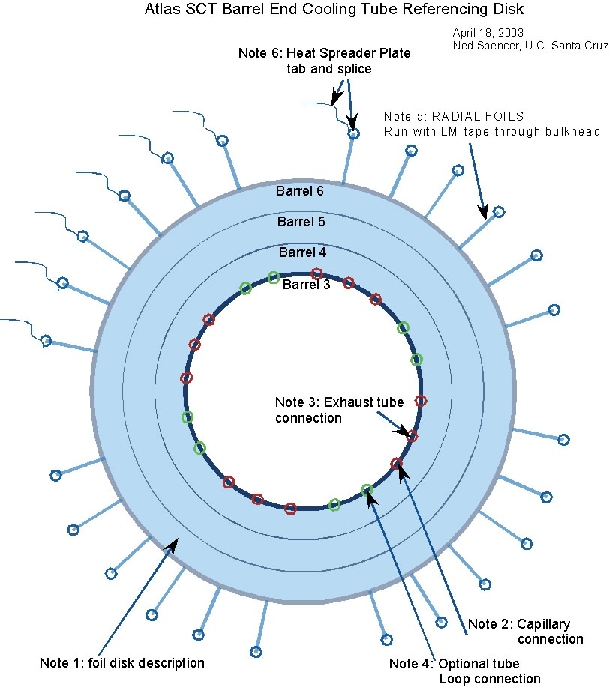

Figure 1

