Investigation of the Resonant Bond Wire Problem

Tony Weidberg and Dave Charlton, V5, 5/8/03

Introduction
CDF have discovered that some SVX bond wires were being broken when the L1 trigger frequency hit a resonance for the bond wires in the magnetic field. This was caused by the Lorentz force for currents that varied when an L1 trigger was issued. This is potentially a problem for the SCT. In particular the bonds carrying current from the VDC to the VCSEL are perpendicular to the magnetic field and the current varies from 1 to 10 mA when sending data. The data is sent at 40 Mbits/s which is of course a much higher frequency than any mechanical resonance. However data is sent in bursts after an L1 trigger so that if the L1 trigger frequency hit a resonance, there could be a problem.

Test Set-Up
Bonds were made on a test board to have the length and loop height used for the VDC to VCSEL bonds on the doglegs. A 50 Ohm resistor was added in series and the current was pulsed by a pulse generator. The current pulse was monitored on the scope by looking at the voltage across a 10 Ohm resistor. The set-up was placed in the Birmingham superconducting magnet facility.

Measurements
The frequency of the pulses was scanned in the range 10 kHz to 100 kHz which is the region where CDF saw resonances. Some preliminary scans were performed with nominal conditions, B=2T, amplitude of current pulse I=10 mA and with a square wave generator. Since this did not break a bond, the magnetic field was increased to B=6T and the amplitude was increased to 30 mA. This then generates a driving force a factor of at least 9 greater than expected during ATLAS operation. Four scans were then performed using a sine wave generator in the frequency range 10 kHz to 120 kHz and the bond wire did not break. Although a sine generator should give the maximum amplitude at any one frequency, it is interesting to check with a square wave as this gives higher harmonics which might create a problem. Therefore one scan was done with a square wave of the same amplitude and frequency range, without the bond wire breaking.

Tests With A Video Camera
A further study was made using a video camera to be able to look at the wire bonds during the frequency scans. The video camera gave a very clear image of the wire bonds when the magnetic field was off but the resolution was seriously degraded by the magnetic field. Therefore the tests were performed at a magnetic field of 0.5T but the amplitude of the current was set to be 40 mA so that the Lorentz force would be the same as for nominal ATLAS operation (2T and 10 mA). It was still possible with this set-up to observe wire bonds resonating. The first resonance that was observed was at a frequency of 15.3 kHz. The resonance was observed by watching the increase in the width of the shadow of the wire bond on the PCB surface. The width clearly increased when the pulse current to the bond wires was turned on. This effect was observed by 4 people but this resonance could not be seen after the system had been left for one hour. The disappearance of this resonance is not understood. One of the bond wires broke and was replaced. The illumination of the bond wires by a blue LED was improved so that it was easier to see the reflection of the wire bonds. With this set-up it was easier to see the resonances. A resonance for the bond wire that was replaced was found at a frequency of 14.3 kHz. The photo of the bond wires without any current is shown in Figure 1 below and the photo with the current pulsing is shown in Figure 2 below.

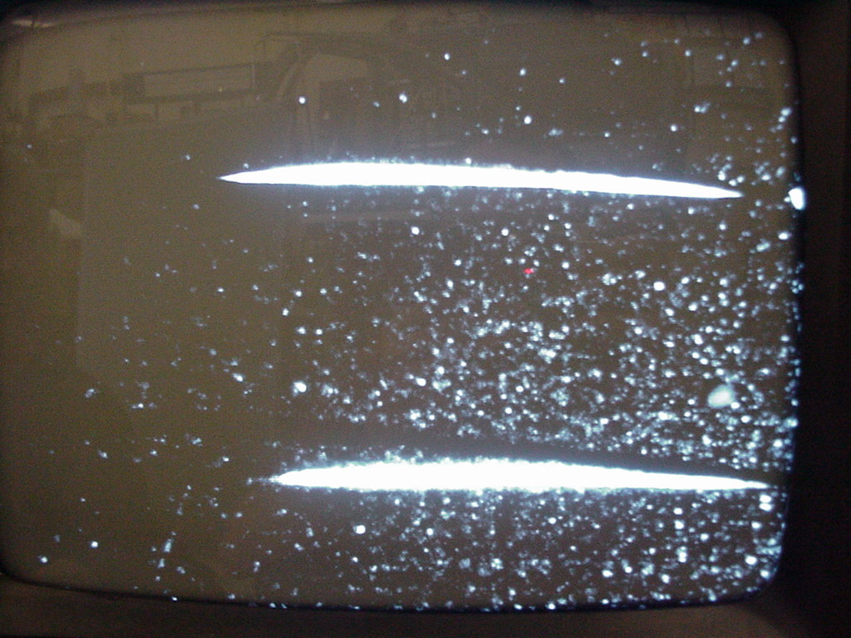
Figure 1 Photo of TV screen showing the two bond wires while there was no current being pulsed through the bond wires.

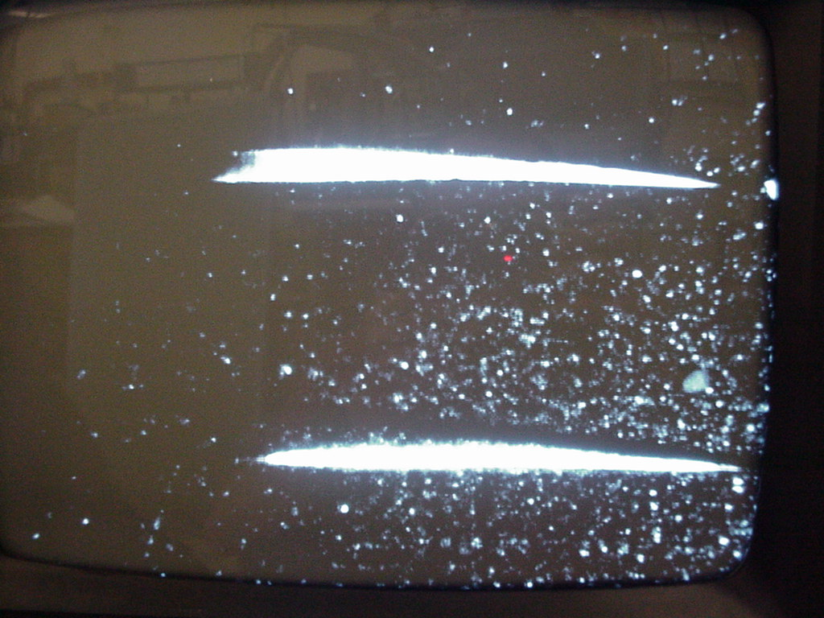
Figure 2 Photo of the TV screen showing the two bond wires while a current of 10 mA was being pulsed through the bond wires.

The upper bond wire can clearly be seen to be resonating. This effect was checked by turning on and off the current to the bond wires. The effect of the resonance could be detected over a frequency range from 13.7 kHz to 15.3 kHz. While checking this resonance the amplitude was observed to suddenly increase dramatically for a fraction of a second and after this the frequency range changed slightly. A search for a resonance in the lower bond wire failed to find any resonance in the frequency range 10-20 kHz. It is not understood why there was no resonance found for the wire bond or why this one showed a resonance earlier in the day but not later. While we were searching for a resonance in the lower bond wire, the upper bond wire was observed to suddenly fail. This wire bond had been operated on resonance for the order of 10 minutes.

Conclusions
Clear resonances were observed for the wire bonds with the same lengths, loop heights and orientation to the magnetic field as for doglegs in ATLAS. These resonances are potentially very dangerous because two of the wire bonds broke after a few minutes of operation on resonance with a similar magnitude Lorentz force to that expected for ATLAS operation. However from the first set of tests with an order of magnitude larger Lorentz force than in ATLAS operation in which no wire bond broke it seems that there is no danger if no significant period of time is spent on resonance.

Two possible solutions that have been used successfully by CDF should be investigated urgently:
- Determine all the resonant frequencies and ensure that triggers are never issued at this fixed frequencies,
- Apply a potting compound to the base of the wire bonds. CDF used a very thin (les than 50 μm ) layer of Sylgard 186 Silicon Elastomer and this reduced the amplitude of resonant vibration by more than an order of magnitude[Error: Reference source not found].

For the doglegs it is not possible to use the hardware solution (2) for the doglegs that have already been assembled with the opto-cover, therefore option (1) needs to be investigated although option (2) could be used for new barrel doglegs and for forward opto-packages.

There is probably a similar problem for the cathode and anode bonds for the VDC chip on the K5 hybrid but here solution (2) could be considered. There may be similar problems for the VDD wire bonds on the barrel and forward hybrids as the current varies with trigger rate so this should also be urgently evaluated.

The effect of random triggers is reduced by two orders of magnitude compared to that of fixed frequency triggers so normal physics running should not be a problem (see the calculations in Appendix A).

Appendix A Fourier Analysis
In order to compare the amplitude of the sine wave with a square wave (expected for a calibration run using a clock trigger) or an exponential distribution (expected in normal physics running) we need to some simple Fourier analysis.

Square Wave
Consider a square wave of unit amplitude and period T
$$\begin{aligned}f(t)=1 0<t<T/2 \\ f(t)=−1 T/2<t<T\end{aligned}$$
This can be analysed as a Fourier series
$f(t)=\sum_{n}{a_{n}}\text{sin}(2π{\text{nt}}/T)$
where the amplitude of the nth harmonic is given by
and the amplitude of the fundamental component is
$$a_{1}=4/π$$

If instead we consider a rectangular pulse of period T defined by
where the amplitude of the n^{th} harmonic is given by

Random Trigger Distribution
The distribution of time between triggers for a random trigger with a mean rate λ is
$$f(t)=λ \text{exp}(−λt)$$
The current pulse corresponding to the readout then lasts a variable amount of time. A simple toy simulation was made in which the mean L1 trigger rate was 75 kHz and the readout time was generated from a uniform distribution in the range 0 to 10 μs. A numerical Fourier transform (FT) was performed on the simulated current versus time data and the resulting spectrum is shown in Figure 3 below. The overall shape of the distribution is not sensitive to the assumptions about the shape of the distribution of read out times; for example the calculation was redone assuming that the readout always lasted for a fixed 5 μs and a rather similar spectrum was obtained.

Figure 3 FT spectrum for random triggers.
The large fluctuations are because of the random nature of the generation and two smoothing algorithms are shown to guide the eye. The FT code was checked by redoing the calculation assuming a fixed L1 frequency of 75 kHz and a fixed readout time of 5 μs and the resulting FT spectrum is shown in Figure 4 below. This shows the peaks at integer multiples of the fundamental frequency as expected.

Figure 4 FT spectrum for fixed frequency triggers.
From the FT spectrum for the random triggers the power contained in the width of the resonance can be estimated and compared to the total power at all frequencies. Consider for example a resonance at f=15 kHz with a full width of 500 Hz and an L1 trigger rate of 75 kHz which has the fraction of the power within the resonance of ~ 8 10⁻³.

Appendix B Trigger Veto Algorithms
A very simple algorithm is being implemented in CDF to veto on fixed frequency triggers; if there are more than N triggers with a difference in time of less than ΔT, a veto is generated. The suggested starting values are N=10 and = ΔT 1μs. A simple toy Monte Carlo programme was used to estimate the probability of generating a trigger veto with this algorithm, assuming that the triggers were generated randomly in time (with an exponential distribution in time between successive triggers). The results of this calculation are shown in Figure 5 below. For the default values (N=10 and = ΔT 1μs) and the worst case L1 trigger rate of 75 kHZ, the predicted veto probability is 3.6 10⁻¹⁰, which corresponds to a veto rate of 2.7 10⁻⁵. Therefore the veto could be allowed to go on for a relatively long length of time and would still create negligible dead time in the presence of random triggers. This algorithm will therefore efficiently distinguish between genuine random triggers and a fixed frequency clock. However this simple algorithm would be fooled by the presence of a fixed frequency clock on top of genuine random triggers. This could happen at the LHC if a trigger on the machine revolution frequency (11 kHz) was added to random triggers as might happen for some special tests. It would therefore be better to implement a genuine FFT if that were practical.
Figure 5 Trigger veto probability versus number of triggers in window for different window times.

Trigger Veto Based on FFTs
The toy Monte Carlo programme was also used to study the efficiency of FFT algorithms to separate clock triggers from random triggers. A fixed interval of time was defined to simulate the triggers and evaluate the FFT. The amplitude of the Fourier transform was evaluated at fixed frequency points from 10 kHz to 100 kHz in steps of 1 kHz. The maximum amplitude was determined over this frequency range. This procedure was repeated in order to generate a distribution of the maximum amplitude. The resulting histograms for the maximum Fourier amplitude for random and clock triggers is shown inFigure 6 below. There is some variation in the Fourier component even for the clock trigger because the length of the readout was generated randomly from a uniform distribution from 0 up to a maximum of 10 μs. For the relatively long integration time of 25 ms, there is clearly an excellent separation between random and clock triggers. This technique would of course be able to detect the presence of a mixture of random and clock triggers, unlike the simpler CDF algorithm. One disadvantage of this FFT method is the relatively long time taken to generate a veto so it is interesting to see if the FFT algorithm can be used to efficiently separate random and clock triggers using a shorter time period for the evaluation. The results for a time period of 2.5 ms are shown in Figure 7 below and it can be seen that the separation is no longer as clean and there is some overlap between the distributions for random and clock triggers. These results suggest that there should be an optimal time interval for the evaluation somewhere between 2.5 ms and 25 ms. Therefore an evaluation time of 10 ms was used and the results shown in Figure 8 below. This shows that a very clear separation between clock and random triggers can be achieved with the FFT technique if an evaluation time of the order of 10 ms is used.

Figure 6 Distribution of maximum Fourier component for random and clock triggers (see legend). The time interval used was 25 ms.

Figure 7 Distribution of maximum Fourier component for random and clock triggers (see legend). The time interval used was 2.5 ms.

Figure 8 Distribution of maximum Fourier component for random and clock triggers (see legend). The time interval used was 10 ms.

In ATLAS operation we expect an approximately equal number of 0s and 1s in the data stream so that the average current during a readout would be about 5 mA.
From the results of appendix A we can see that a square wave with unit amplitude has an amplitude for the fundamental frequency of 4/π so so that a square wave of the same amplitude would in fact be slightly more dangerous than the sine wave used in these tests.
we did not explicitly require the loop shape of the new bond be identical to the previous bond. This may explain the change in resonant frequency.
See talk by Reid Mumford at url: http://ssd-rd.web.cern.ch/ssd-rd/bond/talks/reid_cdf.pdf
J. Goldstein, private communication.

