CC RTM CARD LAYOUT

- GENERAL PLACEMENT
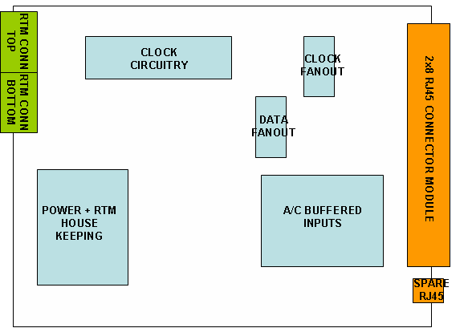

The figure above shows roughly the placement for the xTCA RTM connectors and the RJ45 connectors and the corresponding circuitry.

The dimensions of the board and the other mechanical information can be found in the documents referenced at the end. Please refer to the drawing files attached for the exact dimensions and clearances.

There are several RTM for uTCA standard related components and drill holes (guide pin, faceplate LEDs, faceplate holes) which need to be placed according to the standard.

The component envelope is as seen in the figure below. Maximum height of the component on side 2 is 3mm. The maximum card thickness is 1.76 mm (1.6 mm +/- 10%).

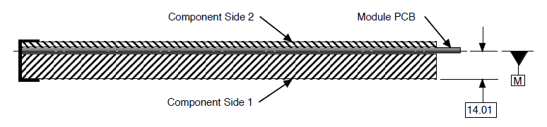
The RTM board will have an ESD strip the dimensions of which is defined in the MTCA.4 R1.0 D0.7t section 2.3.1.24. On the schematic it will be connected as in the following figure (not yet in the schematic 29/03/2011).

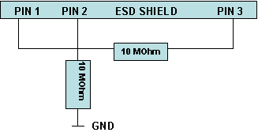

2. POWER RAILS

The three power rails on the board are namely 12V, 3V3_MP and 3V3. 12V coming from the RTM connector is converted to 3V3 which is the main power rail for the board. 3V3_MP coming from the RTM connector is used for the RTM house keeping circuitry. A localized power plane for 3V3_MP, thick traces for 12V and main power planes for 3V3 is suggested.

- DIFFERENTIAL TRACES
All differential traces will be 100 Ohm matched impedance. There is a requirement that each of these pairs belonging to certain groups will be length-matched. This will be detailed in the layout by sheets section. The test points placed on some differential traces will use minimum stub length.

- LAYOUT BY SHEETS

- SHEET 1
The sheet 1 contains the spare I/O circuitry and the corresponding RJ45 connector. The AC coupling circuitries are the same ones that were used in the CC PrePrototype-A card. Therefore similar layout can be followed. The differential pairs to be length matched are:
FPGA_SPARE_IN1_P/N and FPGA_SPARE_IN2_P/N
FPGA_SPARE_OUT1_P/N and FPGA_SPARE_OUT2_P/N
FPGA_SPARE_IN1_I_P/N and FPGA_SPARE_IN2_I_P/N
FPGA_SPARE_OUT1_I_P/N and FPGA_SPARE_OUT2_I_P/N

The 100N decoupling capacitors to be placed close to each IC. 4U7 bypass capacitors to be spreaded in various locations on the board. The 100 Ohm termination resistors should be placed as close to their respective ICs as possible. The 10U bypass capacitor, C185 should be placed near the DC-DC converter module.

- SHEETS 2-5
These sheets contain the AC coupling input circuitry for the status signals. As in the case for the sheet 1 the AC coupling circuitries are identical. The differential pairs to be length matched are.
STATUS_OUT_LA_P/N up to STATUS_OUT_UH_P/N
STATUS_LA_P/N up to STATUS_UH_P/N

- SHEET 6
The sheet 6 contains the bottom RTM connector (SK3) , the DC-DC converter module (LTM4600EV), and the RTM house keeping circuitry (I2C expander (U32), EEPROM (U34), temperature monitor (U35), etc.).
The recommended layout for the DC-DC converter module as stated in the datasheet is as follows.
- Use large PCB copper areas for high current path, including VIN, PGND and VOUT. It helps to minimize the PCB conduction loss and thermal stress.
- Place high frequency ceramic input and output capacitors next to the VIN, PGND and VOUT pins to minimize high frequency noise.
- Place a dedicated power ground layer underneath the unit.
- To minimize the via conduction loss and reduce module thermal stress, use multiple vias for interconnection between top layer and other power layers.
- Do not put a via directly on pad unless it is capped. Use a separated SGND ground copper area for components connected to signal pins. Connect the SGND to PGND underneath the unit.

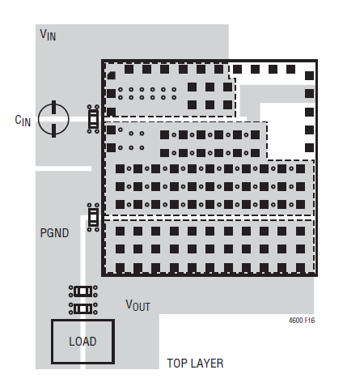
The LEDs, SW_HOT_SWAP, USD_LED, and FAILURE_LED along with the SW_HOT_SWAP switch should be placed according to MTCA.4 R1.0 D0.7t document and the uTCA faceplate kit documents from Schroff.

The differential pairs to be length matched are
VETO_LA_P/N up to VETO_UH_P/N (note that some of the veto signals are on the top RTM connector)

The signal traces belonging to the RTM house keeping circuitry (3V3_MP domain) should ideally be as separate from the other signals as possible. The 470U capacitor, C91 should be placed close to the RTM bottom connector, SK3.

- SHEET 7
The sheet 7 contains the clock generation, conditioning and the fanout circuitry. U4 is the LVDS clock receiver which feeds a clock doubling circuitry ( U8,U5, U11) and a non-PLL clock mux (U14).
The output of U14 goes to a PLL based clock fan-out/mux (U16) whose output goes to a multiplying PLL (U3). A differential driver takes the output of U3 and feeds into the input of an LVDS fanout buffer (U12).

In general the ICs in the clocking circuitry should be placed close together. U4,U5,U8 and U11 are the first group and U14,U15,U16 are the second and U3,U10, and U6 are the third group. U12 should be placed close to the RJ45 connector block.

The rules concerning the PLL ICs, U16 and U3 are as follows.

1) Each 0.01μF decoupling capacitor should be mounted on the component side of the board as close to the VDD pin as possible. No via’s should be used between decoupling capacitor and VDD pin. The PCB trace to VDD pin should be kept as short as possible, as should the PCB trace to the ground via.
2) To minimize EMI the 33Ω series termination resistor, if needed, should be placed close to the clock outputs.
3) An optimum layout is one with all components on the same side of the board, minimizing vias through other signal layers. Other signal traces should be routed away from the ICS527-01. This includes signal traces just underneath the device, or on layers adjacent to the ground plane layer used by the device.

- SHEET 8
The sheet 8 contains the 8x2 RJ45 connector block, the spare RJ45 connector, the top RTM connector SK1, the LVDS data fanout IC, U17 and the LED driver chips.
The differential traces for DATA_LA_P/N up to DATA_UH_P/N that are going to the RJ45 connector block should be length matched.
U17 should be placed as close as possible to the RJ45 connector block.
The placement of the LED drivers are not too crucial.
The 100N decoupling capacitors for U17 should be as close to the ICs power pins as possible as well as the 100 Ohm terminating resistor.

- ADDITIONAL DOCUMENTS

- MTCA.4 R1.0 D0.7t standard
- Schroff documents for the AMC module mechanism PICMG AMC.0 R2.0 RC1.2 – order no 20849-132
http://web.schroff.de/webcat/subgroup/pdf/schroff_cat_39601422_atca_packaging_solutions_2008_e.pdf page 71

