Clock and Control Implementation for 2D Pixels

Introduction
The Clock and Control (CC) system for the 2D pixel detectors at XFEL must integrate with “neighbouring” systems and XFEL stardard configurations. Areas of focus are the crate/backplane standard chosen, the interface to the machine and requirements of the 2D pixel detectors.

A schematic of the system is shown below. All CC electronics is housed in one or multiple xTCA “Timing” crates. The crate backplane provides interconnect between CC and other components, as well as a CPU, disc, networking etc.

Timing Crate
Timing Receiver
Crate PC
Bunch Veto
C+C Master
Non-XFEL
Timing
FEE
C+C Slave
C+C Slave
C+C Slave
Backplane
Bunch Veto
Machine Protection System
64k Pixel
FEE
64k Pixel
FEE
64k Pixel
FEE
64k Pixel
XFEL
Timing
Fig zzz: Overall Timing Crate Structure

The CC must be able to operate standalone for testing purposes, and as part of a larger machine infrastructure. The machine interface is provided by the Timing Receiver (TR) board. Other machine interface boards (e.g. for the Machine Protection System) can also be located in the Timing crate.

The CC system (a sub-component of Timing) comprises a “master” and a number of slaves (if needed). Slave hardware is identical to master hardware, but in some areas, e.g. clock generation, we need to have only one source, so the master will transmit, and the slaves receive. This will be configurable by software.

Detailed CC Structure
Detail on CC signals and connections:

Crate PC
FEE Clock (99 MHz)
Command
Veto
Status
CC Master
C+C Fanout
FEE
Bunch Clock (4.5 MHz)
FEE
CC
Slave
CC Slave
Trig/ Telegram
Timing Receiver
Other
Beamline
Bunch Veto

Topology
Master/Slave detail

“Downward” (FEE) facing signalling
FEE Clock
Command
Veto
Status
Trigger Output

“Upward” facing signalling
Bunch Clock
Start
PCIe
External Clock

FEE Connector choice – RJ45

Crate Connectivity
The Timing crate will be of the xTCA format, with a backplane and layout as per the xTCA4Physics specification. The backplane provides the connectivity required between the crate-PC, Timing Receiver, CC boards. Many of the lines are reserved exclusively for CC functions in the Timing crate.
Backplane signalling is split into two type:
- Star mesh clock lines (TCLKA/TCLKB) that connect to a cross-point switch on the MCH. This allows any card in the crate to be configured (by software) to source a clock for use by all the other cards.
- Bussed lines (RX17-TX20) that use the M-LVDS standard to provide high-speed connections with the option of open-collector like operation if needed.

The table below shows the signals available, and their allocated functions in a CC crate.

< table of signals etc. >

The figure below shows these connections pictorially giving more detail on direction and source.

??? We need to be clear on which signal are expected by the other non-CC cards in the crate (so far I think it is only the MPS) ???
Most of the TR signals are user definable, although using a “standard” configuration is desirable if possible.

CC Master
TCLKA
TCLKB
RX17
TX17
RX18
TX18
RX19
TX19
RX20
TX20 (wired-OR)
Bunch Clock
FEE Clock (99MHz)
Trig/Start
EncClock
BunchClock
Spare
Reset
Command
Veto
Status
CC Slave
Timing Receiver
Ext Clock
Ext Trig
= Signal Source
CC Slave
MCH
Fig ZZZ: Diagram showing crate connections

Specifically:

FEE Clock
We will use TCLKA to broadcast the 2D detector specific FEE Clock (99MHz). The source of these will be either a CC board configured as Master, or the TR, depending on mode of operation.
[NOTE to selves: the master will need to deskew own clock when using TCLK to broadcast to slaves!]

Bunch Clock
We will use TCLKB to broadcast the Bunch Clock. The source of these will be either a CC board configured as Master, or the TR, depending on mode of operation.
[NOTE to selves: the master will need to deskew own clock when using TCLK to broadcast to slaves!]

Trig/Start (RX17)
Syncronous with the bunch train and bunch clock, this signal indicated at train will arrive a fixed number of bunck clock periods later. This is used bt the CC to synchronise all FEEs.

EncClock (TX17)
Used to transfer to broadcast the telegram from the TR to other cards in the crate.
Protocol is undecided, but it is hoped to use the FEE Clock for this transfer.
The original ide is to encode with clock (e.g. Manchester) but this could be abandoned if another clock can be chosen.

< more more more >

BunchClock (RX18)
What it says on the tin. We may not need this, - redefine as TelegramClock?

Spare (TX18)
Errrr, spare!

Reset (RX19)
Timing Reset. “Depth” of reset need to be clarified???

CC Command (TX19)
Distributes FEE Command signalling.

CC Veto (RX20)
Distributes FEE Veto signalling.

CC Status (TX20)

Clock and Control Hardware Specifics
Will use the DAMC2, with custom RTM, and optionally custom FMC for external inputs.

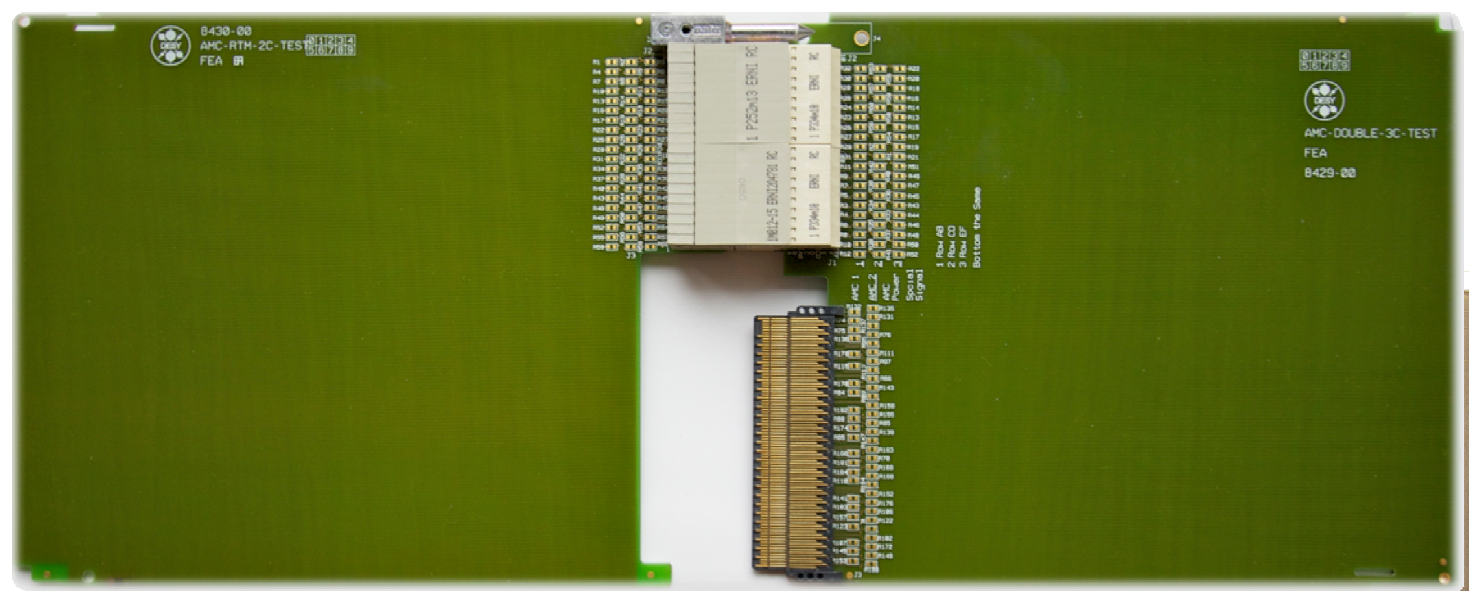
Custom CC RTM
DAMC2
RTM Conn.
8x/16x RJ45
FMC Optional for external signals
FEE Clock (99MHz)
Command
Veto
Status
Backplane
Veto
Veto
xTCA mid-size/double-width AMC
Fig ZZZ CC module, with DAMC2 and custom RTM.

Current idea of using the DAMC2 board with a custom RTM as the CC board. The current design for the DAMC2 board includes 54 differential pair signals connected between the FPGA and the RTM connector. One pair is dedicated to a clock from the clock generation part.

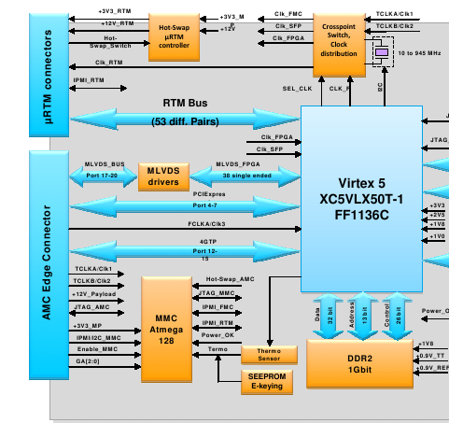

Suitability and Possible Issues

The amount of differential pairs that a CC RTM needs depends on the number of CC slaves supported. Each slave requires 3 input pairs (including the 99MHz clock) and 1 output pair for status. If 16 CC slaves would be supported by a single CC master, there is a need for 64 differential pairs of signals.
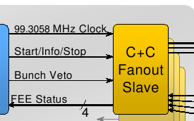

This is obviously higher than 53.

Solution:

If the dedicated clock connection from the clock gen/distribution part of the DAMC2 is used and this clock is distributed to the slaves then the number of pairs needed becomes 48.

Issues here:

- According to the clock and control fast signal specification document there is an option of skewing the command lines (Start/Info/Stop and Bunch Veto) with respect to the 99MHz clock. Would this be possible?
  - The solution could be using the FPGA to generate the 99MHz clock and using the clock block of DAMC2 as a zero-delay clock buffer. The individual fast command lines can be skewed accordingly.
  - Does the clock block of DAMC2 offer this functionality?
  - According to this solution all the slaves should get the same clock. Which leads on to...

- There is a need for a clock distribution/buffer circuitry on the RTM to supply 16 clocks to the slaves and there should be no skew or phase difference between these clocks.

- There will be a skew between the data lines going out to the RTM unless all 54 pairs have the same trace lengths. These might have to be compensated on the FPGA.

Furthermore, the status signal may not have to be differential. However, this depends on what kind of functionality should be implemented by this signal.

More information is needed on the clock generation/distribution block of the DAMC2. There is a plan to generate the 99MHz clock form the 4.5MHz bunch clock using an external PLL. Alternatively, this clock can also be generated by the FPGA's own PLL.

The rough block diagram of the CC RTM should look like the diagram below.
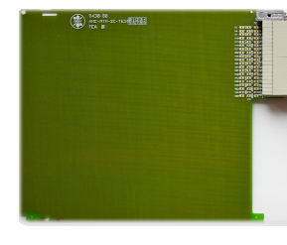
Clock Buffer +
MLVDS driver
RJ45 connectors
LVDS drivers/receivers
RJ45 connectors

New TR card with CC RTM

There is a talk of a new TR card being developed that would support an RTM. This card might be used as a CC card if the TR board offers similar flexibility as the DAMC2 card.

Connections to the RTM: There would have to be no fewer than 53 differential pairs between the FPGA and the RTM connector. Furthermore, at least one pair dedicated to a clock from a flexible clock generation circuitry (PLL/zero-delay switch/FPGA clock connection/crystal)
FMC connector for front panel I/O signals, clock(s). (Clock/Trigger/Laser/Spare)
Possible pin compatibility with the DAMC2 RTM connector. Only one CC RTM to design.

Telegram Distribution Concerns

According to the TR specification a 108 MHz encoded clock will have the telegram data that the CC requires. We have preliminarily decided the telegrams to be
- Start Train
- Train Number
- End Train
- Bunch Pattern Index
- Bunch Pattern Content

The scheme for encoding the data is not determined yet. This will also depend on the encoding of data on the 1.3GHz clock line from the timing transmitter. There are various encoding schemes including Manchester and 8B/10B.

The telegram data will be written to designated registers on the FPGA. There is also an option that these registers might be written by the CPU card over PCIe. (Don't know if this is the case)

The ideal case for CC involves receiving data and its 108 MHz clock sent by the TR in a source-synchronous manner. This would simplify extraction of the telegram data. If this will not be the case then there will be a need for data recovery logic on the FPGA (we don't need to recover the 108 MHz clock) the details of which will be defined by the encoding scheme.

Crate layout and card connector modularity
A crate will contain TR, PC(+harddisk), MPS and the CC system. All cards are double-width, mid-size, which defines the front (rear) panel space.

Crates are available in 6 and 12 slot options. This is defined by xTCA4Physics spec and we will stick to it!
.
A mid-size RTM will only allow 8 of our chosen connector per slot. This could mean we would need 2 slots per 1 Mpix 2D detector. 4Mpix will fill 8 slots in the crate (and require 8x DAMC2). And alternativec we can use a 2 slot wide RTM and populate every second slot. See diagram below.

1
2
3
4
5
6
7
8
9
10
11
12
DAMC2
DAMC2
DAMC2
DAMC2
CC RTM
CC RTM
CC RTM
CC RTM
DAMC2
MCH
MCH
Front
Rear
Slot
FEE
16
FEE
16
FEE
16
FEE
16
CC RTM
CC RTM
FEE
16
FEE
16
TR
CPU
DAMC2
MPS
Although we will evaluate the design presuming 16 FEE connectors per slot, a first prototype might only have 8.

Ideally a 12 slot crate should be able to support 4-8Mpix.

Operating Modes (Use Cases)
To help understand the decisions taken, the most likely use cases are outlined.

XFEL Running
TR receives machine clock and telegram. The local clocks and telegram are derived from this and distributed to the crate.
The CC system processes and distributes these to the FEEs

Hierachy: Machine -> TR -> CC -> FEE

TR Standalone and Testing
(??? Could this mode also be similar to smallDAQ?)
In the mode the TR generates signalling as if connected to the machine. This will allow testing and debugging of a Timing crate.
Another option is to presume a machine emulator exists to drive a TR (probably another TR with different firmware) – if so, we need to conister space in the crate.

Hierachy: Software -> TR -> CC -> FEE

Standalone
We don’t make telegrams!

WITHOUT Timing Receiver (no external inputs)
Generate Bunch Clock
Generate FEE Clock (99MHz)
Generate Start/End (in Bunch clock steps)
Generate Output Trigger for external device
Programmable delay wrt Start Signal (in BC steps + ~1ns steps)
Front-panel outputs, using an FMC.
Generate Reset
Generate Veto (from veto input)
Sequencer
FEE Internal Calibration
Must set internal delays wrt Start Signal (sub BC step)

Hierachy: Software -> CC -> FEE

Other Beamlines

Hierachy: Other Machine -> TR -> CC -> FEE

Timing Receiver Requirements
Sdaas

Local oscillator for stand alone test operation
Capability for stand-alone backplane signals generation
(we could contribute firmware??)
Discussion needed regarding encoding of telegram
Any way around avoiding distributing 108MHz?
Can we revisit TR using our 99MHz?
External Inputs (LVDS/LVTTL) (Front-panel or RTM?) – min required 4?
Clock
Trigger
Laser
Spare
Required telegrams
Start Train (>15ms before train)
Train Number (incrementing)
End Train (?ms after/before?)
Bunch Pattern Index
Bunch Pattern Content (actually distributed by Control – not on CC Command line)
EncClock protocol?
We might suggest Manchester, but is the half BW a problem?
Separate clock + data lines??
BunchClock
Must be continuous (and no phase changes)
Is the RTM in any way similar to the DAMC2 (e.g. is the clock on the same pin)?
APD/PETRA
Local logic: Generate bunch clock from orbit trigger input

References

Bunch Veto
Other
Beamline
XFEL
Timing Receiver
Trig/Telegram
CC Slave
Trig/Data
1-20MHz Clock
CC
Slave
FEE
4.5 Mhz Bunch Clock
FEE
C+C Fanout
CC Master
Status
Veto
Command
FEE Clock (99 MHz)
Crate PC

