Clock and Control Implementation for 2D Pixels
Erdem Motuk, Martin Postranecky, Matt Warren, Matthew Wing, Chris Youngman

1 Introduction 1
2 Detailed CC Structure 2
2.1 Topology 3
2.1.1 “Downward” (FEE) facing signalling 3
2.1.2 “Upward” facing signalling 3
2.2 FEE Connector choice – RJ45 3
3 Crate Connectivity 3
3.1 FEE Clock 4
3.2 Bunch Clock 4
3.3 Trig/Start (RX17) 5
3.4 EncClock (TX17) 5
3.5 BunchClock (RX18) 5
3.6 Spare (TX18) 5
3.7 Reset (RX19) 5
3.8 CC Command (TX19) 5
3.9 CC Veto (RX20) 5
3.10 CC Status (TX20) 5
4 Clock and Control Hardware Specifics 5
4.1 Suitability and Possible Issues 6
4.2 New TR card with CC RTM 8
4.3 Telegram Distribution Concerns 8
5 Crate layout and card connector modularity 9
6 Operating Modes (Use Cases) 10
6.1 XFEL Running 10
6.2 TR Standalone and Testing 10
6.3 Standalone 10
6.4 Other Beamlines 10
7 Typical Run Timeline 10
8 Timing Receiver Questions and Requirements 11
9 Control software 11
10 Veto Sub-system 12
11 CC Hardware requirements 12
12 Timelines 12
13 References 13

Introduction
The Clock and Control (CC) system for the 2D pixel detectors at XFEL must integrate with “neighbouring” systems and XFEL standard configurations. Areas of focus are the crate/backplane standard chosen, the interface to the machine and requirements of the 2D pixel detectors.

A schematic of the system is shown below. All CC electronics is housed in one or multiple xTCA “Timing” crates. The crate backplane provides interconnect between CC and other components, as well as a CPU, disc, networking etc.

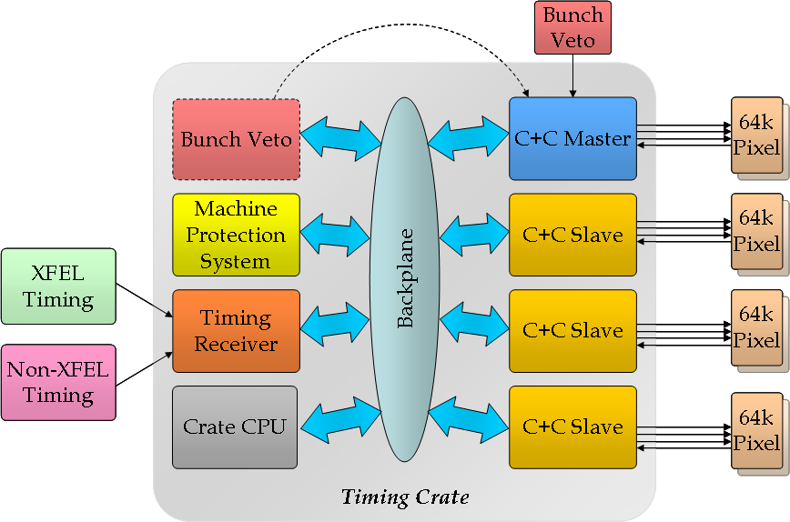
Fig zzz: Overall Timing Crate Structure

The CC must be able to operate standalone for testing purposes, and as part of a larger machine infrastructure. The machine interface is provided by the Timing Receiver (TR) board. Other machine interface boards (e.g. for the Machine Protection System) can also be located in the Timing crate.

The CC system (a sub-component of Timing) comprises a “master” and a number of slaves (if needed). Slave hardware is identical to master hardware, but in some areas, e.g. clock generation, we need to have only one source, so the master will transmit, and the slaves receive. This will be configurable by software.

Detailed CC Structure
Detail on CC signals and connections:

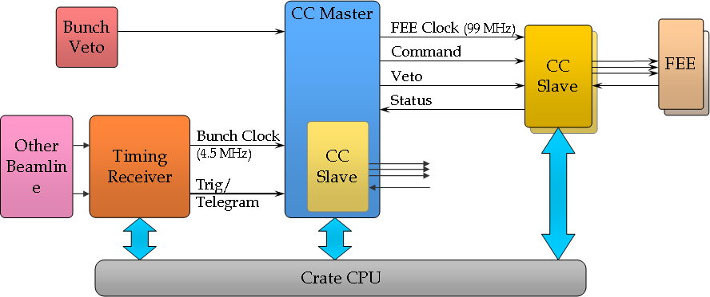

Topology
Master/Slave detail

“Downward” (FEE) facing signalling
- FEE Clock
- Command
- Veto
- Status
- Trigger Output

“Upward” facing signalling
- Bunch Clock
- Start
- PCIe
- External Clock

FEE Connector choice – RJ45
blah

Crate Connectivity
The Timing crate will be of the xTCA format, with a backplane and layout as per the xTCA4Physics specification. The backplane provides the connectivity required between the crate-PC, Timing Receiver, CC boards. Many of the lines are reserved exclusively for CC functions in the Timing crate.
Backplane signalling is split into two type:
- Star mesh clock lines (TCLKA/TCLKB) that connect to a cross-point switch on the MCH. This allows any card in the crate to be configured (by software) to source a clock for use by all the other cards.
- Bussed lines (RX17-TX20) that use the M-LVDS standard to provide high-speed connections with the option of open-collector like operation if needed.

The table below shows the signals available, and their allocated functions in a CC crate.

< table of signals etc. >

The figure below shows these connections pictorially giving more detail on direction and source.

??? We need to be clear on which signal are expected by the other non-CC cards in the crate (so far I think it is only the MPS) ???
Most of the TR signals are user definable, although using a “standard” configuration is desirable if possible.

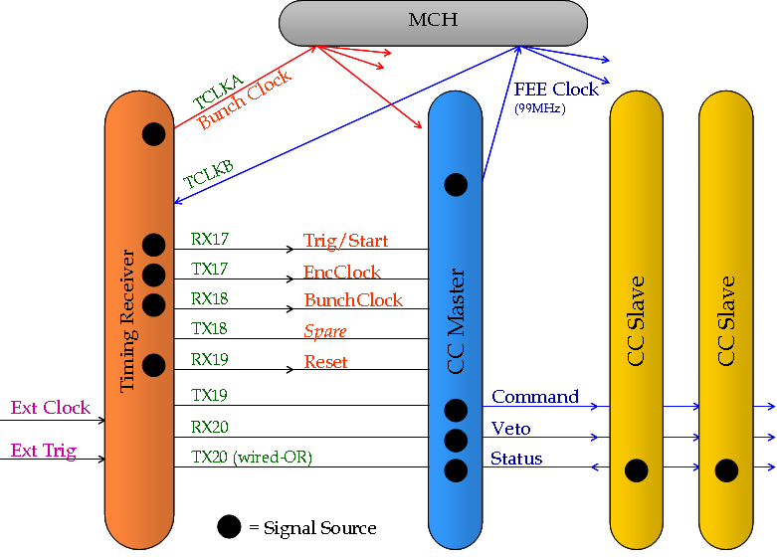
Fig ZZZ: Diagram showing crate connections

Specifically:

FEE Clock
We will use TCLKA to broadcast the 2D detector specific FEE Clock (99MHz). The source of these will be either a CC board configured as Master, or the TR, depending on mode of operation.
[NOTE to selves: the master will need to deskew own clock when using TCLK to broadcast to slaves!]

Bunch Clock
We will use TCLKB to broadcast the Bunch Clock. The source of these will be either a CC board configured as Master, or the TR, depending on mode of operation.
[NOTE to selves: the master will need to deskew own clock when using TCLK to broadcast to slaves!]

Trig/Start (RX17)
Synchronous with the bunch train and bunch clock, this signal indicated at train will arrive a fixed number of bunch clock periods later. This is used bt the CC to synchronise all FEEs.

EncClock (TX17)
Used to transfer to broadcast the telegram from the TR to other cards in the crate.
Protocol is undecided, but it is hoped to use the FEE Clock for this transfer.
The original ide is to encode with clock (e.g. Manchester) but this could be abandoned if another clock can be chosen.

< more more more >

BunchClock (RX18)
What it says on the tin. We don’t need this, - redefine as TelegramClock?

Spare (TX18)
Errrr, spare!

Reset (RX19)
Timing Reset. “Depth” of reset need to be clarified???

CC Command (TX19)
Distributes FEE Command signalling.

CC Veto (RX20)
Distributes FEE Veto signalling.

CC Status (TX20)
If a slave flags an error the master could stop issuing starts (configurable by software)

Clock and Control Hardware Specifics
Will use the DAMC2, with custom RTM, and optionally custom FMC for external inputs.

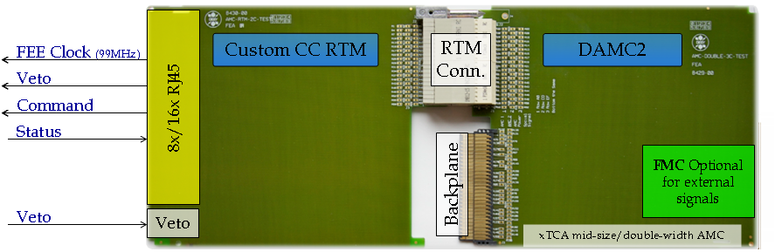
Fig ZZZ CC module, with DAMC2 and custom RTM.

Current idea of using the DAMC2 board with a custom RTM as the CC board. The current design for the DAMC2 board includes 54 differential pair signals connected between the FPGA and the RTM connector. One pair is dedicated to a clock from the clock generation part.

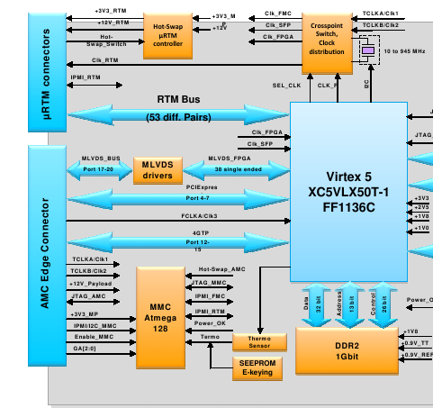

Suitability and Possible Issues

The number of differential pairs that a CC RTM needs depends on the number of CC slaves supported. Each slave requires 3 input pairs (including the 99MHz clock) and 1 output pair for status. If 16 CC slaves would be supported by a single CC master, there is a need for 64 differential pairs of signals.
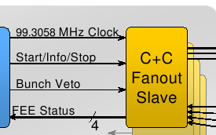

This is obviously higher than 53.

Solution:

If the dedicated clock connection from the clock gen/distribution part of the DAMC2 is used and this clock is distributed to the slaves then the number of pairs needed becomes 48.

Issues here:

- According to the clock and control fast signal specification document there is an option of skewing the command lines (Start/Info/Stop and Bunch Veto) with respect to the 99MHz clock. Would this be possible?
  - The solution could be using the FPGA to generate the 99MHz clock and using the clock block of DAMC2 as a zero-delay clock buffer. The individual fast command lines can be skewed accordingly.
  - Does the clock block of DAMC2 offer this functionality?
  - According to this solution all the slaves should get the same clock. Which leads on to...

- There is a need for a clock distribution/buffer circuitry on the RTM to supply 16 clocks to the slaves and there should be no skew or phase difference between these clocks.

- There will be a skew between the data lines going out to the RTM unless all 54 pairs have the same trace lengths. These might have to be compensated on the FPGA.

Furthermore, the status signal may not have to be differential. However, this depends on what kind of functionality should be implemented by this signal.

More information is needed on the clock generation/distribution block of the DAMC2. There is a plan to generate the 99MHz clock form the 4.5MHz bunch clock using an external PLL. Alternatively, this clock can also be generated by the FPGA's own PLL.

The rough block diagram of the CC RTM should look like the diagram below.

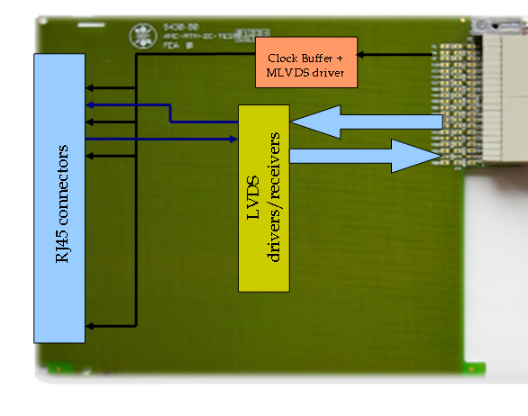

New TR card with CC RTM
There is a talk of a new TR card being developed that would support an RTM. This card might be used as a CC card if the TR board offers similar flexibility as the DAMC2 card.

Connections to the RTM: There would have to be no fewer than 53 differential pairs between the FPGA and the RTM connector. Furthermore, at least one pair dedicated to a clock from a flexible clock generation circuitry (PLL/zero-delay switch/FPGA clock connection/crystal)
FMC connector for front panel I/O signals, clock(s). (Clock/Trigger/Laser/Spare)
Possible pin compatibility with the DAMC2 RTM connector. Only one CC RTM to design.

Telegram Distribution Concerns
According to the TR specification a 108 MHz encoded clock will have the telegram data that the CC requires. We have preliminarily decided the telegrams to be
- Start Train
- Train Number
- End Train
- Bunch Pattern Index
- Bunch Pattern Content

The scheme for encoding the data is not determined yet. This will also depend on the encoding of data on the 1.3GHz clock line from the timing transmitter. There are various encoding schemes including Manchester and 8B/10B.

The telegram data will be written to designated registers on the FPGA. There is also an option that these registers might be written by the CPU card over PCIe. (Don't know if this is the case)

The ideal case for CC involves receiving data and its 108 MHz clock sent by the TR in a source-synchronous manner. This would simplify extraction of the telegram data. If this will not be the case then there will be a need for data recovery logic on the FPGA (we don't need to recover the 108 MHz clock) the details of which will be defined by the encoding scheme.

Crate layout and card connector modularity
A crate will contain TR, PC(+harddisk), MPS and the CC system. All cards are double-width, mid-size, which defines the front (rear) panel space.

Crates are available in 6 and 12 slot options. This is defined by xTCA4Physics spec and we will stick to it!
.
A mid-size RTM will only allow 8 of our chosen connector per slot. This could mean we would need 2 slots per 1 Mpix 2D detector. 4Mpix will fill 8 slots in the crate (and require 8x DAMC2). And alternativec we can use a 2 slot wide RTM and populate every second slot. See diagram below.

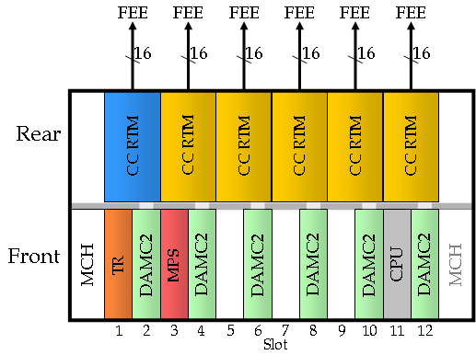
Although we will evaluate the design presuming 16 FEE connectors per slot, a first prototype might only have 8.

Ideally a 12 slot crate should be able to support 4-8Mpix.

Operating Modes (Use Cases)
To help understand the decisions taken, the most likely use cases are outlined.

XFEL Running
TR receives machine clock and telegram. The local clocks and telegram are derived from this and distributed to the crate.
The CC system processes and distributes these to the FEEs

Hierarchy: Machine -> TR -> CC -> FEE

TR Standalone and Testing
(??? Could this mode also be similar to smallDAQ?)
In the mode the TR generates signalling as if connected to the machine. This will allow testing and debugging of a Timing crate.
Another option is to presume a machine emulator exists to drive a TR (probably another TR with different firmware) – if so, we need to conister space in the crate.

Hierarchy: Software -> TR -> CC -> FEE

Standalone
The is a the situation where we do not use a TR at all (no external inputs)
So we must:
- Generate Bunch Clock
- Generate FEE Clock (99MHz)
- Generate Start/End (in Bunch clock steps)
- Generate Output Trigger for external device
  - Programmable delay wrt Start Signal (in BC steps + ~1ns steps)
  - Front-panel output, using an FMC.
- Generate Reset
- Generate CC Veto (from veto input)
- Sequencer
  - Need to decide at what level this operates – bits in serial streams or slightly higher.
We need NOT handle:
    - FEE Internal Calibration
  - FEEs (not CC) must set internal delays wrt Start Signal (sub BC step)

Hierarchy: Software -> CC -> FEE

Other Beamlines

Hierarchy: Other Machine -> TR -> CC -> FEE

Typical Run Timeline
Need to recover the original ideas concerning DAQ sequencing (RC,etc.). What we shoud do is document the time history of all actions we are expecting during a run.

Timing Receiver Questions and Requirements
Means of running standalone, using one of the following
- local oscillator with local telegram generation
- additional frontpanel osc input with local telegram signal generation
- additional machine emulator board to drive the TR (do we need to reserve a slot)

Need to finalise encoding of telegram and transmission in crate
- presume we must use the 108MHz clock
- Manchester has a huge bandwidth hit.
- Is there room for a simple 2 line solution: clock + data

Finalise “global” backplane signals
- we would like to conform to any “standard” layout where possible

External Inputs (LVDS/LVTTL) (Front-panel or RTM?) – min required 4?
- Clock
- Trigger
- Laser
- Spare

Required telegrams
- Start Train (>15ms before train)
- Train Number (incrementing)
- End Train (?ms after/before?)
- Bunch Pattern Index
- Bunch Pattern Content (actually distributed by Control – not on CC Command line)

Interrupts
- The crate CPU control software will need an interrupt to signify train coming so that correct configuration of the DAQ and its subsystems can be verified. This has to be generated as soon as possible after the end train. It cannot be the end train as this would mean the first train would be lost.

BunchClock
- Must be continuous (and no phase changes)

Does the TR have an RTM?
- Is the pinout in any way similar to the DAMC2 (e.g. is the clock on the same pin)?

Control software
We need an additional slide “control software” explaining the requirements on the CPU’s control software. Here are some starting points:
- Interaction with master
  - Read CSRs
  - Read counters
  - Write CSRs
  - Clear counters
  - …
- Interaction with slaves:
  - Same as master?
  - …
- Interaction with TR
  - Read out stored telegram data – how to synch. To this as changes
  - Stop and start TR operation – what is possible
  - Writing control options – enabling interrupts, etc.
  - …

Veto Sub-system
Thoughts about putting into a separate crate:
  - Would require a VETO input line into the master
  - Requires VETO separate crate to have an output (obvious)
  - Vetoing is anyway asynch to BC in CC
  - Laser input we were discussing is not a veto it’s more a flag/marker

CC Hardware requirements
CC hardware requirements
- xTCA Crate (~5 slot job)
- >= 1 TR board + working firmware
- >= 1 DAMC2 + working firmware

Timelines

NOW:
- Discussions with RAL re RTM project
- Finalise design
+2 weeks
- Distribute to FEE+TB+TR+FEA groups
+2 weeks:
- assimilate feedback = FINAL design
+ 1 week
- Firmware development with eval board of telegram encoder/decoder
September
- RAL starts RTM design
- TR available (2 for WP76, later 1 to UCL)
- TB/CC meeting
  - CC design review (freeze)
  - Prioritised list of telegrams for TR group.
- WP76 gets Crate+ADC+TR
  - Control software (i.e. configure TR) + ADC firmware work
  - Firmware development overlap with CC (invitation to UCL)
January
- DAMC2

References

