DAMC2 with CC RTM

Current idea of using the DAMC2 board with a custom RTM as the CC board. The current design for the DAMC2 board includes 54 differential pair signals connected between the FPGA and the RTM connector. One pair is dedicated to a clock from the clock generation part.

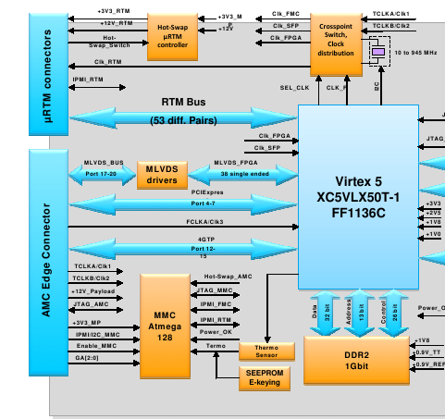

Suitability and Possible Issues

The amount of differential pairs that a CC RTM needs depends on the number of CC slaves supported. Each slave requires 3 input pairs (including the 99MHz clock) and 1 output pair for status. If 16 CC slaves would be supported by a single CC master, there is a need for 64 differential pairs of signals.
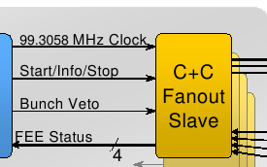

This is obviously higher than 53.

Solution:

If the dedicated clock connection from the clock gen/distribution part of the DAMC2 is used and this clock is distributed to the slaves then the number of pairs needed becomes 48.

Issues here:

- According to the clock and control fast signal specification document there is an option of skewing the command lines (Start/Info/Stop and Bunch Veto) with respect to the 99MHz clock. Would this be possible?
  - The solution could be using the FPGA to generate the 99MHz clock and using the clock block of DAMC2 as a zero-delay clock buffer. The individual fast command lines can be skewed accordingly.
  - Does the clock block of DAMC2 offer this functionality?
  - According to this solution all the slaves should get the same clock. Which leads on to...

- There is a need for a clock distribution/buffer circuitry on the RTM to supply 16 clocks to the slaves and there should be no skew or phase difference between these clocks.

- There will be a skew between the data lines going out to the RTM unless all 54 pairs have the same trace lengths. These might have to be compensated on the FPGA.

Furthermore, the status signal may not have to be differential. However, this depends on what kind of functionality should be implemented by this signal.

More information is needed on the clock generation/distribution block of the DAMC2. There is a plan to generate the 99MHz clock form the 4.5MHz bunch clock using an external PLL. Alternatively, this clock can also be generated by the FPGA's own PLL.

The rough block diagram of the CC RTM should look like the diagram below.

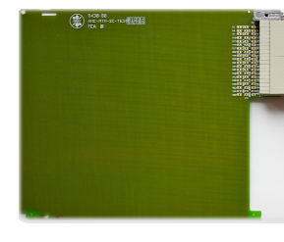
Clock Buffer +
MLVDS driver
RJ45 connectors
LVDS drivers/receivers
RJ45 connectors

New TR card with CC RTM

There is a talk of a new TR card being developed that would support an RTM. This card might be used as a CC card if the TR board offers similar flexibility as the DAMC2 card.

- Connections to the RTM: There would have to be no fewer than 53 differential pairs between the FPGA and the RTM connector. Furthermore, at least one pair dedicated to a clock from a flexible clock generation circuitry (PLL/zero-delay switch/FPGA clock connection/crystal)
- FMC connector for front panel I/O signals, clock(s). (Clock/Trigger/Laser/Spare)
- Possible pin compatibility with the DAMC2 RTM connector. Only one CC RTM to design.

Telegram Distribution Concerns

According to the TR specification a 108 MHz encoded clock will have the telegram data that the CC requires. We have preliminarily decided the telegrams to be
- Start Train
- Train Number
- End Train
- Bunch Pattern Index
- Bunch Pattern Content

The scheme for encoding the data is not determined yet. This will also depend on the encoding of data on the 1.3GHz clock line from the timing transmitter. There are various encoding schemes including Manchester and 8B/10B.

The telegram data will be written to designated registers on the FPGA. There is also an option that these registers might be written by the CPU card over PCIe. (Don't know if this is the case)

The ideal case for CC involves receiving data and its 108 MHz clock sent by the TR in a source-synchronous manner. This would simplify extraction of the telegram data. If this will not be the case then there will be a need for data recovery logic on the FPGA (we don't need to recover the 108 MHz clock) the details of which will be defined by the encoding scheme.

