Clock and Control Implementation for 2D Pixels

Erdem Motuk, Martin Postranecky, Matt Warren, Matthew Wing, Chris Youngman

( DRAFT Version 2-0 dated 07-07-2010 )

1 Introduction 2
2 Detailed CC Structure 2
2.1 Topology 3
2.1.1 CC-Master to / from CC-Slave signalling 3
2.1.2 CC-Master to/from TR / VETO / Crate CPU signalling 3
2.2 FEE Connector choice – RJ45 4
3 Crate Connectivity 4
3.1 FEE Clock (TCLKB) 5
3.2 Bunch Clock (TCLKA) 5
3.3 Trig/Start (RX17) 6
3.4 EncClock (TX17) 6
3.5 BunchClock (RX18) 6
3.6 Spare (TX18) 6
3.7 Reset (RX19) 6
3.8 CC Command (TX19) 6
3.9 CC Veto (RX20) 6
3.10 CC Status (TX20) 6
4 Clock and Control Hardware Specifics 6
4.1 Suitability of the DAMC2 8
4.1.1 RTM Connections and Clocking 8
4.1.2 Proposed clocking Solutions 11
4.2 Telegram Distribution 12
5 Crate layout and card connector modularity 13
6 Operating Modes (Use Cases) 13
6.1 XFEL Running 13
6.2 TR Standalone and Testing 14
6.3 Standalone 14
6.4 Other Beamlines 14
7 Typical Run Timeline 14
8 Timing Receiver TR - CC Requirements 17
9 DAMC2 - CC Requirements 18
10 Control software 19
11 Veto Sub-system 19
12 CC Hardware requirements 19
13 Firmware required 19
14 Timelines 19
15 References 20

Introduction
The Clock and Control (CC) system for the 2D pixel detectors at XFEL must integrate with “neighbouring” systems and XFEL standard configurations. Areas of focus are the crate/backplane standard chosen, the interface to the machine and requirements of the 2D pixel detectors.

A schematic of the system is shown below. All CC electronics is housed in one or multiple xTCA “Timing” crates. The crate backplane provides interconnect between CC and other components, as well as a CPU, disc, networking etc.

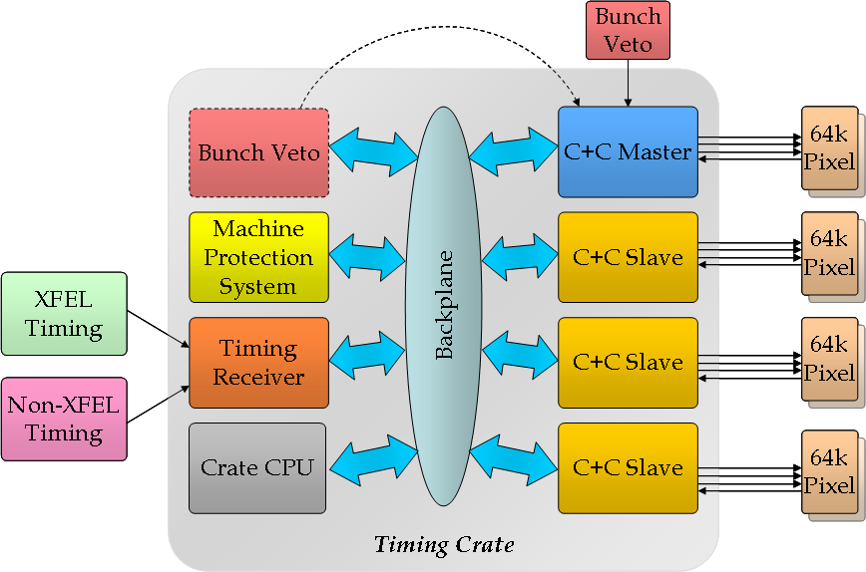
Fig 1: Overall Timing Crate Structure

The CC must be able to operate standalone for testing purposes, and as part of a larger machine infrastructure. The machine interface is provided by the Timing Receiver (TR) board. Other machine interface boards (e.g. for the Machine Protection System) can also be located in the Timing crate.

The CC system (a sub-component of Timing) comprises a “Master” and a number of “Slaves” (if needed). CC Slave hardware is identical to CC Master hardware, but in some areas, e.g. clock generation, we need to have only one source, so the CC Master will transmit, and the CC Slaves receive. This will be configurable by software.

Detailed CC Structure
Detail on CC signals and connections:

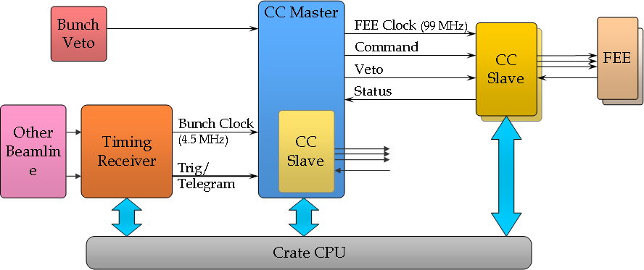

Fig 2: Detailed CC connections

Topology
Master/Slave detail

CC-Master to / from CC-Slave signalling
- FEE Clock
- Command
- Veto ( We can support the two different (BC and 99MHz) modes in one crate. The 99MHz is always sent and conversion to BC type can be performed by the slave. This will allow operating LPD and AGIPD detectors from 1 crate)
- Status
- ‘Calibration Trigger’ Output to trigger any calibration device used by FEE. (This is for test calibration use only) This signal will be synchronous to the bunch clock. Furthermore it will have the capability to be delayed. The connection can be diff. LVDS from the FMC or a dedicated connector for a single-ended output (e.g. NIM ??). Discuss with users ??.

CC-Master to/from TR / VETO / Crate CPU signalling
- Bunch Clock (when TR in crate and used)
- Start/Trig -ditto-
- Telegram -ditto-
- PCIe
- Reset -ditto-
- Spare -ditto-
- Bunch Veto (from VETO card)

FEE Connector choice – RJ45

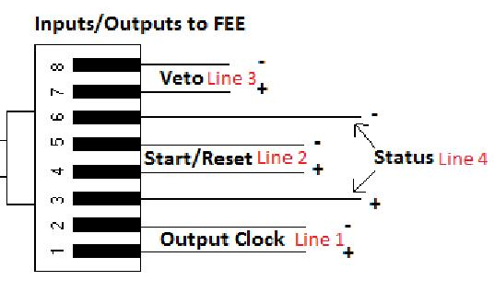
Fig 3: Pin connections on the RJ45 connectors

Actual connectors to be used are Tyco 2x8 double-stack parts.
See : http://www.tycoelectronics.com/catalog/products/en?q=6116317-2

Crate Connectivity
The Timing crate will be of the xTCA format, with a backplane and layout as per the xTCA4Physics specification. The backplane provides the connectivity required between the crate-PC, Timing Receiver, CC boards. Many of the lines are reserved exclusively for CC functions in the Timing crate.
Backplane signalling is split into two types:
- Point-2-point : Two clock lines (TCLKA and TCLKB) that connect to a cross-point switch on the MCH. This allows any card in the crate to be configured (by software) to source a clock for use by all the other cards.
- Bussed: lines (RX17-TX20) that use the M-LVDS standard to provide high-speed connections with the option of open-collector like operation if needed.

The table below shows the bussed and p2p signals used, and their allocated functions in a CC crate.

Port | Name | Description
TCLKB | FEC | 99.8 MHz FEE clock
TCLKA | BC | Bunch clock (usually 4.51 MHz)
Rx17 | Trig (Start) | See section 3.3
Tx17 | EncClock | Preferably data only (See section 3.4)
Rx18 | BunchClock | Preferably 108 MHz telegram clock  (See section 3.5)
Tx18 | Spare
Rx19 | Reset | See section 3.7
Tx19 | CC Command | See section 3.8
Rx20 | CC Veto | See section 3.9
Tx20 | CC Status | See section 3.10

The figure below shows these connections pictorially giving more detail on direction and source.

We need to be clear on which signals are expected by the other non-CC cards in the crate ( e.g. MPS )
Consult non-CC cards owners

Most of the TR signals are user definable, although using a “standard” configuration is desirable if possible.

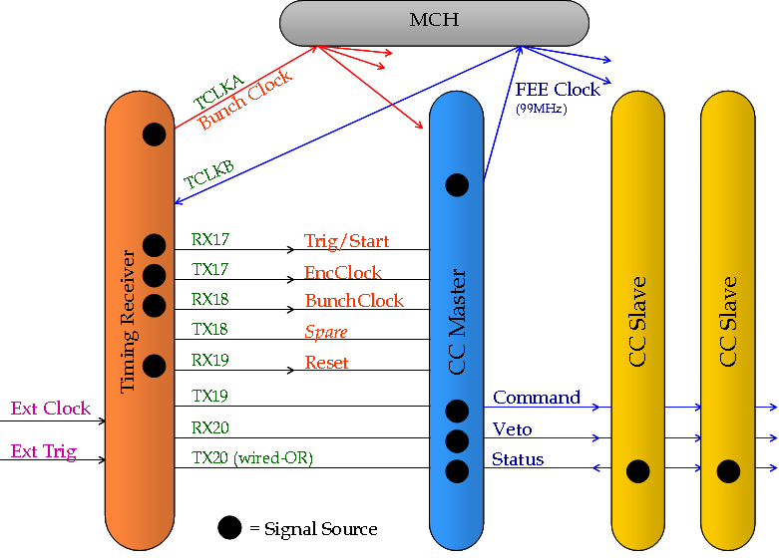
Fig 4: Diagram showing crate connections

Specifically:

FEE Clock (TCLKB)
We would prefer TCLKB to broadcast the 2D detector specific FEE Clock (99MHz).
The alternatives for the generation of the FEE clock from the Bunch Clock are discussed In section 4.1.2. In stand-alone mode the FEE clock is generated on CC RTM.

Bunch Clock (TCLKA)
The Bunch Clock will be broadcast on TCLKA. The source of these will be either the TR, or a CC board configured as Master, depending on the mode of operation.

Trig/Start (RX17)
Synchronous with the bunch train and bunch clock, this signal indicates that a train will arrive a fixed number of bunch clock periods later. This is used by the CC to synchronise all FEEs.

EncClock (TX17)
Used to broadcast the telegram from the TR to other cards in the crate.
Protocol is undecided, but it is hoped to use the FEE Clock for this transfer.
The original idea is to encode with clock (e.g. Manchester) but this could be abandoned if another clock can be chosen. (see sections 3.5 and 8)

BunchClock (RX18)
What it says on the tin. As we don’t need this (Bunch Clock is distributed p2p as TCLKA) – we would like to redefine this as the TelegramClock (108MHz). This needs implementation on TR. (see sections 3.4 and 8)

Spare (TX18)
Spare… Could be used for an alternative clock distribution - see section 4.1.2

Reset (RX19)
Timing Reset. This is generated by TR. This signal can be used as a “TR OK” signal by the CC system. This signal will indicate whether there is a loss of functionality in the TR. (e.g. 1.3GHz clock lost). According to this signal:
- The CC system might take necessary measures not to disrupt FEE operation.
- Clear internal counters and registers for a possible restart condition.
(Consulting Kay R. for definition of TR Reset)
In addition, the CC cards will also be reset from crate CPU (functionality not yet defined). For stand-alone and test purposes, the CC card will have a ‘hard’ hardware reset from front panel switch.
The backup (stand-alone) clock generated on CC will ensure that the 99MHz clock is never interrupted in powered crate.

CC Command (TX19)
Distributes FEE Command signalling.

CC Veto (RX20)
Distributes FEE Veto signalling.

CC Status (TX20)
If a CC Slave flags an error the CC Master could stop issuing starts (configurable by software). Will be a wired-OR line from all CC Slaves

Clock and Control Hardware Specifics

We propose to use the DAMC2, with custom RTM, and optionally custom FMC for external I/O..

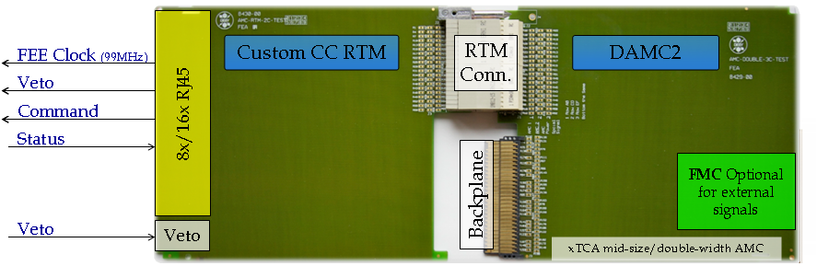
Fig 5: CC module, with DAMC2 and custom RTM.

The current design for the DAMC2 board includes 54 differential pair signals connected between the DAMC2 FPGA and the RTM connector. One pair is dedicated to a clock which is an output of the crosspoint switch. (4.5MHz TCLKA distribution ).

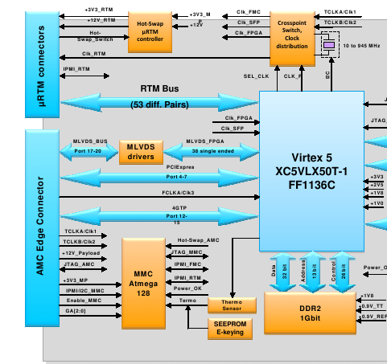
Fig 6: DAMC2 block diagram (uRTM and AMC connector section)

Suitability of the DAMC2

RTM Connections and Clocking

The number of differential pairs that a CC RTM needs depends on the number of CC FEEs supported. Each FEE requires 3 input pairs ( including the 99MHz clock ) and 1 output pair for status. If 16 FEEs would be supported by a single CC card, there is a need for 64 differential pairs of signals. However, the differential clock to each FEE does not need to originate from the DAMC2 card, hence 16 pairs will not be needed. The dedicated clock line from the DAMC2 is going to be used for transmitting the clock to the RTM. The number of signal pairs needed then becomes 48.

Furthermore, the status signal from each FEE may not need to be differential. This depends on what kind of functionality will be implemented by this signal.
The remaining signal lines will be used either as differential pairs or single-ended for RTM functions. Figure 8 shows a rough block diagram of the FEE connections on the RTM.

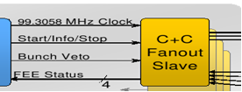
Fig 7: Signals to a CC slave

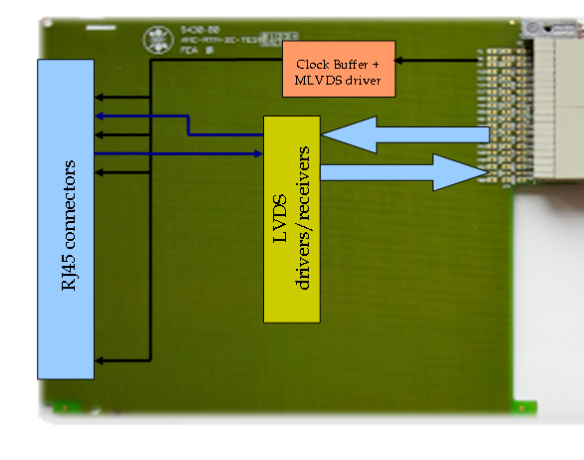
Fig 8: CC RTM

The requirements for the connections on the RTM are:

- According to the clock and control fast signal specification document there is an option of skewing the command lines ( Start/Info/Stop and Bunch Veto ) with respect to the 99MHz clock.

- There is a need for a clock distribution/buffer circuitry on the RTM to supply 16 clocks to the FEEs and there should be no skew or phase difference between these clocks.

- There will be a skew between the data lines going out to the RTM unless all 54 pairs have the same trace lengths. These might have to be compensated on the DAMC2 FPGA.

The initial clocking scheme considered is shown in figure 9. This scheme presents an ideal case for clock distribution on the CC crate. The clocking scheme that will be chosen is limited by the current capabilities of the DAMC2 card which are:

  - DAMC2 clock distribution circuitry consists of an I2C controlled XO and a 4x4 crosspoint switch (figure 10).
  - XO can generate any-rate programmable frequencies from 10 MHz to 945 MHz and select frequencies up to 1.4 GHz. (according to the schematic part 10-810 MHz)
  - The start-up frequency for the part is 118 MHz. (according to the schematic part)
  - The crosspoint switch can route any of the four inputs to any of the four outputs and also can act like a low jitter clock fan-out buffer.
  - The diagram in figure 10 shows the clock distribution circuitry.
  - TCLKs are inputs to the DAMC2 card. The card doesn’t have the capability to drive them according to the specs.

TCLKA (4.5MHz Bunch)
TCLKB (99MHz FEE)
99MHz FEE
CLOCK GEN/SWITCH
XTCA BACKPLANE
PLL
99MHz FEE
99MHz FEE
4.5MHz
Currently not possible on DAMC2?
Would this be better? Sorting out the skew between master and slave cards
Only a PLL or PLL+zero delay buffer/fanout?

Fig 9: Initial clocking scheme

XO
X-POINT
SWITCH
FPGA CLK
FMC CLK
SFP CLK
RTM CLK
CLK1-FPGA
OSC CLK
TCLK2
TCLK1

Fig 10: DAMC2 clocking distribution

The issues that arise from the current capabilities of the DAMC2 card can be summarised as below:

- There doesn't seem to be a PLL on the DAMC2 card. We need to generate the 99 MHz clock from the 4.5 MHz bunch clock by an external PLL.
- The PLL can be on the RTM. However, this clock would have to go back to the DAMC2 card to be distributed across the backplane on the TCLKB line.
- According to the diagram and the clock circuitry schematic for the DAMC2, there is no facility to supply a TCLK to the xTCA backplane. ( TCLKs are inputs to the x-point switch )
- Any generated clock on the RTM can return back to the DAMC2 FPGA via the RTM connector. ( There is one pair on the RTM connector that is routed to a GCLK input of the DAMC2 FPGA )

Proposed clocking Solutions
Considering the limits of the DAMC2 card stated in the above sections, there are two major solutions for using the DAMC2 board with a custom RTM as a CC card.

1) A PLL will be on the CC RTM and the 99MHz clock to the slaves are going to be transmitted on the MLVDS bus lines. (The spare line can be used for this). The diagram in figure 11 summarises this approach. This solution puts further requirements on the DAMC2 card which are stated as below and also summarised in section 9.

- The MLVDS signal pair that the 99MHz is transmitted should be on a clock capable output from the FPGA.
- There will be a skew between the 99MHz sent to FEEs from the master and the one sent to FEEs from the slave. More discussion is needed to reduce this skew. (Detailed low-level design work)
- Extra RTM lines are needed to control the PLL and one differential pair is needed to send the 99MHz clock back to DAMC2. The remaining signal connections on the RTM can be used for these.
- The 99MHz clock will have to pass through the CC/DAMC2 FPGA on the way to the MLVDS Bus lines ( jitter ??? )

99 MHz
99 MHz to slave CCs
4.5 MHz
99 MHz
4.5 MHz TCLKA
99 MHz FEE
X-POINT
FPGA
PLL
xTCA BACKPLANE
MLVDS TRCV

Fig 11: Clocking scheme 1

2) TR generates the 99MHz and transmits it on TCLKB. This signal obviously has to be in synch with 4.5MHz and 108MHz clocks. The diagram in figure 12 summarises this approach.

99 MHz
4.5 MHz
99 MHz TCLKB
4.5 MHz TCLKA
99 MHz FEE
X-POINT
FPGA
PLL/ zero-skew fanout
99 MHz
xTCA BACKPLANE
MLVDS TRCV

Fig 12: Clocking scheme 2

This scheme is relatively more straight-forward. The requirements for the TR card arising from the use of this solution are:
- The TR card should generate the 99MHz clock and distribute it on TCLKB.
- The skew on the 99MHz clock between the master and the slave CC cards is reduced, however not totally eliminated. (Detailed low-level design)

As in the case for the first solution there needs to be RTM lines for PLL control and a pair for the 99MHz clock returning to the DAMC2 card.

Telegram Distribution
According to the TR specification a 108 MHz encoded clock will have the telegram data that the CC requires. We have preliminarily decided the telegrams to be
- Start Train
- Train Number
- End Train
- Bunch Pattern Index
- Bunch Pattern Content
- DAQ ready

The scheme for encoding the data is not determined yet. This will also depend on the encoding of data on the 1.3GHz clock line from the timing transmitter. There are various encoding schemes including Manchester and 8B/10B.

The telegram data will be written to designated registers on the CC FPGA. There is also an option that these registers might be written by the CPU card over PCIe.

The ideal case for CC involves receiving data and its 108 MHz clock sent by the TR in a source-synchronous manner. This would simplify extraction of the telegram data. If this will not be the case then there will be a need for data recovery logic on the CC FPGA ( we don't need to recover the 108 MHz clock) the details of which will be defined by the encoding scheme.

Crate layout and card connector modularity
A crate will contain TR, CPU(+hard disk), MPS and the CC system. All cards are double-width, mid-size, which defines the front (rear) panel space.

Crates are available in 6 and 12 slot options. This is defined by xTCA4Physics spec and we will stick to it!

A mid-size RTM will only allow 8 of our chosen connector per slot. This could mean we would need 2 slots per 1 Mpix 2D detector. 4Mpix will fill 8 slots in the crate ( and require 8x DAMC2 ). And alternatively we can use a 2 slot wide RTM and populate every second slot. See diagram below.

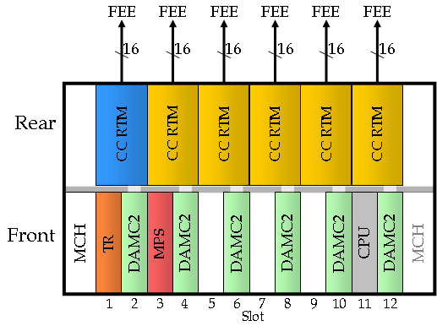
Fig 13: CC Crate layout

Although we will evaluate the design presuming 16 FEE connectors per slot, a first prototype might only have 8.

Ideally a 12 slot crate should be able to support 4-8Mpix.

Operating Modes (Use Cases)
To help understand the decisions taken, the most likely use cases are outlined.

XFEL Running
TR receives machine clock and telegram. The local clocks and telegram are derived from this and distributed to the crate.
The CC system processes and distributes these to the FEEs

Hierarchy: Machine -> TR -> CC -> FEE

TR Standalone and Testing
In the mode the TR generates signalling as if connected to the machine. This will allow testing and debugging of a Timing crate.
Another option is to presume a machine emulator exists to drive a TR (probably another TR with different firmware) – the ideal solution would be to have a
separate mini-crate with the TR test transmitter etc. generating the 1.3GHz
and telegrams

Hierarchy: Software -> TR -> CC -> FEE

Standalone
The is a the situation where we do not use a TR at all (no external inputs)
So we must:
- Generate Bunch Clock
- Generate FEE Clock (99MHz)
- Generate Start/End (in Bunch clock steps)
- Generate Output Trigger for external device
  - Programmable delay wrt Start Signal (in BC steps + ~1ns steps)
  - Front-panel output, using an FMC.
- Generate Reset
- Generate CC Veto (from veto input)
- Sequencer
  - Need to decide at what level this operates – bits in serial streams or slightly higher.
We need NOT handle:
    - FEE Internal Calibration
  - FEEs (not CC) must set internal delays wrt Start Signal (sub BC step)

Hierarchy: Software -> CC -> FEE

Other Beamlines
TR must handle any clock translation.

Hierarchy: Other Machine -> TR -> CC -> FEE

For Petra3 we get BT (revolution counter in singleton mode) and a 500 MHz clock. Using the PBU we would crudely time in the setup followed by fine tuning using TR or CC-master. Need firmware on the TR to do clock translation, start/trig generation and telegram production (needed?).

Typical Run Timeline
Need to recover the original ideas concerning DAQ sequencing (RC,etc.). What we shoud do is document the time history of all actions we are expecting during a run.
Trig (10 to 30 Hz)
DAQ ready event
Start event
bunches
End event
0 ms
~1 ms
≥ 15 ms
~1 ms
33 to 100 ms
interrupt CPU
interrupt CPU
DAQ/CC timing events

Fig.14: DAQ / CC Timing Events

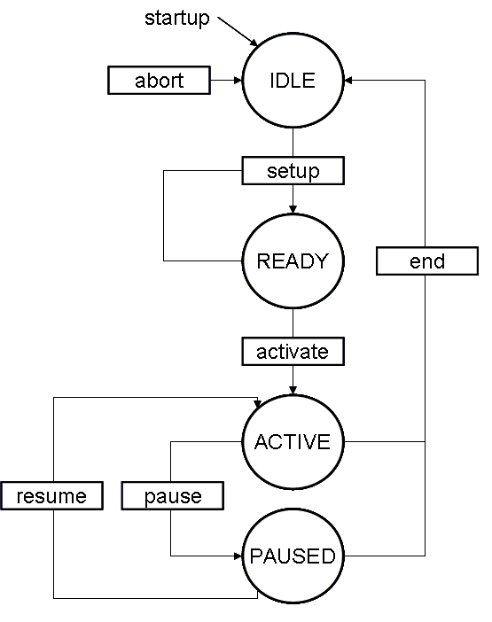
Fig.15: Software State Machine

- IDLE to READY
  - Ensure sub-systems are in IDLE state
    - Stop CC issuing STARTS
    - Stop TR interrupting CPU
    - Stop any other sub-systems as required
    - State is IDLE
  - Configure
    - Configure CC-master and CC-slaves
      - via PCIe writes to CSRs
    - Configure FEE
      - via network messages
    - Configure TR…
      - ?
    - Set state READY

- READY to ACTIVE
  - Enable running
    - enable TR interrupting CPU
  - On first DAQ ready event
    - enable any other sub systems (FEE, TB…)
      - via network messages
    - enable START generation at CC
      - via PCIe writes
    - Set state ACTIVE

- ACTIVE to PAUSE
  - On next DAQ ready event
    - Stop CC issuing STARTS
    - Set state PAUSED

- PAUSE to ACTIVE
  - On next DAQ ready event
    - Enable CC issuing STARTS
    - Set state ACTIVE

- ACTIVE (or PAUSED) to IDLE
  - Stop run
    - Stop CC issuing STARTS
    - Stop TR interrupting CPU
    - Stop any other sub-systems as required
    - State is IDLE
  - Tidy up, summary statistics, etc.

- On ERROR
  - Depends on error source and recovery possibilities, but generally end/abort run and get to IDLE.

- whilst ACTIVE
  - On end event
    - Monitor CC CSRs, on error do something – minimum flag and set ERROR

- Whilst PAUSED
  - Do nothing

Timing Receiver TR - CC Requirements

Incorporate means of running standalone, using one of the following :
- local oscillator with local telegram generation
- additional front panel oscillator input with local telegram generation
- additional machine emulator board to drive the TR ( do we need to reserve a slot ? – preferably use a separate crate with stand-alone machine emulator / TR ‘transmitter’ )

We would prefer the TR to generate the 99MHz clock from the 4.5MHz and distribute
it on the TCLKB p2p line (see section 4.1.3)

We would prefer the telegram to be encoded using the 99MHz clock, instead of the 108MHz. Telegram Clock

If that is not possible, we need to finalise telegram transmission in crate :
- Manchester has a huge bandwidth hit -
Is there room for a simple 2 line solution: clock + data (see section 3.4) ?
- The 108 MHz telegram clock as required above should be on the RX18 line of the MLVDS bus. (named as the bunch clock in section 3.5)

Finalise “global” backplane signals
- we would like to conform to any “standard” layout where possible

External Inputs (LVDS / LVTTL) on Front-panel (or on RTM ?) – minimum required 4 :
- Clock
- Trigger
- Laser (clock typically ½BC or BC rate)
- Spare

Required telegrams
- Start Train (>15ms before train)
- Train Number (incrementing)
- End Train (? ms after / before ?)
- Bunch Pattern Index
- DAQ ready (generates interrupt to CPU to mark start of DAQ cycle)

Possibly required telegrams
- Bunch Pattern Content (actually distributed by Control – not on CC Command line)

Interrupts
- The crate CPU control software will need an interrupt to signify train coming so that correct configuration of the DAQ and its subsystems can be verified. This has to be generated as soon as possible after the end train. It cannot be the end train as this would mean the first train would be lost.

Bunch Clock
- Must be continuous (and no phase changes)

Does the TR have an RTM ?
- Is the pinout in any way similar to the DAMC2 (e.g. is the clock on the same pin) ?

Firmware required - see section 13

TR boards required on start-up:
At UCL = 1 (2 depending on test mode)
At WP76 = 1 (2 depending on test mode)

DAMC2 - CC Requirements

The DAMC2 design appears to be fixed at the moment, however below is a list of requirements needed for it to be used in the CC system.

- DAMC2 shall be an xTCA card which will be able to drive and receive the bussed MLDVS signals in the xTCA specification.
- DAMC2 shall at least be able to receive the TCLKA & B in the xTCA specification and route them to the RTM and the FPGA on board.
- The RTM connector shall have enough differential pair and single ended signal lines to support the CC functionality. For requirements on the connection and the topology of these lines see sections 4.1.1 and 4.1.3.
- DAMC2 shall support an FMC module. From this FMC module at least one differential pair shall be routed to a clock capable input of the FPGA.
- There shall be at least one differential pair routed as a clock from the DAMC2 card to the FMC connector. (Either from the FPGA or the X-point switch)
- We require +3v3 and +12V supply rails (providing 30W of power) to the RTM

In addition to the above basic requirements there are some features which would make life so much easier for CC. We would like to ask that they be incorporated if at all possible.

- DAMC2 card should have an external PLL and a zero skew clock buffer which could generate any signal between 4.5 and 108 MHz.
- The DAMC2 card should be able to drive the TCLKA & B lines in the xTCA specification.
- The x-point clock switch chip on the DAMC2 card should be more flexible, i.e. more inputs and outputs. (preferably with configurable bi-directional inputs and outputs)

Alternatively, we would be prepared to make use the DAMC2 schematics and layout but to change the design to incorporate these modifications. The details of any such agreement could be worked out by DESY and XFEL collaboration to take into account any commercial sensitivities.

DAMC2 boards required on start-up:
At UCL = 1 (2 ?)
At WP76 = 1

Control software
We need additional slide “control software” explaining the requirements on the CPU’s control software. Here are some starting points:
- Interaction with master
  - Read CSRs
  - Read counters
  - Write CSRs
  - Clear counters
  - …
- Interaction with slaves:
  - Same as master?
  - …
- Interaction with TR
  - Read out stored telegram data – how to synch. To this as changes
  - Stop and start TR operation – what is possible
  - Writing control options – enabling interrupts, etc.
  - …

Veto Sub-system
Our preference is for a separate VETO Manager crate. This will require :
- VETO input line into the master
- Laser input we were discussing is not a veto - it is more a flag / marker

CC Hardware requirements
CC hardware requirements
- xTCA Crate (~5 slot job)
- >= 1 TR board + working firmware
- >= 1 DAMC2 + working firmware

Firmware required
A list of FPGA firmware ( modules ) required per board type:
Module | Master | Slave | TR ( for the requirements )
Telegram decoder | yes | yes | N/A
PCIe | Yes | Yes | Yes
memory access | yes | yes | Yes
Fast command, Veto and Feedback handling | yes | Yes (Veto & Feedback)
Non XFEL running |  |  | Clock translation, start/trig generation, telegram generation

Timelines

End of June:
- Discussions with RAL re RTM project
- Preliminary Design
July 9th:
- Distribute to FEE+TB+TR+FEA groups
July 23rd:
- assimilate feedback = FINAL design
July 30th:
- Firmware development with eval. board of telegram encoder/decoder
September
- RAL starts RTM design
- TR available (2 for WP76, later 1 to UCL)
- TB/CC meeting (9th Sept)
  - CC design review (freeze)
  - Prioritised list of telegrams for TR group.
- WP76 gets Crate+ADC+TR
  - Control software (i.e. configure TR) + ADC firmware work
  - Firmware development overlap with CC (invitation to UCL)
January
- DAMC2 and CC-RTM prototype

References

