Clock and Control Hardware Specifics
Propose to use the DAMC2, with custom RTM, and optionally custom FMC for external inputs.

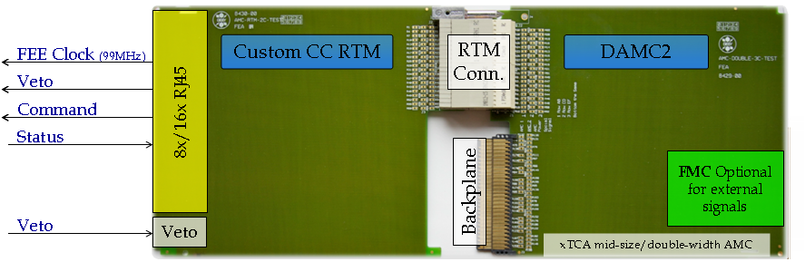
Fig 5: CC module, with DAMC2 and custom RTM.

The current design for the DAMC2 board includes 54 differential pair signals connected between the DAMC2 FPGA and the RTM connector. One pair is dedicated to a clock which is an output of the crosspoint switch. (4.5MHz TCLKA distribution ).

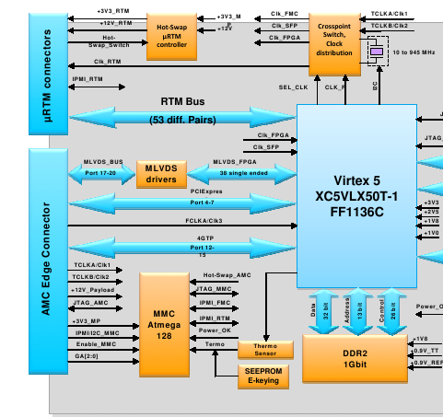
Fig 6: DAMC2 block diagram (uRTM and AMC connector section)

Suitability of the DAMC2

RTM Connections and Clocking

The number of differential pairs that a CC RTM needs depends on the number of CC FEEs supported. Each FEE requires 3 input pairs ( including the 99MHz clock ) and 1 output pair for status. If 16 FEEs would be supported by a single CC card, there is a need for 64 differential pairs of signals. However, the differential clock to each FEE does not need to originate from the DAMC2 card, hence 16 pairs will not be needed. The dedicated clock line from the DAMC2 is going to be used for transmitting the clock to the RTM. The number of signal pairs needed then becomes 48.

Furthermore, the status signal from each FEE may not need to be differential. This depends on what kind of functionality will be implemented by this signal.
The remaining signal lines will be used either as differential pairs or single-ended for RTM functions. Figure 8 shows a rough block diagram of the FEE connections on the RTM.
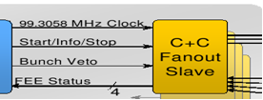
Fig 7: Signals to a CC slave

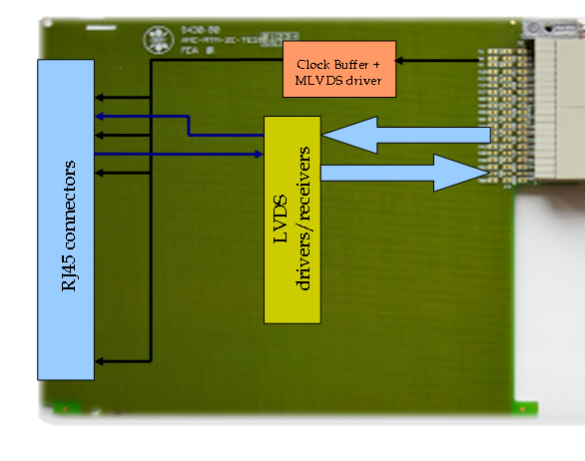
Fig 8: CC RTM

The requirements for the connections on the RTM are:

- According to the clock and control fast signal specification document there is an option of skewing the command lines ( Start/Info/Stop and Bunch Veto ) with respect to the 99MHz clock.

- There is a need for a clock distribution/buffer circuitry on the RTM to supply 16 clocks to the FEEs and there should be no skew or phase difference between these clocks.

- There will be a skew between the data lines going out to the RTM unless all 54 pairs have the same trace lengths. These might have to be compensated on the DAMC2 FPGA.

The initial clocking scheme considered is shown in figure 9. This scheme presents an ideal case for clock distribution on the CC crate. The clocking scheme that will be chosen is limited by the current capabilities of the DAMC2 card which are:

  - DAMC2 clock distribution circuitry consists of an I2C controlled XO and a 4x4 crosspoint switch (figure 10).
  - XO can generate any-rate programmable frequencies from 10 MHz to 945 MHz and select frequencies up to 1.4 GHz. (according to the schematic part 10-810 MHz)
  - The start-up frequency for the part is 118 MHz. (according to the schematic part)
  - The crosspoint switch can route any of the four inputs to any of the four outputs and also can act like a low jitter clock fan-out buffer.
  - The diagram in figure 10 shows the clock distribution circuitry.
  - TCLKs are inputs to the DAMC2 card. The card doesn’t have the capability to drive them according to the specs.

TCLKA (4.5MHz Bunch)
TCLKB (99MHz FEE)
99MHz FEE
CLOCK GEN/SWITCH
XTCA BACKPLANE
PLL
99MHz FEE
99MHz FEE
4.5MHz
Currently not possible on DAMC2?
Would this be better? Sorting out the skew between master and slave cards
Only a PLL or PLL+zero delay buffer/fanout?
Fig 9: Initial clocking scheme

XO
X-POINT
SWITCH
FPGA CLK
FMC CLK
SFP CLK
RTM CLK
CLK1-FPGA
OSC CLK
TCLK2
TCLK1
Fig 10: DAMC2 clocking distribution

The issues that arise from the current capabilities of the DAMC2 card can be summarised as below:

- There doesn't seem to be a PLL on the DAMC2 card. We need to generate the 99 MHz clock from the 4.5 MHz bunch clock by an external PLL.
- The PLL can be on the RTM. However, this clock would have to go back to the DAMC2 card to be distributed across the backplane on the TCLKB line.
- According to the diagram and the clock circuitry schematic for the DAMC2, there is no facility to supply a TCLK to the xTCA backplane. ( TCLKs are inputs to the x-point switch )
- Any generated clock on the RTM can return back to the DAMC2 FPGA via the RTM connector. ( There is one pair on the RTM connector that is routed to a GCLK input of the DAMC2 FPGA )

Proposed clocking Solutions
Considering the limits of the DAMC2 card stated in the above sections, there are two major solutions for using the DAMC2 board with a custom RTM as a CC card.

1) A PLL will be on the CC RTM and the 99MHz clock to the slaves are going to be transmitted on the MLVDS bus lines. (The spare line can be used for this). The diagram in figure 11 summarises this approach. This solution puts further requirements on the DAMC2 card which are stated as below and also summarised in section 9.

- The MLVDS signal pair that the 99MHz is transmitted should be on a clock capable output from the FPGA.
- There will be a skew between the 99MHz sent to FEEs from the master and the one sent to FEEs from the slave. More discussion is needed to reduce this skew. (Detailed low-level design work)
- Extra RTM lines are needed to control the PLL and one differential pair is needed to send the 99MHz clock back to DAMC2. The remaining signal connections on the RTM can be used for these.
- The 99MHz clock will have to pass through the CC/DAMC2 FPGA on the way to the MLVDS Bus lines ( jitter ??? )

99 MHz
99 MHz to slave CCs
4.5 MHz
99 MHz
4.5 MHz TCLKA
99 MHz FEE
X-POINT
FPGA
PLL
xTCA BACKPLANE
MLVDS TRCV
Fig 11: Clocking scheme 1

2) TR generates the 99MHz and transmits it on TCLKB. This signal obviously has to be in synch with 4.5MHz and 108MHz clocks. The diagram in figure 12 summarises this approach.

99 MHz
4.5 MHz
99 MHz TCLKB
4.5 MHz TCLKA
99 MHz FEE
X-POINT
FPGA
PLL/ zero-skew fanout
99 MHz
xTCA BACKPLANE
MLVDS TRCV
Fig 12: Clocking scheme 2

This scheme is relatively more straight-forward. The requirements for the TR card arising from the use of this solution are:
- The TR card should generate the 99MHz clock and distribute it on TCLKB.
- The skew on the 99MHz clock between the master and the slave CC cards is reduced, however not totally eliminated. (Detailed low-level design)

As in the case for the first solution there needs to be RTM lines for PLL control and a pair for the 99MHz clock returning to the DAMC2 card.

Telegram Distribution
According to the TR specification a 108 MHz encoded clock will have the telegram data that the CC requires. We have preliminarily decided the telegrams to be
- Start Train
- Train Number
- End Train
- Bunch Pattern Index
- Bunch Pattern Content
- DAQ ready

The scheme for encoding the data is not determined yet. This will also depend on the encoding of data on the 1.3GHz clock line from the timing transmitter. There are various encoding schemes including Manchester and 8B/10B.

The telegram data will be written to designated registers on the CC FPGA. There is also an option that these registers might be written by the CPU card over PCIe.

The ideal case for CC involves receiving data and its 108 MHz clock sent by the TR in a source-synchronous manner. This would simplify extraction of the telegram data. If this will not be the case then there will be a need for data recovery logic on the CC FPGA ( we don't need to recover the 108 MHz clock) the details of which will be defined by the encoding scheme.

