Clock and control fast signal specification
M.Postranecky, M.Warren and D.Wilson 26 Feb. 2009

1Introduction 1
2Overview of 2D pixel detector DAQ and control 1
1.4 FEE fast signal interface 4

Introduction
This document is aimed at updating the definition of fast signals used by the Clock and Control system of XFEL 2D pixel detectors.

Overview of 2D pixel detector DAQ and control
Three 2D pixel detector collaborations (AGIPD, DSSC and LPD) are building detectors for use at XFEL. All detectors will use common backend DAQ and control systems and consist of three sub-systems:

- Front End Electronics (FEE) of the detectors. The FEEs are detector specific custom implementations.
- Train Builder (TB) data readout. The TB is used to build data into frame ordered bunch train specific contiguous blocks which are then sent on to a computing farm layer for processing.
- Clock and Control (C&C). The C&C interfaces to the XFEL timing system, generates and receives fast signals used to synchronize detector FEEs, and distributes configuration information using the fast signals or network messages.

3 Timing interfaces

This section describes C&C timing interfaces. Timing interfaces (clocks and triggers) are required to allow detector operations at XFEL and other, non XFEL, light sources like LCLS. Additionally standalone running using internally generated timing signals is required.

A schematic showing the proposed fast signal connectivity is show in Figure 1)

RJ45 connectors are used for both the inputs and outputs. Socket A is the default input from the XFEL Timing Receiver (TR) board. Socket B is used for the external non XFEL timing sources like LCLS. The pin assignments of A and B are defined so that the sockets can be combined into a single socket if there are physical space limitations. Timing input cable lengths are expected to be short, e.g. the XFEL TR resides in the same crate as the C&C.

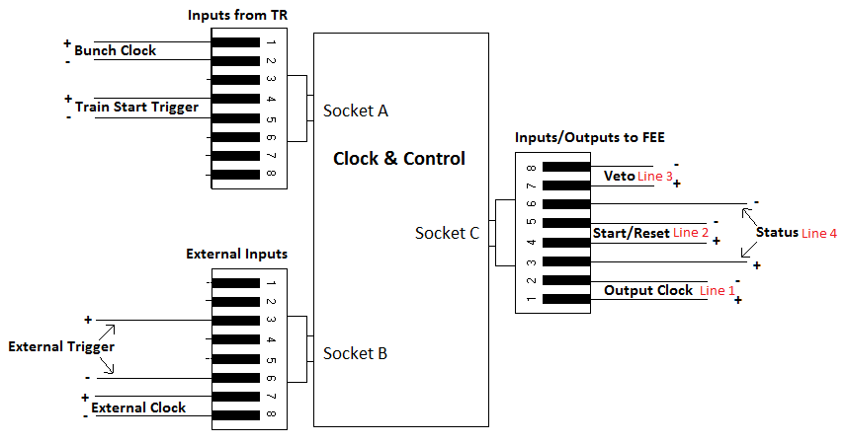
Figure 1 Timing and FEE connection schematic

The different timing interfaces required are described below.

3.1 XFEL timing interface

The XFEL TR board will provide front panel and backplane timing signal outputs.
Four 5-pair har-link (http://www.harting-connectivity-networks.de/en/produkte/produktauswahl/interface-steckverbinder/metrische-interface-steckverbinder-im-20-mm-kontaktraster-har-link) front panel connectors provide access to the encoded trigger message data stream, the 4.51 MHz bunch clock and to programmable outputs. The later can provide trigger pulse (train START, STOP…), delayed trigger pulses (START + 15ms…), gates, bursts and patterns. The backplane PCIe will allow interrupt driven C&C crate CPU synchronization to the TR. Note that no technical or user documentation exists for the TR board which is currently being prototyped.

e definesdTR signals required by the C&C.

Name | Signal type | Socket / Pin | Signal | Purpose
Bunch clock | Differential LVDS | A / 1+2 | 4.51 MHz clock | 4.51 MHz clock – used to generate the synch clock (see Line 1).
Encoded trigger message | Differential LVDS | A / 4+5 | see par. 1.6 | Used to generate control (START, STOP…) messages (see Line 2).
Table 1 XFEL TR timing signals required

The encoded trigger message stream contains START train, STOP train, and other trigger messages.

The C&C requirements for trigger messages should be made known to the XFEL timing group, as should input signal characteristics (LVDS, CML…).

3.2 Non XFEL timing interface

Table 2 defines non XFEL timing signals required by the C&C.

Name | Signal type | Socket / Pin | Signal | Purpose
Bunch clock | Differential LVDS | B / 7+8 | 750 kHz to  6 MHz clock | 4.51 MHz clock – used to generate the synch clock (see Line 1).
Trigger | Differential LVDS | B / 3+6 | Pulse only? | Used to generate START control message (see Line 2).
Table 2 Non XFEL timing signals required (not finalized)

The information in this section can only be finalized when timing interface information is know from LCLS, Spring8, FLASH, etc. Open issues:
- Where do the signals come from?
- Must additional in crate hardware be foreseen to access timing information
- Are unique bunch numbers used and, if so, how can they be accessed.

In view of these uncertainties the following will also be provided :
- Bunch clock: LVTTL or NIM, single ended, LEMO 00, permissible range 750 kHz - 6 MHz. Slower clocks below 750 kHz might require additional (external) circuitry, and will not meet jitter etc. specs. Faster clocks above 6 MHz acceptable but will not permit synchronous veto.
Trigger input: LVTTL or NIM, single ended, LEMO 00

3.3 Standalone timing interface

An internally generated 4.51 MHz clock is provided for standalone running.
This also provides, smoothly and without glitches, the 99.31 Mhz clock in case of loss of
the machine clock from the TR.

Standalone trigger could be generated by software or on FPGA.

4 FEE fast signal interface

This section describes the C&C FEE fast signal interface. Fast signals are clocks and pulses transferred over CAT5 ( or better ) cables (≤ 5 m). Any shielding ( outer or or individual T.P. ) is to be connected directly to ground on C&C.

The FEE interface is used to distribute synchronization and bunch train configuration information train ID, bunch pattern ID…) to the FEEs. Currently only one quantity is sent from the FEE to the C&C.

A schematic showing the proposed connection functionality is shown in Figure 1 and fast signal definitions in ed

If shown necessary, the C&C could individually skew the fast command lines 2 & 3, w/respect to the clock Line 1, using the programmable ODELAY feature of the 'Virtex-5' Xilinx FPGAs. This provides 64 steps of about 75ps delay ( up to 4.8 ns range ).

Name | Receiver | Signal type | Socket / Pin | Signal | Purpose
Line 1 | FEE | Differential  LVDS | C / 1+2 | 99.31 MHz clock | Synch Clock
Line 2 | FEE | Differential  LVDS | C / 4+5 | 99.31 MHz clock encoded message | Control command (START train, STOP train…)
Line 3 | FEE | Differential  LVDS | C / 7+8 | 99.31 MHz clock encoded bunch number  AND / OR  4.51 MHz clock encoded yes/no | Veto command
Line 4 | C&C | Differential  LVDS | C / 3+6 | C / 3+6 | FEE status
Table 3 C&C FEE (FPGA-FPGA) fast signal definitions

4.1 Line 1: clock

Line 1 distributes a 99.31 MHz synchronization clock derived from the glitch less input bunch clock.
It is proposed that the overall jitter of this clock at the C&C output will be 100 ps or better.

Line 1 is to be AC-coupled on the FEE ( see section 5 )

4.2 Line 2: control commands

Line 2 distributes control commands to the FEEs by encoding information on a 99.31 MHz carrier clock.

Command | Start bits | Payload | Purpose
START | 1100 | Train ID (32 bit) +  Bunch pattern ID (8 bit) +  ex-OR checksum (8 bit) | Notifies FEE of coming train (in N clocks = 15ms) and provides train relevant information
STOP | 1010 | none | Notifies FEE that train ended
RESET | 1001 | none | Reset FEE micro-controller, etc. via FPGA
reserved | 1111
Table 4 Line 2 control commands

NB : Train ID to be a unique number for each train, correlated to ( or derived from ) the Train ID information received from TR. It could be generated by a counter on the C&C and incremented by '1' for each subsequent train ( while storing the original Train ID as received from TR ).

Line 2 is to be AC-coupled on the FEE ( see section 5 )

4.3 Line 3: VETO command

Line 3 distributes a VETO command to the FEEs. Two protocols are defined for distributing the command: a 99.31 MHz clock-synchronised with the bunch number to be vetoed encoded on it, or a 4.51 MHz clock-synchronised with yes/no (high/low) encoding and with a fixed ( but re-configurable ) latency. The later provides backwards compatibility with the original veto signal definition.

As described above, the 100 MHz message, being acceptable to LPD, AGIPD and DSSC, will be
distributed. The LPD will receive the VETO message with a fixed ( but reconfigurable ) latency w/respect to the pulse being VETO'd or NOVETO'd. For AGIPD and DSSC, the VETO messages will have variable latency, but still remain synchronised to the 4.51 MHz clock.

See the attached schematics of the VETO solutions as proposed in section 6.

Command | Start bits | Payload | Purpose
VETO | 110 | Bunch ID (12 bit) +  Reserved (4 bins) | Identifies the Bunch ID to be vetoed
NO-VETO | 101 | current Bunch ID (12 bit) +  Reserved (4 bits) | No bunch veto set
reserved | 111
Table 5 Bunch ID VETO command definition

Line 3 is to be AC-coupled on the FEE ( see section 5 )

4.4 Line 4: FEE status

Line 4 allows the C&C to see that the fast signal cable C is correctly plugged in and that FEEs are powered up.

The signal send is currently defined to be a continuous clock derived from the 99.31 MHz clock on Line 1. It was agreed to keep open the option of encoding information onto Line 4.

Line 1 is to be AC-coupled on the C&C ( see section 5 )

5 AC Coupling

All four fast lines need to be AC-coupled. Lines 1,2 and 3 will be AC-coupled on the FEEs, line 4 will be AC-coupled on the C&C.

The suggested default capacitive AC-coupling circuit is shown on Fig. 2 below. This also requires a balanced signal to operate correctly, and simple Manchester coding ( using the 99.31 MHz clock ) is suggested for lines 2 and 3 signals ( and possibly for line 4 status if any encoded information is carried )

An alternative version of capacitive AC-coupling with feedback latching – which does not require balanced signals – is being investigated and will be tested. If this proves capable of working at our frequencies, it should be adopted instead.

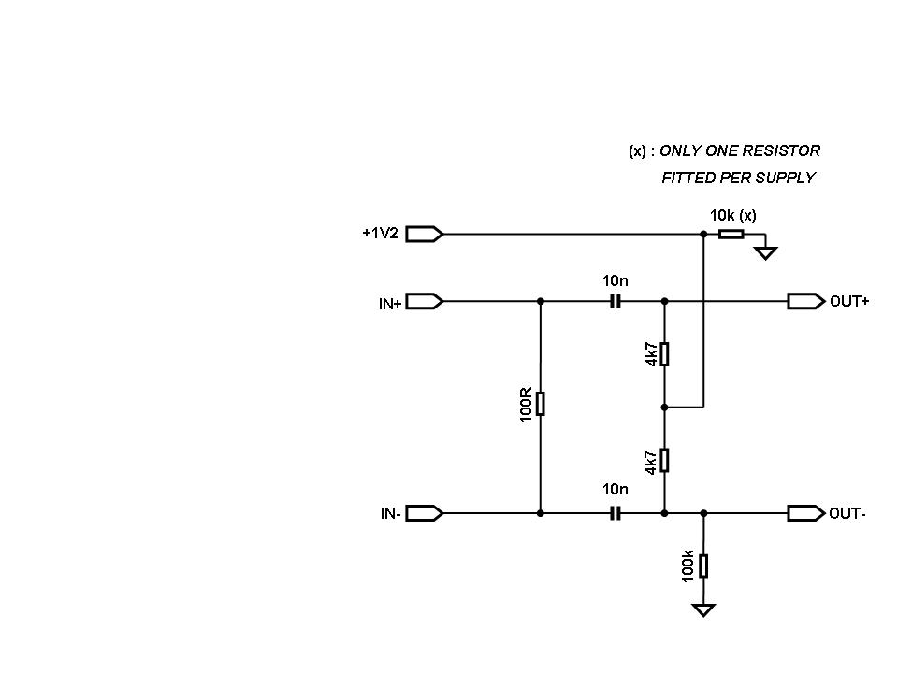

Figure 2 : Suggested default capacitive AC-coupling circuit schematics

6 VETO Solutions

Two slides from the VETO schematics distributed by Chris Youngman on 24 Feb 2010 :

The original VETO definition(s) are here :

http://www.xfel.eu/project/organization/work_packages/wp_76/daq/2d_pixel_detectors/clock_and_control/

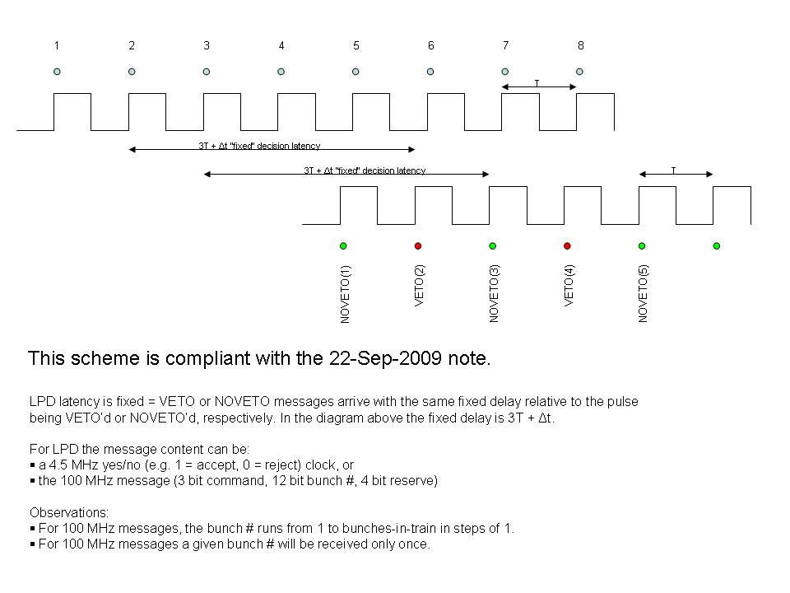

There are still questions regarding the veto generation and management.

For example, since it appears that there are likely to be many ( and increasing ) sources of veto, we will need to have a dedicated “Veto Management Unit” - if only to accommodate the input hardware – which will aggregate the various sources and provide the output in the agreed format. This may need to be a separate/daughter card from the C&C master (?)

