HEP group

The UCL High Energy Physics (HEP) group is one of the largest particle physics groups in the UK with a wide range of research projects spanning energy frontier studies at the Large Hadron Collider (LHC), neutrino physics, dark matter searches, precision muon physics, theoretical physics studies and many more. Apart from research in fundamental particle physics with leading contributions to several international collaborations (the UCL HEP group has two international spokespersons and one deputy-spokesperson) we are involved in a number of interdisciplinary and knowledge exchange projects with academic and industrial partners. These include research into improving cancer treatment with precision proton beams, advancement of accelerator technologies, environmental studies.

In 2018 members of HEP group took part in establishing a new initiative – Quantum Sensors for Fundamental Physics (QSFP) – with the aim to bridge the gap between different branching of physics and use recent advances in quantum sensors and atomic physics to address “traditional” particle physics questions such as the origin of dark matter and the neutrino mass. The HEP group collaborates closely with the UCL AMOPP and Astrophysics groups as well as with groups from other universities on the QSFP programme.

Below we report on main highlights of 2018-19.

Arrivals and Departures

Robert Buck, a new mechanical engineer, started at UCL in January 2019. Robert will support experimental programmes of the HEP and AMOPP groups. A new lecturer, Rebecca Chislett will start at UCL HEP in October 2019. Rebecca is UCL “born and bred” having completed her PhD at UCL and worked as a postdoc since 2014 on the g-2 experiment. She has secured a lectureship position after a very competitive selection process.
After 20 years at UCL Prof. Mark Lancaster will be leaving UCL to move to University of Manchester. Mark has been instrumental in making the HEP group a success. He was head of the group between 2008 and 2016 and initiated precision muon physics in the UK led by UCL. A detailed story about Mark’s multiple contributions to research, teaching and life at UCL can be found here:

https://www.ucl.ac.uk/physics-astronomy/sites/physics-astronomy/files/annual-review_15_16.pdf Page15.

We will continue to work with Mark very closely on the g-2 and Mu2e experiments in which UCL and Manchester groups are heavily involved.

Energy Frontier (ATLAS)

The LHC and the ATLAS experiment had another very successful year of data taking in 2018. This concluded the so-called LHC Run-2 (2015-18), during which ATLAS recorded an impressive 150 fb⁻¹ of integrated luminosity, at 13 TeV centre-of-mass energy. The ATLAS team at UCL, comprising around 30 members, continued its strong contributions to the ATLAS data taking, particularly supporting the online event selection (Trigger), and maintained its leading role in analysing the Run-2 data to produce many exciting new publications. A major milestone in the Higgs physics programme was the publication of the first observation (at 5 σ level) of the Higgs boson decay to a pair of b-quarks. This is by far the dominant decay mode of the Higgs boson, but its observation was very challenging, due to the overwhelming levels of background, and required the use of advanced machine learning techniques to optimize the sensitivity of the analysis. UCL was instrumental in this observation, with Dr Tim Scanlon the editor of the publication, and our PhD student, (now Dr.) Andrew Bell, receiving the prestigious ATLAS PhD Thesis Award for his leading work on this analysis and his major role in the optimization and calibration of the b-jet identification algorithms.

The UCL group is also a leader within ATLAS in making and exploiting model-independent measurements, both to explore the limits of the Standard Model and to probe the parameter space of possible new physics beyond it. We published the first measurement of the differential cross section as a function of the four-lepton mass in 13 TeV data, as well as measurements of Z bosons and jets containing b-quarks as part of a search for Leptoquarks. We also published a search for so-called long-lived particles, decaying within the ATLAS hadronic calorimeter, something completely novel, which cannot be addressed by conventional/generic techniques. Finally, we continued our tradition in the exploration of QCD, both regarding jet physics and the study of PDFs, and the study of jet substructure, where we hold a historical leadership.

Neutrino Physics and Dark Matter

The HEP group is involved and have provided leading contributions to several neutrino oscillation experiments that are responsible for one of the most important physics discoveries of the past decades – the observation of non-zero neutrino mass.
We are part of the largest international neutrino project – DUNE (see Headline Research “Hunting Neutrinos with DUNE Detector”) and are actively involved in the NOvA experiment that is taking data with neutrinos produced at the Fermi National Accelerator Laboratory (FNAL) near Chicago and detected at a site in Minnesota.

Due to a very feeble nature of neutrino interactions with matter neutrino detectors have to be very large and consequently expensive. The CHIPS experiment funded by ERC and led by Prof. Jenny Thomas of UCL is setting out to prove a radically cheaper way to build a very large water Cherenkov neutrino detector. The deployment of a detector prototype, submerged in a flooded mine pit in the path of the same neutrino beam from FNAL received by NOvA will take place in the summer 2019. The detector parts have been constructed over the past year and will be assembled during a short deployment period in North Minnesota between May and September to avoid very cold and snowy Minnesota winters.

The SuperNEMO neutrinoless double-beta decay experiment (co-led by UCL) has achieved a major milestone in the last year with the completion of the detector and the start of commissioning in a French underground laboratory, LSM, located in the Frejus tunnel connecting Italy and France. Major components of the detector were assembled at UCL’s MSSL laboratory over the last 5 years, and the whole team is excited to begin the search for extremely rare nuclear decay modes which can help understand the nature of the neutrino and shed light on the mystery of the observed asymmetry between the matter and antimatter in the Universe.

The UCL HEP group has continued playing a leading role in an international project, LZ. The experiment’s goal is to search for dark matter using a large quantity of liquid Xenon in an ultra-low background detector located in a deep underground laboratory in South Dakota, USA (see Project in Focus).

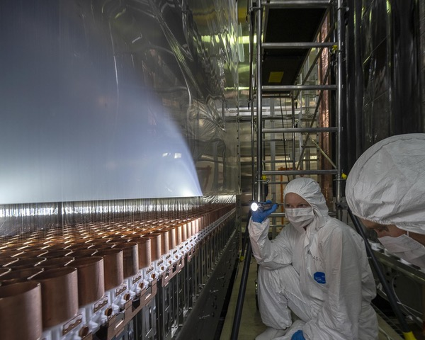
Caption: UCL physicist Anastasia Basharina-Freshville performing final checks before the SuperNEMO detector closure. Photo credit: K.O'Sullivan

Precision Muon Physics

The first Muon g-2 physics run started in April 2018 at Fermilab's Muon
Campus, and the experiment has already accumulated a data sample larger
than that taken by the predecessor Brookhaven experiment over a 5 year
period. The straw tracking detectors that were built in the UK and for
which UCL provided the data acquisition system have been pivotal in the
analysis of the first data, providing critical information on the
spatial and temporal properties of the muon beam. A publication from
this data is expected in 2019 and will hopefully determine whether the
measurement of the Brookhaven experiment, which is at odds with the
prediction of the Standard Model (SM) of particle physics by 3.7
standard deviations, is an indication of new physics beyond the SM or not.

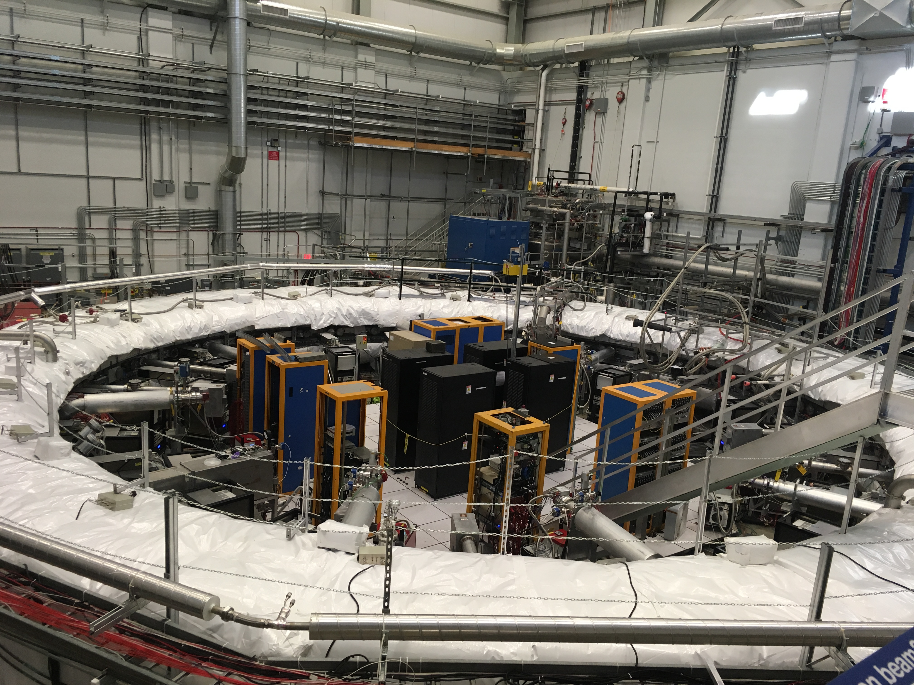
Caption: The g-2 experiment muon storage ring insulated with white fiber glass
blankets to stabilise the temperature.

