AWAKE: A Novel Compact Accelerator for High Energy Physics

The Advanced Wakefield (AWAKE) experiment has demonstrated proton-driven plasma wakefield acceleration for the first time. By injecting a high-charge, high-energy proton bunch into plasma, the free electrons in the plasma are set into oscillatory motion generating large electric fields. These fields can be harnessed to accelerate a witness electron bunch to high energies much more rapidly than is possible with current accelerators.

The UCL team are one of 18 member institutes of the AWAKE collaboration and were responsible for the development of a magnetic spectrometer (see photo) to measure the accelerated electrons. The electrons passed through a scintillator screen and the light generated was imaged with a high-resolution camera. The UCL group analysed the data and clear signals of electrons were seen on the imaged scintillator screen where the figure shows electrons of energy of about 0.8 GeV. By varying the conditions of the experiment, electrons could be accelerated up to 2 GeV within 10 m of plasma which is about 10 times faster than conventional accelerators. The UCL-led paper was published in Nature in August.

The group is now working on a next stage in which electrons are accelerated to higher energies and higher-quality bunches are achieved. This could then lead to future particle physics experiments with much shorter accelerators.

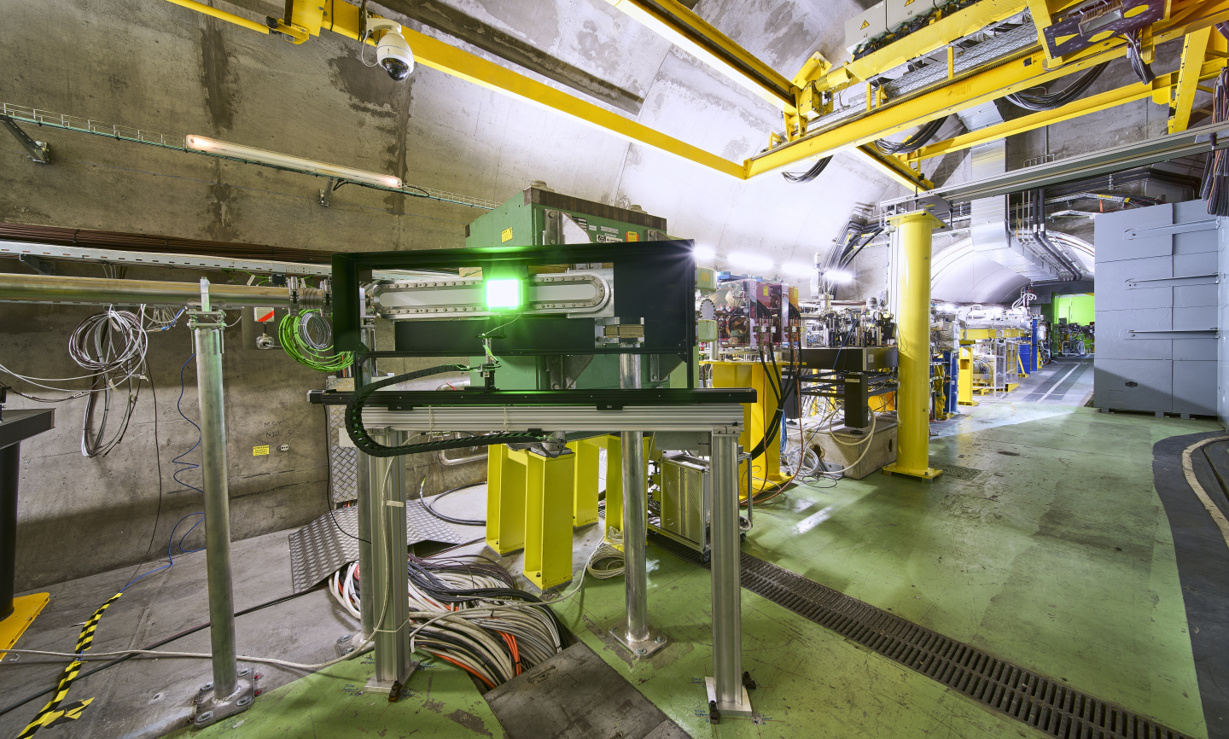

A high-resolution photo is available at: https://cds.cern.ch/record/2293889?ln=en
The photo should be credited as: "Image: Maximilien Brice, Julien Ordan/CERN”.

Caption: A UCL-built magnetic spectrometer to measure accelerated electrons in AWAKE. Image: Maximilien Brice, Julien Ordan/CERN

Caption: An image of the scintillator (top) and its projection (bottom) showing electrons accelerated to an energy of 0.8 GeV. Reproduced from Nature volume 561, pages363–367 (2018).

