Hunting Neutrinos with DUNE Detector

The DUNE detector will be a very large Time-Projection chamber filled with liquid argon. It will be hosted in 4 super-modules, 10 kton each, located 1.5 kilometres underground, in the Homestake mine in South Dakota.

This detector has a rich physics program, ranging from searches for nucleon decay to studies of supernovae and atmospheric neutrinos. It will precisely measure neutrino oscillation parameters using a beam of neutrinos produced at a distance of 1300 km at the Fermi National Accelerator Laboratory (FNAL) near Chicago.

Particles interacting with liquid argon will ionise it, creating electrons that will drift in an electric field before reaching an anode creating electrical pulses which can then be collected and analysed to reconstruct particle tracks and energies. Two possible options for the readout have been proposed. In a single-phase configuration, the readout planes are immersed in liquid argon, while for a dual-phase configuration the readout planes are placed in gaseous argon above the liquid surface, and the electron’s signal can be further amplified.

Given the size and complexity of the detector, two large prototypes (for the single- and dual-phase configurations) of about half a ton each have been built at CERN. The single-phase detector took data in a test beam at CERN at the end of 2018, while the dual-phase prototype is under construction and is expected to start taking cosmic-ray data in summer 2019. The operation of these detectors will demonstrate feasibility of the detector and the performance of both approaches.

UCL has been involved in the construction of purity monitors for the dual-phase detector, and in simulation and reconstruction work for both single- and dual-phase technologies.

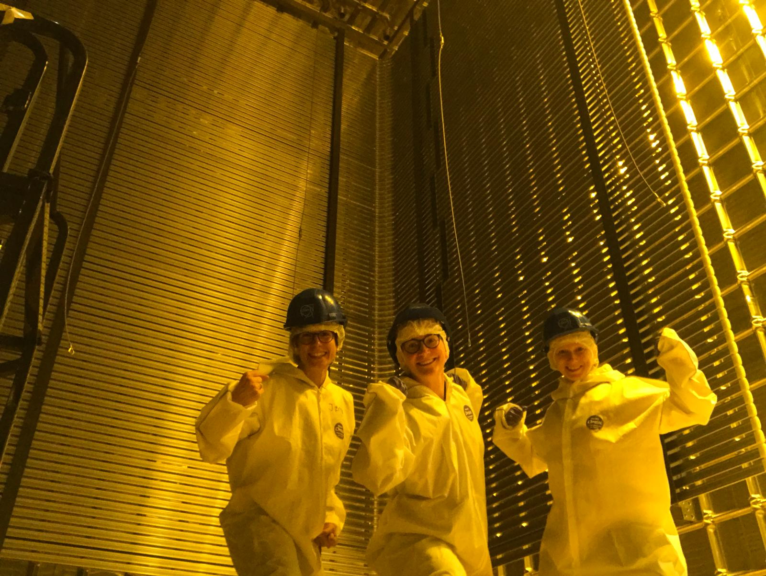
Caption: UCL physicists Laura Manenti, Linda Cremonesi, and Anastasia Basharina-Freshville (left to right) inside the ProtoDUNE detector.

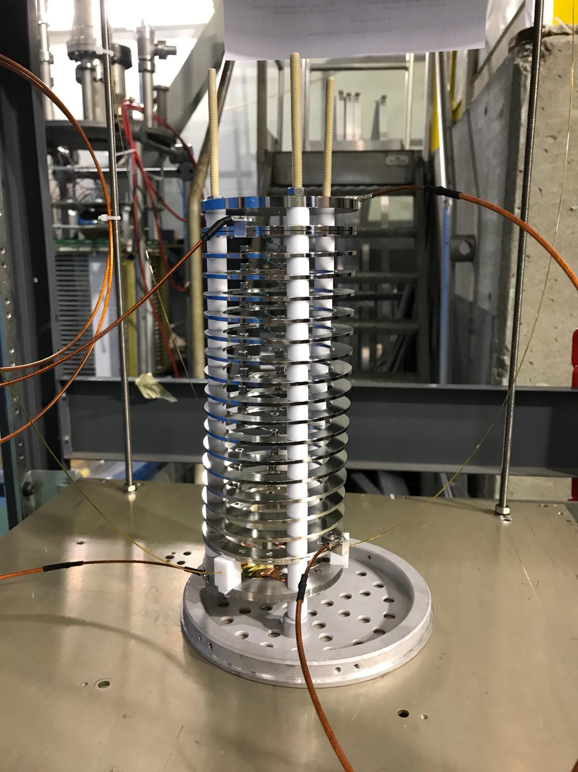

Caption: A liquid argon (LAr) purity monitor built and commissioned at UCL for the dual-phase ProtoDUNE detector. The detector is sensitive to electronegative impurities in LAr at a level of 1 part in 10¹⁰.

