Project in Focus

The LUX-ZEPLIN experiment at the Sanford Underground Research Facility

Aim:
Using a 7 tonne Xe detector to search for low-energy interactions with Weakly Interacting Massive Particles (WIMPs), hypothesised to make up the dark matter in our galactic halo. Its unprecedented size and ultra-radiopure design mean Lux-Zeplin (LZ) will not only be sensitive to WIMP cross sections 20 times smaller than those probed to date but also a host of (non-WIMP) new physics.
Results to date:
It takes a while to design and build the world’s most sensitive dark matter detector. R&D started in 2012 and in early 2017 the design of LZ was finalised and construction of the experiment began in earnest. Right now LZ’s 250 scientists and many engineers are racing to complete assembly of the detector and move it into its new home 1 mile underground ready to take first data in 2020.
UCL Involvement:
UCL has played a major role in the selection of the radiopure materials used to build the detector and in developing simulations to guide the design and evaluate the performance of LZ. The focus is now on preparations for data analysis and on-site assembly of the experiment.

See images below.
All photo credits should go to:
Matthew Kapust, Sanford Underground Research Facility

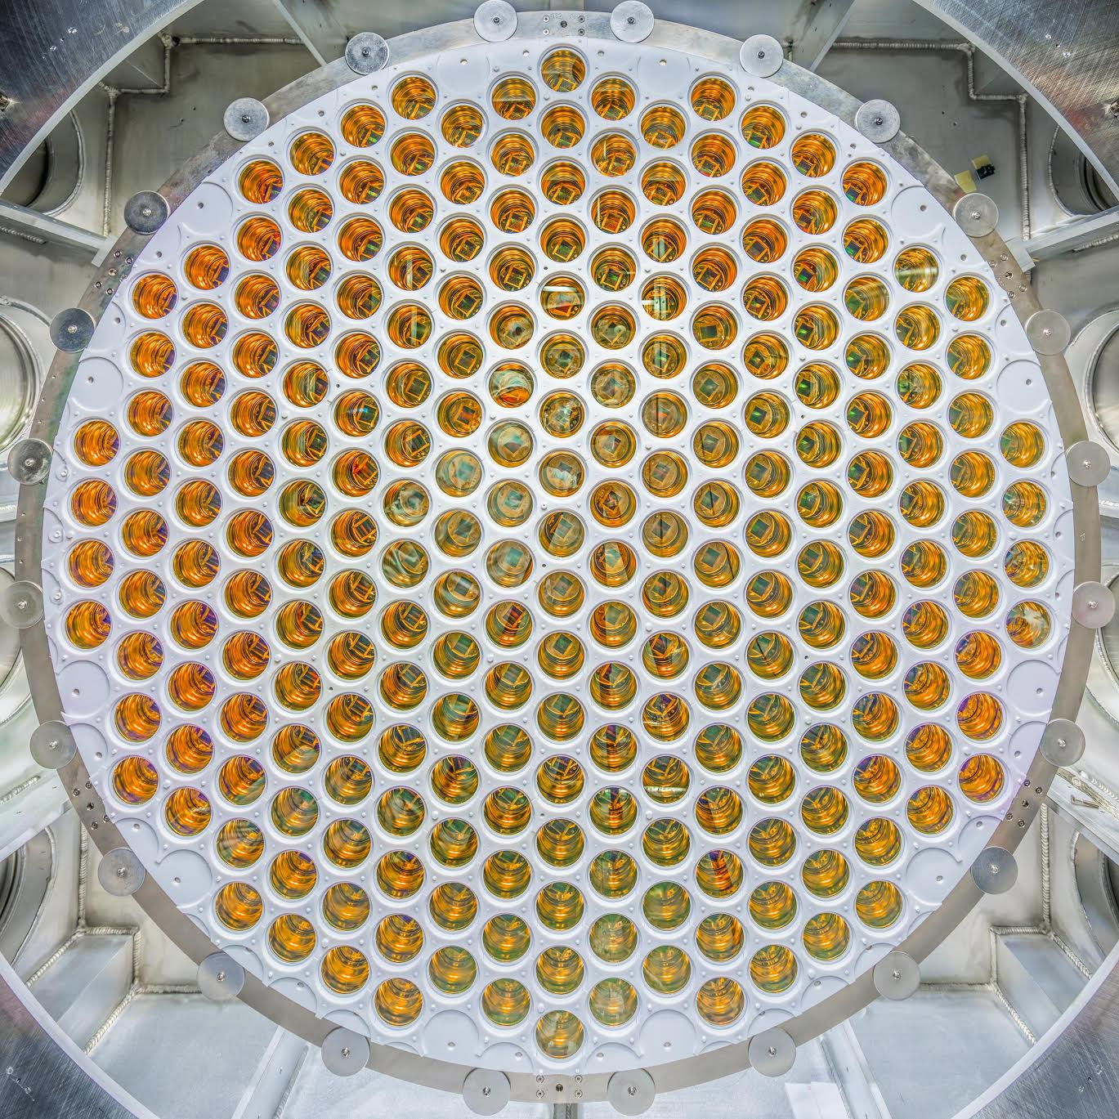
Caption: An assembled array (one of two) of 241 ultra-radiopure photomultiplier tubes that will image the liquified xenon target at the heart of the LUX-ZEPLIN experiment.

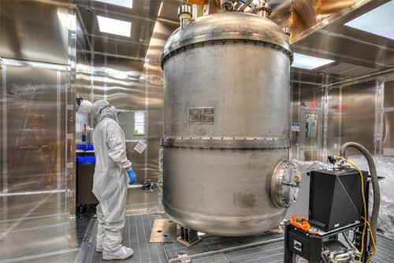
Caption: The LUX-ZEPLIN Titanium cryostat being inspected at the surface laboratory prior to its journey a mile underground to the Davis cavern of the Sanford Underground Research Facility, South Dakota, USA.

