L1Track: R3 Signalling
Matt Warren, UCL, 20 May 2013

Introduction
The upgraded tracker will operate with an extended set of triggers and controls. Aside from a modified L1A there will be the new L0A and R3 signals.

L0A (Level-0-Accept) is a synchronous signal that copies data from pipelines and stores it in FE buffer memories for possible readout. The data is indexed by L0ID. Note that no data leaves the FE-chip at this stage.

L1A (Level-1-Accept) is asynchronous and is sent as a word that includes the L0ID of the data requested. Data is retrieved from the FE buffers for the given L0ID and sent to the counting room.

R3 (Regional-Readout-Request) is asynchronous and targeted only at FE objects (modules) that are within an RoI. To allow for larger objects (e.g. staves) that share a control-bus with many modules, the R3 word contains a bit-map of all the modules that need to readout on the stave. The R3 word also contains the L0ID of the data to be retrieved.

The L0A and L1A are broadcast and we can expect these to be transmitted using the next-generation TTC system. The R3 word is unique for each stave as each stave falls within a unique set of RoIs. R3 words are generated by decoding the list of RoIs that formed a given L0A. If R3 words are generated centrally, e.g. as part of the L0-trigger, then broadcasts are not feasible. Each ROD will require a dedicated link for reception its R3 words. Alternatively R3 words can be formed on the ROD. In this case a list of RoIs can be broadcast for each L0A. We can also consider a more hierarchical system where groups of RODs receive TTC/R3 from a crate-level TTC distribution/generation board, for example, but it is likely that each ROD will have it's own receiver for simplicity.

The means and medium for RoI-list broadcast are not yet defined. It could be an independent system - a passive optical distribution tree with dedicated inputs on RODs, or it could use the next-generation TTC distribution system - with its far increased bandwidth. The interfaces between the L0-trigger, the distribution medium and the RODs are not yet defined, and similar issues need to be addressed in both options. As the TTC option is the most efficient (one fibre instead of 2 per ROD) and interface firmware/hardware needs to be developed regardless, this will be the system described in this document.

It should be noted that there are (currently) latency constraints for the R3 distribution and lower latency options are preferred.

RoI distribution format
To distribute an RoI-list we need a message that contains the list and the L0ID it is associated with. Assuming ATLAS will be segmented into <4000 RoIs and that there will be <20 RoIs per L0A, we need of order 12*20=240 bits for an RoI list. Assuming that the TTC will provide >5Gb/s data transfer rate we can likely make messages that can be transferred in <50ns. This allows for a higher instantaneous rate than that of the L0A (25ns + 25-50ns dead-time) and will not contribute to any queuing delays.

At an L0A rate of 1MHz this is of order 250Mb/s of data.

L0-Trigger
To generate an R3, we need to know which RoIs were used to form an L0A*. RoIs are identified in the jFEX, eFEX and MuCTPi. These are sent to L1Topo, but not as part of the lowest-latency L0A logic, so further optimisation is needed.

The shorter RoI lists (sub-messages) from the eFEX, jFEX and MuCTPi need to be combined into a single message for distribution by the TTC. In all cases a firmware block and some interfaces will be required. As these systems are all synchronous, aggregation can be done without queuing or sorting. It is proposed that dedicated inputs are provided for this purpose on the L1Topo, where the full RoI-list message is formed and sent to the TTC system for distribution.

*We may want to use the type of object that created to RoI to decide if this RoI would be useful for L1Track.

Using the TTC System
The top of the ATLAS TTC distribution tree is the Central-Trigger-Processor (CTP). The CTP will/should provide an input for data that will be broadcast on the TTC network (Sophie Baron suggested this). An interface specification (and/or firmware block) will need to be developed for this task.

It is expected that the L0Topo will send RoI-list messages to the CTP on a dedicated fibre. The CTP will combine these with the other timing signals (and data?) and send on to the RODs. Note that at present we have an array of boards between the CTP and the RODs (LTP, TTCvi, TTCex, TTCrq) - this is being conveniently ignored with the assumption that provision will be made for integrating data into the TTC stream where appropriate by the TTC designers [when we make our requirements clear!].

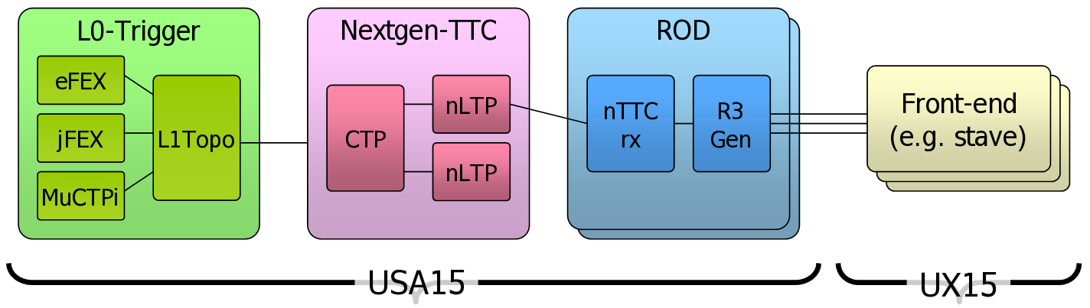

ROD Processing
RoI-list messages need to be translated into R3-words on the ROD. Each GBT-link will have a dedicated look-up-table (LUT) for this purpose. The output of the LUT is a map of the modules within a given RoI (the LUT is a RAM with address=RoI-ID and module-map=dataout). Each RoI in the list is fed into the LUT sequentially and the outputs are ORd together to create a composite module-map. Once processing of the list is complete the module-map and L0ID are serialised and sent to the FE.

The R3 word is comprised 2 start bits, 15b module-map, 8b L0ID and 1 stop bit = 26b and is distributed on the FE serially at 40Mb.

Latency Estimates
It is presumed that links are all optical and use the GBT in wide-band mode for transmission. The GBT is synchronous and is essentially a 120b parallel bus operating on a 25ns clock, with a claimed FPGA-FPGA delay of 125ns.

R3 Generation and Distribution Latency
Description | Latency (ns)
L0A | 0
RoIs GBT to L0Topo | 125
Aggregation on L0Topo | 25
RoI list GBT to CTP | 125
- 10m Fibre | 50
CTP stream integration | 100
CTP PON* to RODs | 125
- 20m Fibre | 100
RoI-list to module-map (20*6.25+25) | 150
- 120m fibre | 600
R3 serialise to FE (26b @ 40Mb) | 650
TOTAL | 2050

* PON latency is estimated at 225ns at 1Gb, but the 10Gb version could be less. Here we assume it is the same as the GBT.

Page 23 https://indico.cern.ch/getFile.py/access?contribId=101&sessionId=46&resId=1&materialId=slides&confId=233533
Page 22 https://indico.cern.ch/getFile.py/access?contribId=99&sessionId=46&resId=1&materialId=slides&confId=233533

