A Practical Track Trigger for ATLAS (with Regional Readout)

(DRAFT)

Nikos Konstantinidis, Gordon Crone, Matt Warren

University College London

Introduction
A tracking trigger is a relatively new proposal for the ATLAS upgrade, which already has a well-established tracker project without a track-trigger. A re-design would be ideal, but without a full physics study to support the case, and with viable possibilities to adapt the design as it stands, the additional effort and time required seems too costly. We have attempted to work within the architectural and technological constraints of the existing design. In many areas we seek extensions of existing capabilities, but little in complete re-design.
Various options for tracking readout exist, falling into 3 areas:
1) BC readout of the whole detector. This increases data-volume/bandwidth by a factor of 300, and is deemed infeasible.
2) Auto/local event selection with special layers. On-detector logic selects good events autonomous of any trigger, which are pushed out as needed. In the case of strips, both sides (strip + stereo) are joined – either at the chip, module or super-module level (with increasing bandwidth requirements respectively). Early studies show that high readout rates required, as it is difficult to distinguish between low and high-pT tracks (influenced by magnetic field). Options for on-detector track finding are also being investigated, although these needs to group data from modules spread over multiple layers/discs – a very difficult readout scheme. These ideas are in their infancy and not covered here.
3) Readout only regions of the detector prior to an L1A being issued, making use of seeding from early stages of the L1 trigger system. This is detailed here.

Regional Readout
Regional readout uses L1Calo and L1Muon to identify potentially interesting features at a few hundred kHz. Readout requests are issued to the specific regions in the tracker at this rate, providing the (η, φ) position of the objects identified as interesting. In this way, only a small fraction of the detector is read out, and only at a reduced rate, such that the required additional bandwidth will be modest.
Several variations are possible with this approach, depending on how fast the regional data can be read out and processed, and on the overall Level-1 Trigger latency envelope. Tracking information could be used directly within the Level-1 Trigger, or as part of a two-stage Level-0/Level-1 trigger. A two stage trigger requires additional buffers on all ATLAS detector front-end ASICs (FEICs) such that data can be held until the slower, definitive hardware trigger decision is available.
Regional readout builds on the existing Level-1 Trigger architecture, in which a potentially interesting event is identified, and a signal synchronous with that event is sent to the detector front-end (FE) modules. The front-end FEICs transfer the event data from their pipelines to a readout buffer where they are queued for transfer off-detector.
For regional data readout, the process is similar, but the trigger in this case is a regional-readout-request (R3), and is not broadcast to all FE modules. Instead it is sent only to the modules inside the RoI.

Regional Readout Implementation
Regional readout is an auxiliary system that operates independently of the normal trigger (L1A) readout system. The constraints placed on the RR are defined by the trigger/readout architecture (and almost all of these are to do with latency) but the mechanism remains the same. The process is detailed below and in Figure 1.
- L1Calo/L1Muon provide RoIs at a rate of ~400kHz-1MHz on an electrical or optical bus
- A hardware unit that we’ve called a RoI Mapper (RoIM) decodes (and re-synchronises, if necessary) this signalling.
- RoIs are broadcast to individual Read-Out Drivers (RODs) or local ROD-crate fanouts.
- RODs have a look-up table configured such that it can map RoI to link/modules/MCC and generate R3. These are encoded for transmission over optical link (GBT) to the Super-Module Controller (SMC).
- The SMC decodes and generates R3 signalling required for super-module distribution and sends the R3s to the relevant MCCs.
- The MCC prepares for regional readout while forwarding the R3 (or derivative) signal to the FEICs. The FEICs copy the event data from their pipeline/buffer, processes it, and then send the event out as soon as possible.
- In the case of dedicated RR links, these data would go directly to the Track Trigger Processor (TTP), otherwise they are intercepted on the ROD and forwarded on the to the TTP.
ROD Crate x20
ROD Crate x20
RODs
RoI Mapper
L1 Muon/Calo
FE-Modules
RoIs
Track Finder
L1
Figure 1: Conceptual Regional Readout System within ATLAS DAQ.

Readout/Trigger Architectures
Track trigger data readout can be split into two options: 1) as part of what we call the Level-1 Trigger, where the a trigger decision is required within the pipeline length, and 2) as a new system that makes use of smart buffers on the front end.

Classic Level-1
This is the same as the current ATLAS, but with additional information being used for the trigger decision. In this case regional readout and a fast track-finder are the source of extra data. The most important attribute here is latency – the entire process (Muon/Calo -> Regional Readout -> Track-finder -> L1 Accept, see Figure 2) needs to happen within the pipeline length.
Estimates for a latency-optimised system (including an extremely optimistic track-finder) are
- BC → RoI 1200ns + 500ns fibre
- Decode RoI/R3 650ns + 500ns fibre
- Data Volume 2375ns
- Readout 325ns + 500ns fibre
- Track Finder + L1 2000ns + N + 500ns fibre
- Total 8550ns + N
Figure 2 describing contributions to latency.
Trackfind+L1
L1 Muon/Calo
RoI/R3
0
1
2
3
4
5
6
X
Readout
Data
µs
fibre
Pros/Cons
+ No changes to FE buffers
- Will need longer pipelines – latency becomes an extremely hot topic
- Only enough time for the most basic track-finding (<5us)
- Track-finder will need to be fast and comprise multiple parallel units

Smart Buffers
All FEICs have de-randomising buffers that absorb data from bursts of high-rate triggers. These are essentially FIFOs. By adding some extra addressing to these buffers, a new type of trigger can be used that contains and ID that identify events to accept or reject asynchronous to their BC. This system uses 2 levels of trigger - a new “Level-0” synchronous trigger that copies events from the pipeline to the buffer (exactly as our current Level-1 does), and an enhanced Level-1 that is distributed asynchronously with addition information on which L0/BCID it is accepting/rejecting (a little like the current L2 does in the ROS/ROB-In).
[We are aware that a fast-clear system is also an option, but we presume this is a smart buffer implementation.]
The process is as follows:
- The Muon/Calo trigger system reduce the trigger rate from 40MHz to 400kHz-1MHz
- This is broadcast as a Level-0 Accept (L0A) to the entire detector
- Event data is copied from the pipeline to the buffer, and tagged with a unique ID - likely the level-0 number (L0ID) and bunch-crossing number (BCID)
- unique within the buffer maximum event retention time
- If regional readout is used, modules in the RoI will process/transfer this data too
- The Level-1 Accept (or Reject) (L1A/R) is broadcast at 10-50kHz
- The L1A signalling identifies events using the ID mentioned in 3) above
- Data reads-out as normal data

Pros/Cons
+ Latency is less of an issue – expected to be up to ~100us
+ Allow more time for Level-1 decision
+ Shorter pipelines are possible as Muon/Calo systems may be faster
+ Track-finder can be pipelined and share resources (more CPU) based
– More complex FEIC
– More of a redesign
– Data spends more time on detector

Design Considerations
Incorporating a track-trigger, involves changes to all sub-detectors and almost all the sub-systems of the inner-detector. Latency reduction is at the root of most changes.
The various factors are interdependent:

Overall Latency
FEICs have finite pipelines, defining the Level-1 trigger latency. The current ATLAS has a maximum latency of ~3.2µs (128 BC). The upgrade already prefers more (6-10µs is a common assumption), but this needs to be evaluated against cost and complexity – in both new hardware and increased power.
Much of the trigger latency is consumed by cable lengths between the counting room and the detector – a round-trip time is 1µs. Reading out regional-data prior to a Level-l decision introduces an additional 1µs round trip. The track-finding efficiency increases with processing time. An initial estimate, based on D0 indicates a minimum of 2µs.

Data Volume and Dead-time
Event data is the largest contributor to latency on-detector. Although queuing regional data in the FEICs would only slightly increase latency due to the low R3 rate per module, the peak latency would be much higher. It follows, therefore, that a module cannot accept a second R3 while busy with readout of the previous, and data-volume equates to dead-time.
To reduce data-volume (and latency) data compression on the FE module is desirable. For track-finding not all hit data is useful - in general, if a module (or FEIC) has too many hits, or wide clusters, there will be little opportunity of a track-finder to identify un-ambiguous tracks.
To effect this, simulations have been carried out where the cluster width is restricted to <3 strips and the number of clusters per FEIC and per MCC are capped. Using SLHC-like events (400 pile-up) it can be shown that <1% of high-pT track derived hits are lost, as shown in Figure 3.
To further reduce data-volume, only the first strip of 2 strip hits can be used. Combining the low number of hits with known hit-count maxima allows for an efficient packing algorithm that will improve further with larger (more strip channel) chips.

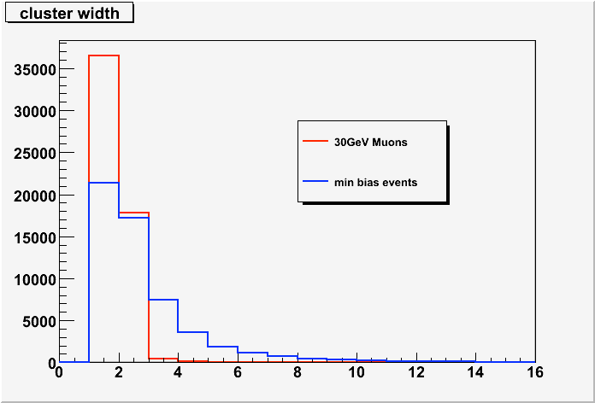
Tracker Upgrade Strips (75um pitch)
30GeV Muons

Min Bias Events
Figure 3: Plot showing cluster width differences between higher pT and min-bias events.

Data Transfer and Synchronisation
Ideally regional data would have a dedicated path off-detector allowing for fixed latency and no congestion. This introduces many new readout paths, and could double the number optical links between the detector and counting room. This is obviously not desirable.
Sharing a readout “channel” with event-data makes sense (especially when considering the low data-volume), but this both de-synchronises the data and increases latency: Event data will most-likely be transferred in packets [] with headers, trailers, bunch-crossing IDs, event IDs, chip IDs etc. A packet might be broken into frames allowing it to be transferred non-continuously. Regional data will need to wait for any in-progress packets or frames to finish transferring before initiating readout.
Smaller frames will reduce the impact they have on regional-data latency/synchronisation, but will also decreases data-volume efficiency. Ideally a frame of the order 10 bits would be a compromise worth investigating: 1 start bit, 1 normal/regional event select bit, and 8 bits data.

Off-detector Readout
In the case of dedicated links, regional-data will be transferred directly to the track-finder, and there is little complication at this stage. As this doubles much of the readout infrastructure it more likely that normal ROD readout links are used.
Data from the detector are transferred, via optical links, to RODs in the counting-room. Regional data does not need to be processed by the ROD in a significant way. Here the ROD acts as a router diverting the incoming data out to the track-finder hardware.
As track-trigger data-volume is low, the number of links to the track-finder can be optimised and data concentrated (although queuing during times of peak volume needs to be taken into account). Tags will need to be added to the data to identify which link (or module ID) it belongs to. As the data will arrive relatively slowly from the front-end (a single optical link is shared by 12 modules) it might be fragmented when sent to the track-finder and require more tagging. The additional latency incurred while queuing can be reduced, on average, by prioritising older data (i.e. that with earlier bunch-crossing IDs).
Detector layout plays a part in level readout latency too. As an RoI will encompass adjacent super-modules, data should be routed to different RODs. For example, in the barrel, only every 3rd super-module, radially, should be connected to the same ROD.

Track-Finder
Due to the distinct differences in layout between barrel and end-cap, the track-finder will likely have optimised configurations divided geographically along the length of the detector: barrel, end-cap and both. The detector will also likely be divided into quadrants, with overlap. This motivates independent track-finder units servicing these 24 zones. Incoming data from the detector will need to be routed first to its’ zonal unit (and duplicated in the case of overlaps).
Two types of track-finder are envisaged, depending on the latency (aka classic or smart L1): 1) 5us parallel, purely LUT based, 2) 150us pipelined with various finder elements.
1) To allow for asynchronous data, the track-finder unit will assign a processor to an individual event (BCID). Each processor is expected to operate using a “bingo” technique – as data arrives it is used and if tracks are found they are logged. This allows tracks to be found with incomplete data-sets. By setting a processing cut-off time synchronous to the event being processed, all tracks found can be passed to the next stage of the trigger system synchronously if needed, with outstanding data discarded.
2) With more time the system can be pipelined, allowing multiple styles of processor (hardware LUT/CAM, CPU fitter), as well as resource sharing.

Regional-Readout-Request Distribution
The regional-readout-request signal operates similarly to the L1-Accept (L1A) signal – it is synchronous to the BC it acts on, used to copy data from the front-end pipelines, generated by the Level-1 Trigger, and is desired to be low-latency.
However, unlike the L1A, the R3 is not broadcast, but instead targeted at specific modules. There are of the order 50000 modules in the tracker alone, so this is a large-scale system.
With ~4000 RoIs it will be most efficient to distribute RoI-IDs as opposed to R3 signal where possible. Using CERN Giga-Bit Transceivers (GBTs) in the counting room, we can distribute 6 to 10 RoIs/BC, allowing RoIs to be broadcast to all ROD-Crates (containing ~10 RODs each) via the TIM, or directly to each ROD (of order 200 in the SCT+Pixels).
Each ROD identifies which of its connected super-modules are inside the RoI and generates an R3 map for these modules. This requires a custom look-up table on each ROD which will need uploading at configuration.
The R3 signals are transferred using a special GBT word to the super-module where the SMC decodes the signal and forwards to the modules.
Super Module
RoI Mapper
ROD
L1 Muon
L1 Calo
ROD
ROD
FEIC
FEIC
Module
FEIC
FEIC
Module
GBT
GBT
Figure 4: Schematic of R3 generation and distribution system.
As each module needs to be identified individually, point-to-point links between the SMC and the module would be ideal, but resources on-detector are limited. Sending the signal serially (at 40Mb/s) is slow and introduces latency (300-600ns). Latency can obviously be improved by broadcasting at higher rates.
A compromise between signalling and latency on-detector would be to split the super-modules into ‘zones’ allowing simultaneous short bitmaps to be sent to each group of modules.
Other options include broadcasting just the central module ID and let the modules decide if they are inside the RoI or not.

Granularity
It is expected an RoI encompasses ~1% of modules on the detector, and that ~4 RoI are expected per event at 400kHz. Figure 5 shows a lepton RoI in the barrel.

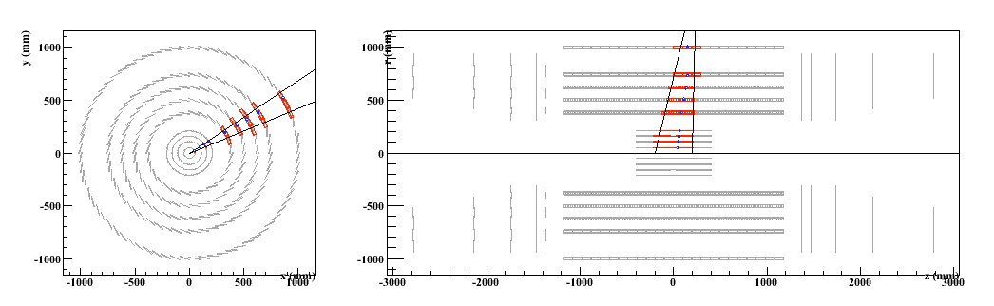
Figure 5: Event display showing RoI geometry (RoI: Δφ=0.2, Δη=0.2 at Calo Δz=40cm at beam line).

With occupancy this low it is tempting to set the granularity at the super-module level, but studies are needed to understand the effect this will have on dead-time as the super-module could be dead for as long as it takes to readout the regional data. Figure 6 shows some early simulation results.

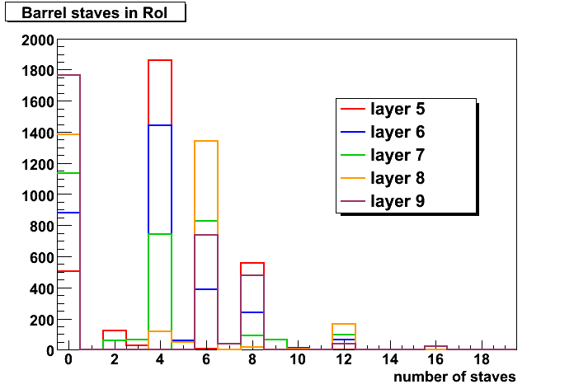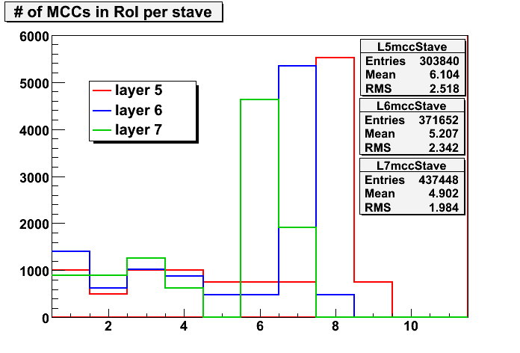

Figure 6: Number of super-modules (staves)/RoI and MCCs/RoI/super-module

Pros/Cons
Finer granularity (Module/MCC/Column/chip level)
+ more efficient use of bandwidth and deadtime
– needs infrastructure to address individual elements:
per super-module (barrel) 12 modules, 24 MCCs, 48 columns, 240-480 FEICs.
Coarser (whole/half/quarter super-module level)
+ Less “address lines” needed to target module (zzz see “R3 distribution” below.)
– more deadtime

Hardware considerations for all ATLAS (non track-trigger specific)
For a regional readout based track trigger to operate at ATLAS, it is almost certainly the case that we need to either extend pipelines or introduce a new buffering scheme. The existing latency of 3.2us is not sufficient to support 2 round-trips between the counting room and the detector.
Even without a track trigger, the Level-1 system will likely need more time make a trigger decision due to the higher luminosity, so all front-end electronics will need upgrading to some degree.
Choosing between architectures - longer pipelines or larger buffers (or both) - needs input from all sub-detectors, particularly in defining constraints, and will need to be debated within ATLAS as a whole.

Pros/Cons
Classic level-1:
+ No change to architecture
– Longer pipelines (more power, ASIC real-estate)
– Expense track-finding (fast/massively parallel)
– Not clear this is feasible
Smart buffers:
+ Allows order(s) of magnitude more time for a trigger decision
+ Possible reduction in pipeline length
– More complexity in FEICs (addressing logic needs more power, ASIC real-estate)
– More complexity in trigger distribution (event-id with trigger)
– Data spends more time on-detector (possible SEU problems)
Neither (readout at Level-0 rate):
+ Simplest FEIC
+ Possible pipeline REDUCTION
+ Level-1 operates in counting-room
– Need 5-10x increase in readout bandwidth

Hardware considerations for Inner Detector with Regional Readout

Front-end ASICs
The ID front-end ASICs are the most import part of a new design. Any changes here need to be carefully evaluated for feasibility in terms of complexity, power (cooling) and radiation tolerance.

Pros/Cons
Classic level-1:
+ No change to architecture
– Reduced latency is extremely important (see latency considerations below
Smart buffers:
+ Latency requirements eased (but not forgotten)
– More complex
Latency considerations:
– Regional data needs fast routes – possibly dedicated FIFOs and I/O
– Data format must accommodate priority data (small frames = inefficiency)
– Regional data compression on ASIC

Module/Hybrid/MCC
The hybrid will need to transport any regional data. If ultra-low latency readout is required, the feasibility of faster and/or dedicated links will need to be evaluated.

Pros/Cons
Regional Readout:
– R3 signal distribution mechanism
– Additional interfaces to R3 distribution on stave
Classic level-1:
– Extra tracking for reduced latency
– Faster on-module data links (for reduced latency)
Smart buffers:
+ Latency requirements eased (but not forgotten)
– Event ID distribution mechanism required
– Additional FIFO on MCC for regional data

Super-Module Inter-connect (Tapes) with Regional Readout
Ideally R3 distribution would be over point-to-point links between the SMC and MCC. To cater for event ID distribution rates may need to be increased too. For lowest latency regional readout, dedicated, or increased bandwidth links may be needed.

Pros/Cons
Regional readout:
– Increased command signaling
– Higher rate command system
– Increased readout rates (for lower latency)
Classic level-1:
+ No change
Smart buffers:
+ Reduced readout bandwidth
– Increased signaling for event ID distribution

Acknowledgments
This incorporates ideas and feedback from many members in the collaboration (and some from outside), in particular Elliot Lipeles (UPenn), Mitch Newcomer (UPenn), Philippe Farthouat (CERN) and Richard Brenner (Uppsala).

