Medical Module

Read all details of the task before beginning the exercise.

This task seeks to broaden your knowledge of Excel. It uses features of Excel that have already been encountered but also requires the student to seek help on functions not used previously.
You will have produced a chart before; here you will need to combine two datasets in one chart for comparison purposes. You need to put data in order and to make conditional tests on cell entries. Finally you need to prepare a page for printing.

Open the spreadsheet document ‘Med_mod_results.xls’. This shows the marks of 96 medical students on 10 modules.

- Find the average mark for each student.
- Plot a histogram of the average mark for each student with intervals of 5%. These plots may be done using the Histogram tool from the Tools/Data Analysis/Histogram dialogue box. Enter values for Input range (the column of values to histogram); bin range (the column range that contains the bin intervals 0, 5, 10…100 - these you have to provide yourself); output range (where to put the results; beware of overwriting existing data); and tick chart if you want to create a chart. The chart can either be put on a separate “Chart” sheet or placed below the mark data. If “Data Analysis” is not visible on the Tools drop-down menu, you will need to install it. Select “Add-ins” and click on the first two entries; then re-look for “Data Analysis”.
- Make new columns to right of the existing data to show the scores gained throughout the tests in descending order for each person. (Hint: look up the LARGE() function using the Help facility.) The column with the highest score is first (furthest left) and the lowest score is last (furthest right). For each student you should be able to see their third highest score, tenth highest score (lowest score) etc. e.g.

Mark1 | Mark2 | Mark3 | Mark4 | Mark5 | Mark6 | Mark7 | Mark8 | Mark9 | Mark10
90 | 88 | 75 | 69 | 54 | 50 | 49 | 47 | 39 | 35

- In a separate column, find the average mark for each student based on the highest 7 marks only.
- Plot a histogram of this average mark (highest seven marks) for each student with intervals of 5%.
- Combine the two histograms on one graph and annotate the bars as illustrated. The annotations have been created using text boxes – accessible via the drawing toolbar (If not visible go to View/toolbars/drawing.)

- It is necessary to give each of the students a grade based on the average of the highest 7 marks. A simple differentiation is between those that pass with a mark greater or equal to 50% and those with a lower mark who fail. This is achieved by entering a conditional formula into a column, e.g. the column adjacent to the average of the highest 7 marks.
The form of a simple IF condition is
=IF(logical expression that can evaluate to TRUE or FALSE, value if true, value if false).
Hence, for example, placing an expression of the kind =IF(M2>=50,”Pass”,”Fail”)
in cell Z2 will test the value in cell M2 against 50 and place in cell Z2, either the words “Pass” or “Fail” according to whether the logical test is true or false. Modify this formula to refer to the cell containing the average of the highest seven marks in your spreadsheet for a student. This formula should then copied to all the rows for the students.
- If more than one level is to be tested, for example if the average of the highest seven marks is
≥ 70 – then award a Distinction,
≥ 50 - Pass,
<50 – Fail
the test could be written as a nested test with one IF test within the other. An example is =IF(M2>=70, ”Distinction”, IF(M2>=50, “Pass”, “Fail”) ) .
The second IF is carried out when the first one evaluates to false. Use this formula in a different column with M2 changed to refer to the average of the highest seven marks. Again apply this test to all the students.
- Finally extend this method to give the students a final result based on the following (complex) criteria:
≥ 70 - Distinction,
≥ 50 - Pass,
40 ≤ (Average mark) <50 - Narrow Fail
However if the average mark is between 40 and 50 and the highest individual mark is more than 65 the result is “Narrow fail with resit”.
<40 – Fail
However if the average mark is less than 40 and the highest individual mark is more than 70, the result is “Fail with resit”.
- Make a print preview showing for each student only
  - name,
  - the final result,
  - average (%) over all marks,
  - average of seven highest marks,
  - the marks in descending order for each student.
The whole list should be sorted so as to give the “Average of highest seven marks” column in descending mark order. Give the printout a title “Medical Module MM01” and display a date-time which would be automatically updated if the printout were to be remade at another time.

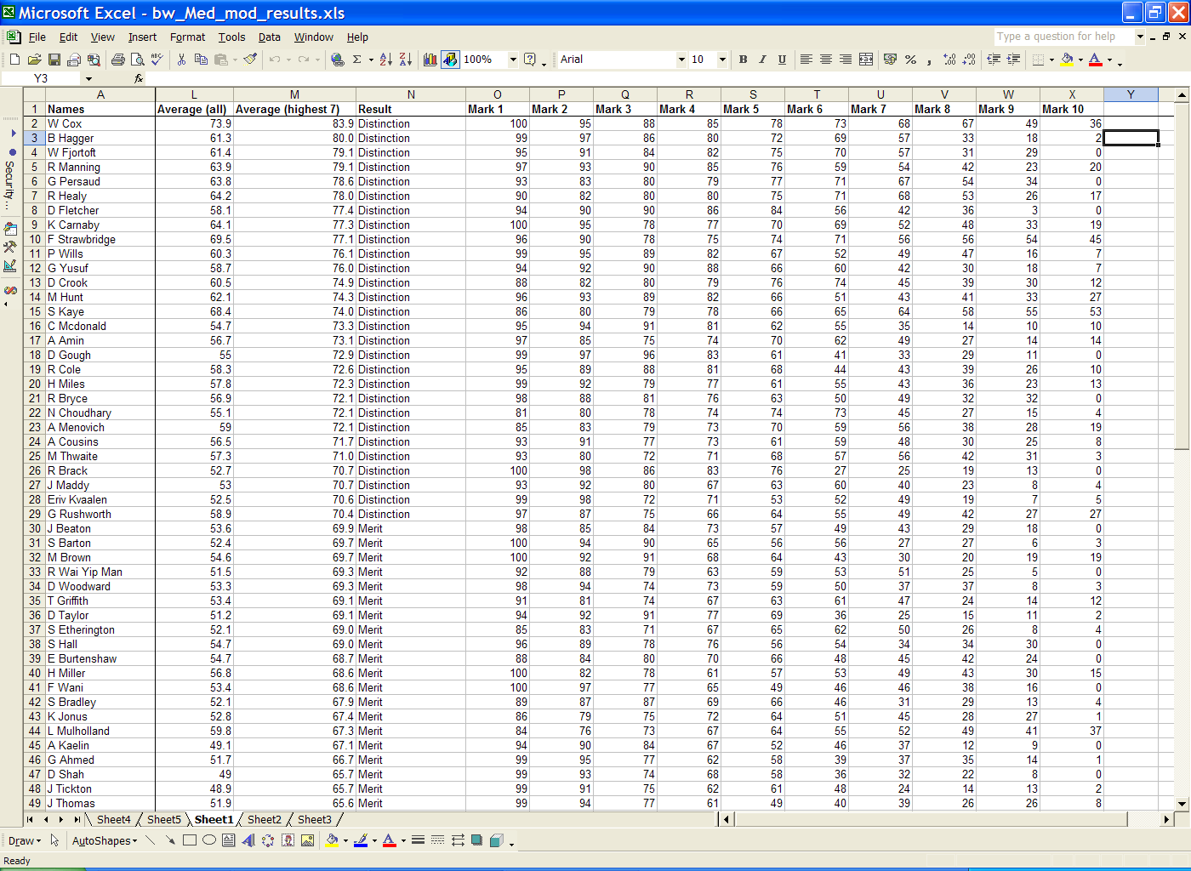

- Save your spreadsheet as “your username”-mod_med.xls.

